Table of Contents

**JANUARY 2026 | STRATEGIC INTELLIGENCE**

**ANIMAL NUTRACEUTICALS**

The Wellness Market at an Inflection Point

*Mapping value creation across a $6 billion global industry  
driven by pet humanization and the post-antibiotic transition*

# **ANIMAL NUTRACEUTICALS**

## **The Wellness Market at an Inflection Point**

**JANUARY 2026 | STRATEGIC INTELLIGENCE**

*Mapping value creation across a $6 billion global industry driven by pet humanization and the post-antibiotic transition*

# **Master White Paper: The Animal Nutraceutical Landscape (2024-2030)**

## **Executive Summary**

The global animal nutraceutical market stands at a critical inflection point, driven by two powerful secular trends: the “humanization” of companion animals and the post-antibiotic transition in livestock production. This whitepaper provides a comprehensive strategic analysis of a **$13+ billion industry** (comprising ~$6B in pet supplements and ~$7B in livestock feed additives), projected to reach **$18-24 billion by 2030-2035**.

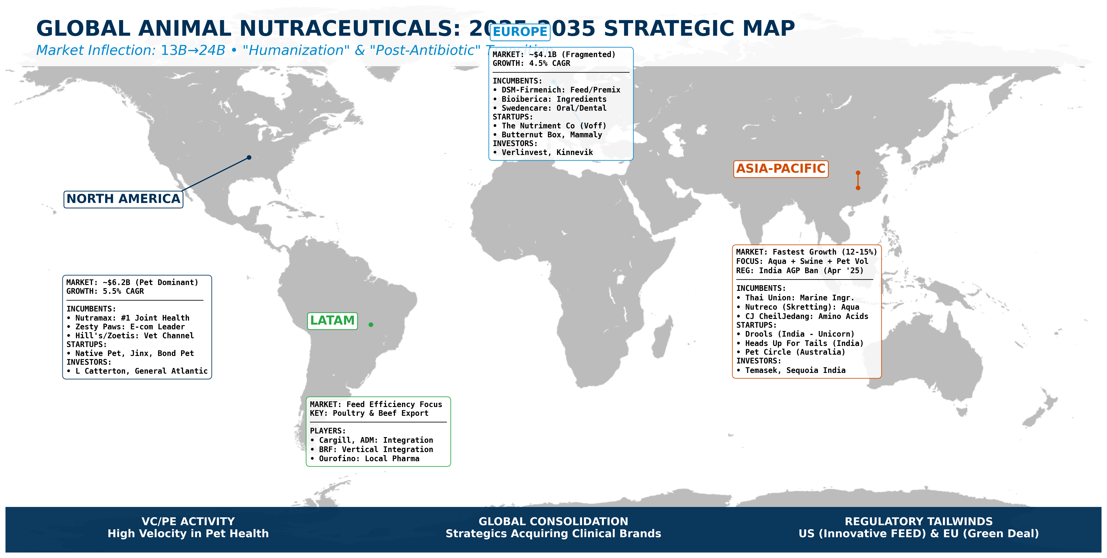

*Figure: Global Market Snapshot: Regional Dynamics and Drivers.*

### **Global Strategic Snapshot (2026-2035)**

*A unified view of the regional profit pools and key players defining the next decade.*

| **Region** | **Market Size & Growth** | **Strategic Focus** | **Incumbents (Key Players)** | **Startups & Disrupters** | **Investors** |
| --- | --- | --- | --- | --- | --- |
| **North America** | **~$6.2B** (Pet Dominant)**5.5% CAGR** | **“Humanization” & Health**Vet Channel & E-com Leader | **Nutramax** (#1 Joint)**Hill’s/Zoetis** (Vet)**Zesty Paws** (E-com) | **Native Pet** (Clean Label)**Bond Pet Foods** (SynBio)**Jinx** (DTC) | L CattertonGeneral Atlantic |
| **Europe** | **~$4.1B** (Fragmented)**4.5% CAGR** | **Regulation & Science**Green Deal & Clinical Data | **DSM-Firmenich** (Feed)**Bioiberica** (Ingredients)**Swedencare** (Dental) | **The Nutriment Co** (Voff)**Butternut Box** (Fresh)**Mammaly** (Supplements) | VerlinvestKinnevik |
| **Asia-Pacific** | **Fastest Growth** (12-15%) | **Volume & Safety**Aqua + Swine FocusIndia AGP Ban (Apr ’25) | **Thai Union** (Marine)**Nutreco** (Skretting)**CJ CheilJedang** (Amino) | **Drools** (India Unicorn)**Heads Up For Tails** (India)**Pet Circle** (Aus) | TemasekSequoia India |
| **LATAM** | **Feed Efficiency Focus** | **The “Export Visa”**Poultry & Beef Export | **Cargill/ADM** (Integration)**BRF** (Vertical)**Ourofino** (Local Pharma) | **N/A** (Focus on Ag-Tech efficiency tools) | - |

### **Key Findings**

* **Market Structure**: The pet nutraceutical segment ($5.8-6.2B) commands premium valuations (15-20x EBITDA), while livestock feed additives ($7-8B) operate on thinner margins (3-10% EBITDA) but benefit from regulatory tailwinds. The market exhibits a “two-speed” dynamic: pet brands are trophy assets; livestock feed is essential infrastructure.
* **Competitive Landscape**: Top 5 players (Zoetis, Merck, DSM-Firmenich, Cargill, Novonesis) control ~55% of global feed additive market. Clinical differentiation drives 20-40% price premiums, but e-commerce disruption is compressing traditional veterinary channel margins.
* **Investment Themes**:
* **Science as moat**: Companies with peer-reviewed efficacy data command sustained pricing power.
* **Regulatory de-risking**: The Innovative FEED Act (US) and EU harmonization are shortening approval timelines.
* **ESG integration**: Methane-reduction additives (Bovaer, 3-NOP) are becoming strategic procurement requirements.
* **Regional Dynamics**: North America leads with 48% of global pet supplement revenue ($2.26B). Europe shows cat-dominant demographics with stricter regulatory frameworks. Asia-Pacific represents the fastest-growing opportunity.

## **I. Definition, Scope and Structural Dynamics**

***In this section:*** *We define the regulatory “grey area” between food and medicine, mapping the divergent compliance pathways in the US (FDA/AAFCO) versus the EU (EFSA Zootechnical). This foundational analysis establishes the “rules of the road” for market entry.*

### **I.1. Terminology**

The term nutraceutical is a fusion of “nutrition” and “pharmaceutical,” coined in 1989 to describe food or food derivatives that provide health benefits, such as the prevention or treatment of disease, beyond basic nutrition. This common terminology is central to the market but lacks a harmonized legal definition, forcing many products into a regulatory “grey area between pharmaceuticals and food. In the context of intensive farming, most health-focused products fall under the rigorous regulation applied to feed additives, defined as substances intentionally incorporated into animal feed or water to improve its quality, enhance animal health and performance, or improve the quality of food derived from animals.

The European Union (EU) provides a strict framework (Regulation (EC) No 1831/2003), classifying functional ingredients into specific categories, including zootechnical additives, which offer performance-enhancing, non-nutritive benefits like promoting gut flora stability or increasing digestibility. In contrast, the United States typically forces these products into a binary choice between “food” (if Generally Recognized As Safe or GRAS) or a fully regulated “new animal drug” (if therapeutic claims are made).

This intense regulatory friction has spurred recent US legislative attempts, such as the proposed Innovative FEED Act (H.R. 2203/S. 1906), aiming to create a clearer pathway for “zootechnical animal food substances” to gain market approval as food additives rather than facing the long and costly drug application process. This fundamental international divergence in classification and required scientific evidence establishes a highly complex environment for manufacturers, necessitating a detailed review of the Regulatory Landscape by Region.

### **I.2. Regulatory Landscape by Region**

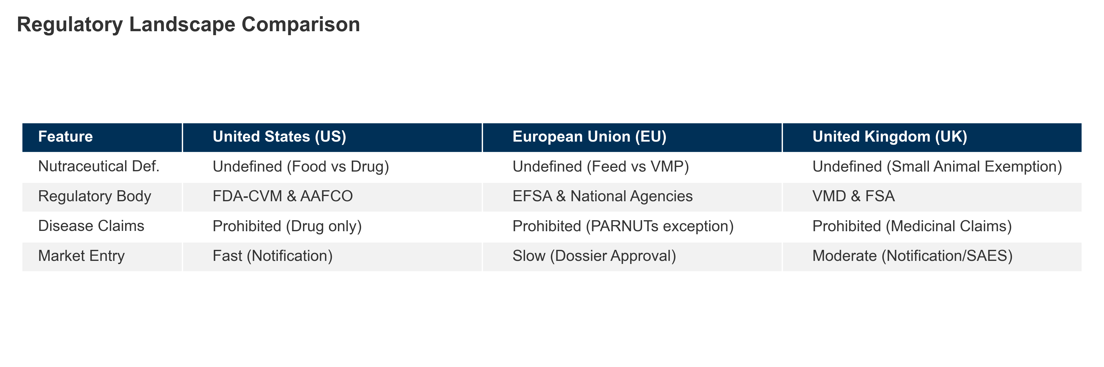

*Figure I.1: Key regulatory differences between US and EU animal nutraceutical frameworks.*

#### **I.2.1. United States (US)**

##### I.2.1.1. Nutraceuticals

No formal regulatory category for “veterinary nutraceuticals”: Unlike the human sector, where the Dietary Supplement Health and Education Act (DSHEA) of 1994 created a distinct legal class for supplements, the FDA Center for Veterinary Medicine (CVM) has explicitly determined that DSHEA does not apply to animal products. Consequently, there is no legal definition for “veterinary nutraceuticals.” Products are classified strictly as either “animal food” (feed) or “new animal drugs” based on their intended use. This binary framework forces manufacturers to market supplements as “food” to avoid the prohibitive costs and multi-year timelines associated with the New Animal Drug Application (NADA) process required for pharmaceutical approval.

Companion animal supplements fall under FDA-CVM and AAFCO guidelines: Historically, the FDA-CVM and the Association of American Feed Control Officials (AAFCO) operated under a Memorandum of Understanding (MOU) to harmonize ingredient approvals. However, this partnership dissolved on October 1, 2024, creating a fractured regulatory environment.

Federal Review (FDA): The FDA now independently reviews new ingredients through the Animal Food Ingredient Consultation (AFIC) process (GFI #294). Successful review results in a “Consultation Complete” letter, granting federal enforcement discretion.

State Review (AAFCO): In parallel, AAFCO has launched the Scientific Review of Ingredient Submissions (SRIS) pathway, managed by Kansas State University, to vet ingredients for inclusion in the AAFCO Official Publication, which is legally adopted by most states.

Note: The “PURR Act of 2025” (H.R. 597) has been introduced in Congress to potentially centralize this authority solely under the FDA, though it faces opposition from state regulators.

##### I.2.1.2. Feed additives

Products marketed as feed additives must use approved ingredients; therapeutic claims trigger drug classification: To remain compliant as “food,” products must strictly adhere to ingredient and labeling standards:

Ingredients: Manufacturers must use ingredients that are Generally Recognized As Safe (GRAS), approved food additives, or listed in the 2024 AAFCO Official Publication (protected under FDA GFI #293 enforcement discretion). AAFCO also maintains a “Common Food Index” for standard items like vegetables to clarify their status without full definition.

Labeling Claims: Marketing is restricted to “structure/function” claims (e.g., “supports joint health”). Any claim to diagnose, cure, mitigate, treat, or prevent disease (“treats arthritis” for example) classifies the product as an unapproved new animal drug, rendering it adulterated under the FD&C Act.

**Exhibit I.A: The Regulatory Claims Ladder (Risk vs. Reward)**

| **Tier** | **Allowed Claims** | **Evidence Barrier** | **Regulatory Status** | **Commercial Implication** |
| --- | --- | --- | --- | --- |
| **1. Therapeutic** | “Cures arthritis”, “Prevents disease” | Pharma-grade (FDA NADA / EMA MA) | **Drug** (Strict) | High Barrier / High Margin |
| **2. Functional** | “Supports joint health”, “Maintains gut flora” | Competent Reliable Scientific Evidence | **Feed/Supplement** (Grey Area) | **The “Sweet Spot”** |
| **3. Nutritional** | “Contains Glucosamine” | Analysis of composition | **Feed Material** (Low) | Commodity / Low Margin |

##### I.2.1.3. Food supplements

NASC (National Animal Supplement Council) labeling is a voluntary standard used in pet supplements: Given the lack of a formal “supplement” category, the National Animal Supplement Council (NASC) fills the regulatory void through rigorous self-regulation.

Quality Seal: To display the NASC Quality Seal, companies must pass third-party facility audits ensuring compliance with current Good Manufacturing Practices (cGMPs) under FSMA (Food Safety Modernization Act).

Adverse Event Reporting: Members are required to participate in the NASC Adverse Event Reporting System (NAERS), sharing post-market safety data with the FDA-CVM to demonstrate product safety and transparency. This voluntary compliance is widely viewed by the industry as a “shield” against enforcement action for products operating in the regulatory grey area.

#### **I.2.2. European Union (EU)**

##### I.2.2.1. A Strict Binary System: The Absence of a “Nutraceutical” Status

The European Union operates under a rigid legal framework that does not recognize the term “nutraceutical.” A product is classified strictly as either a Feed (subject to feed law) or a Veterinary Medicinal Product (subject to drug law). There is no “middle ground” legal category like dietary supplements for humans.

##### I.2.2.2. Feed Materials vs. Feed Additives: A crucial didactic distinction exists within the “Feed” category.

Feed Materials: Natural ingredients used for nutrition (e.g., glucosamine, chondroitin sulphate, yeast) are regulated under Regulation (EC) No 767/2009. They generally do not require pre-market authorization, provided they are safe and listed in the EU Catalogue of Feed Materials (Regulation (EU) No 68/2013).

Feed Additives: Substances added for a specific technological, sensory, or nutritional function (e.g., pure vitamins, preservatives, trace elements) are governed by Regulation (EC) No 1831/2003. These require a rigorous, expensive pre-market authorization and must be explicitly listed in the Community Register of Feed Additives.

##### I.2.2.3. Zootechnical Additives

The “Performance” Category Unlike the US, the EU has established a specific, highly regulated category for ingredients that affect animal physiology: Zootechnical Additives (Category 4 under Reg. 1831/2003). This includes gut flora stabilizers (probiotics) and digestibility enhancers (enzymes).

Efficacy Requirement: To obtain this classification, manufacturers must submit a dossier to the European Food Safety Authority (EFSA) proving not only safety but also efficacy. They must demonstrate valid scientific evidence that the additive significantly improves the animal’s performance or welfare. This provides a legal route for performance claims that would otherwise be considered “medicinal.”

##### I.2.2.4. Claims Landscape: The Prohibition of Medicinal Claims and the “PARNUTs” Exception

The marketing of supplements is defined by a strict “Negative Scope”: feed cannot claim to treat, prevent, or cure disease. Making such a claim reclassifies the product as a Veterinary Medicinal Product (VMP) by presentation, triggering the heavy compliance burden of Regulation (EU) 2019/6.

Functional Claims: Products may make “functional” claims (e.g., “Supports joint health”) if they are substantiated by science, as outlined in the FEDIAF Code of Good Labelling Practice.

The PARNUTs Exception: The only legal exception allowing diet-disease linkage is for Feeds for Particular Nutritional Purposes (PARNUTs), regulated under Regulation (EU) 2020/354. This regulation provides a “positive list” of permitted dietetic claims for specific conditions (“Support of renal function in cases of chronic renal insufficiency” for example). If a condition is not on this list, no disease-related claim can be made.

##### I.2.2.5. Focus on Safety and Environmental Risk Assessment (ERA)

Under the “Farm to Fork” strategy, the authorization of additives requires a comprehensive Environmental Risk Assessment (ERA).

The Phase I/II System: EFSA employs a tiered approach. If the Predicted Environmental Concentration (PEC) of an additive in soil or water exceeds specific trigger values (e.g., 10 µg/kg in soil), the applicant must conduct Phase II ecotoxicity studies on non-target organisms (e.g., earthworms, algae, fish). This is particularly critical for additives used in aquaculture or intensive livestock farming, where environmental accumulation is a key regulatory concern.

Quality Standards: To ensure traceability and safety across the supply chain, operators often adhere to third-party certification schemes like FAMI-QS (for additives) or GMP+, which enforce standards often exceeding statutory requirements.

#### **I.2.3. United Kingdom (UK)**

##### I.2.3.1. Post-Brexit Regulatory Autonomy

Following its withdrawal from the European Union, the UK has repatriated full regulatory sovereignty, transitioning from EU-dependent structures to independent national oversight. While the legal foundation remains “Assimilated Law” (formerly Retained EU Law) derived from EU regulations, the UK has begun to actively diverge to suit domestic needs. This new framework is primarily governed by the Veterinary Medicines Regulations (VMR) 2013, which were comprehensively modernized by the Veterinary Medicines (Amendment etc.) Regulations 2024.

The Dual Authority Structure: Responsibility is strictly divided. The Veterinary Medicines Directorate (VMD) oversees veterinary medicines and the “borderline” with supplements, while the Food Standards Agency (FSA) and Food Standards Scotland (FSS) regulate feed additives and feed safety.

The Windsor Framework Challenge: A unique complexity exists regarding Northern Ireland (NI). Under the Windsor Framework, NI remains subject to EU veterinary medicine laws (Regulation (EU) 2019/6) to prevent a hard border on the island of Ireland. This creates a “dual regime” where manufacturers must navigate UK rules for Great Britain (England, Scotland, Wales) and EU rules for Northern Ireland, complicating supply chains for companies operating UK-wide.

##### I.2.3.2. The VMD and the Strict “Medicine vs. Feed” Boundary

Similar to the EU and US, the VMD does not recognize the term “nutraceutical” as a legal category. A product is classified strictly based on its presentation and function, as detailed in the VMD’s Guidance Note 14.

Medicinal Claims: Any product presented as treating, preventing, or curing a disease, or which modifies physiological function through pharmacological action, is classified as a Veterinary Medicinal Product (VMP). Marketing such a product without a Marketing Authorization (MA) is a criminal offense.

The Small Animal Exemption Scheme (SAES): A distinct and commercially vital feature of the UK landscape is the SAES (Schedule 6 of the VMR). This scheme allows for the marketing of certain medicines for “minor” pet species (such as aquarium fish, cage birds, and small rodents—but notably not dogs or cats) without the prohibitive cost of a full Marketing Authorization, provided they meet strict safety and labeling criteria.

##### I.2.3.3. Feed Additives and Supplements: FSA Conformity and the 2025 Reforms

Functional ingredients that are not medicines fall under the jurisdiction of the FSA/FSS. Post-Brexit, the UK replaced the EFSA authorization route with its own Regulated Products Application Service.

Accelerated Approvals (April 2025 Reform): the UK government implemented significant reforms in April 2025. Most notably, the FSA abolished the requirement for 10-year renewals of feed additive authorizations. The UK regulator deemed this EU-inherited process to be administratively burdensome with little safety benefit. By removing this hurdle, the FSA aims to free up regulatory capacity to assess new innovative ingredients faster, potentially making the UK a more agile market for novel feed technologies than the EU.

##### I.2.3.4. Future Outlook: An Independent Path for Innovation

The UK is positioning itself as a testbed for regulatory innovation. The 2024 VMR amendments introduced some of the world’s strictest controls on antimicrobial resistance (AMR), including mandatory data reporting on antibiotic usage. Simultaneously, the streamlined authorization process for feed additives allows approvals to be granted by Ministerial decision and published directly in a register, bypassing the lengthy legislative voting process required in Brussels. Manufacturers targeting the UK must now build a strategy that leverages these streamlined pathways for Great Britain while managing the separate compliance requirements for Northern Ireland.

##### I.2.4. The Push for Alternatives: AGP Bans and Zinc Oxide Restrictions

Two critical regulatory milestones have fundamentally reshaped the global feed additive landscape, acting as primary catalysts for the nutraceutical boom:

**1. The End of Antibiotic Growth Promoters (AGPs):** Historically, antibiotics were used at sub-therapeutic levels to mask poor hygiene and promote rapid growth. The EU banned this practice in 2006 (Regulation 1831/2003), followed by the US in 2017 (FDA VFD) and China in 2020. This “post-antibiotic” era created an immediate vacuum for products that could support gut health and performance without contributing to antimicrobial resistance (AMR), directly fueling the rise of probiotics (Direct-Fed Microbials), organic acids, and phytogenics.

**2. The Ban on Medicinal Zinc Oxide (ZnO):** For decades, high levels of Zinc Oxide (2500 ppm) were the standard treatment for post-weaning diarrhea in piglets. However, environmental concerns regarding heavy metal accumulation in soil led the EU to ban medicinal ZnO in June 2022. This “Zero Zinc” mandate has forced swine producers to adopt sophisticated nutraceutical strategies—combining acidifiers, highly digestible proteins, and fiber modulators—to manage piglet gut health during the critical weaning transition.

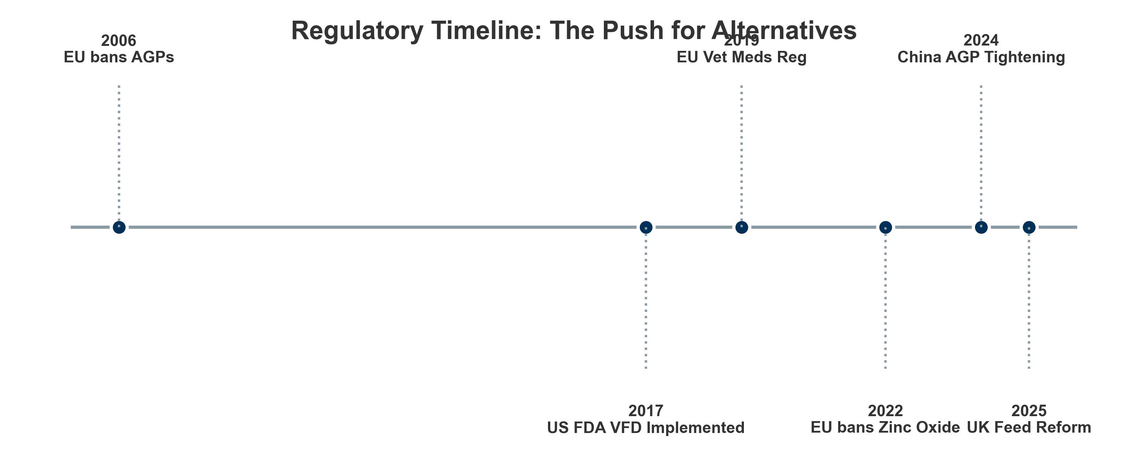

*Figure I.2: Timeline of major regulatory developments in animal nutraceuticals (2020-2026).*

### **I.3. Scope of Analysis**

This report examines the veterinary nutraceutical landscape through the dual lens of physiological function and regulatory status. As definitions remain blurred between supplements, functional feeds, and drugs, establishing clear analytical boundaries is essential to avoid semantic and commercial ambiguity.

**Market Definition: What Counts as an “Animal Nutraceutical”?**

To ensure analytical precision and comparability with the benchmark (“Data Centres” quality), this report uses a **Harmonized Definition** of the Animal Nutraceutical market.

**1. Headline Market Definition (~$13B in 2024):** * **“Animal Nutraceuticals”** = **Pet Supplements** (~$6B) + **Livestock Functional Feed Additives** (~$7B). * *Why combined?* Both categories rely on the same upstream ingredient supply chain (probiotics, vitamins, amino acids) and increasingly overlapping regulatory science, despite divergent downstream business models.

**2. Included Segments (The “Green” List):** * **Pet Supplements:** Functional treats, soft chews, powders, and liquids helping joints, gut, anxiety, and skin. * **Functional Feed Additives (Livestock):** Probiotics, prebiotics, enzymes, organic acids, and phytogenics utilized for performance (FCR), gut health, and emission reduction. * **“Borderline” Products:** Products sold under feed laws but marketed with functional claims (e.g., “Supports Joint Health”).

**3. Excluded Segments (The “Red” List):** * **Veterinary Medicinal Products (VMPs):** Prescription-only drugs (NSAIDs, antibiotics, vaccines) regulated as medicines. * **Bulk Commodities:** Caloric feed inputs (corn, soybean meal) without specific functional enrichment. * **Human Supplements:** Products not formulated/approved for animal use (e.g., human vitamin D).

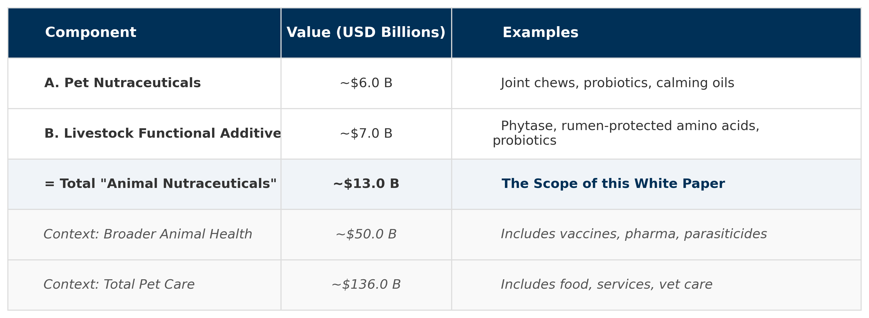

*Figure I.3: TAM Reconciliation and Market Scope (2024 Estimates).*

#### **I.3.1. What Is Included**

The analysis focuses on functional bioactive compounds that go beyond basic nutritional support, aiming to modulate physiological processes related to joint health, gut function, immune resilience, cognition, and behavioural balance. These products are typically integrated into delivery systems tailored to species-specific compliance and bioavailability constraints.

##### I.3.1.1. Delivery Systems Across Species

Companion animals (palatability-driven): In dogs and cats, product success often hinges on owner compliance. According to 2023 consumer research, only ~15% of pet owners prefer tablets, while soft chews account for nearly 59% of preferred supplement formats due to their treat-like appeal. Other viable formats include powders (for dosage flexibility), liquids, and functional gels.

Horses (routine-driven, precision and practicality): In equine, nutraceutical delivery sits between the pet and production models. Daily feeding routines make top-dressed powders, pellets, and balancers the dominant formats, because they allow repeatable dosing without pill administration. For situations where timing matters (competition, transport, acute stress windows), oral pastes/syringes and concentrated liquids are frequently preferred to ensure rapid administration and reduce “feed refusal” risk. In practice, equine products also need tighter attention to batch consistency, traceability, and label discipline, because professional users (trainers, yards, sport-horse owners) expect predictable outcomes and conservative ingredient profiles.

Livestock and aquaculture (efficiency-driven): In production animals, delivery formats are engineered for integration into industrial feed or water systems. These include:

Premixes, typically incorporated at 0.5–4% inclusion rates, enabling uniform distribution of concentrated actives.

Microencapsulation, used especially in ruminants, protects sensitive compounds (e.g., amino acids, enzymes) from ruminal degradation, ensuring targeted intestinal release.

Water-soluble powders, deployed during stress phases (e.g., heat stress or weaning), when feed intake drops but water consumption persists.

Boluses, high-density tablets retained in the reticulorumen, allowing slow release over weeks or months — commonly used for minerals and long-acting actives in cattle (León-Cruz & Ramírez-Bribiesca, 2020).

##### I.3.1.2. Functional Targets Over General Nutrition

This report prioritizes ingredients with a defined therapeutic or physiological objective, such as modulating inflammation, microbiota composition, neurotransmission, or oxidative stress. These products differ from basic feed additives or multivitamins by their mechanistic specificity, evidence-backed functionality, and regulatory sensitivity.

While precise ingredient analysis is provided in later sections, categories include bioactives targeting:

Joint and mobility support

Gut health and feed conversion

Anxiety and cognitive aging

Immune system priming in production settings

#### **I.3.2. What Is Excluded**

To maintain analytical precision, the following categories are out of scope — though they may influence adjacent market dynamics:

Prescription veterinary pharmaceuticals, such as NSAIDs or antimicrobials, which are regulated separately as New Animal Drugs (FDA) or VMPs (EU/UK)

Agricultural commodities (corn, soybean meal, etc.) used for bulk caloric or protein input, unless functionally enhanced

General multivitamin blends without a clearly defined health indication (e.g. “insurance” formulations for micronutrient adequacy)

Human dietary supplements, which are not legally recognized under veterinary frameworks like DSHEA (1994) and often contain ingredients toxic to animals — e.g. xylitol or excessive vitamin D (FDA, 2021; AVMA, 2019)

## **II. Functional Segmentation, Use Cases, Drug-Sparing Logic, and Clinical Validation**

***In this section:*** *We analyze the market through two lenses: its “Biological Core” (Performance, Mobility, Gut Health) and “Strategic Enablers” (Delivery Systems, Bio-Defense). This structure highlights the industry’s shift from simple nutrient supply to precise, outcome-driven health solutions.*

**Taxonomy Key:** * **Pet/Companion:** Focus on longevity, humanization, and palatability. * **Livestock/Production:** Focus on efficiency, FCR, and sustainability. * **Multi-Species:** Ingredients crossing both domains.

The animal nutrition industry has moved beyond basic feeding to focus on precise biological outcomes. The market is now organized around specific physiological goals, creating distinct categories based on value. Part II outlines this framework in two parts. First, we examine the **Biological Core (II.1–II.7)**. This section covers the essential drivers of the industry, where the traditional focus on **Performance & Efficiency** ($7.1 billion) is now supported by advanced health management. This includes the **Gut Health** sector ($5.6 billion), which is crucial for reducing antibiotic use, and the **Mobility** ($2.9 billion) and **Behavioral** ($1.4 billion) markets, which are growing due to the closer bond between owners and their pets.

Next, we explore the **Strategic Enablers (II.8–II.11)** that support these core functions. This includes the **Bio-Defense** infrastructure ($3.5 billion), **Natural Parasite** controls ($1.0 billion), and **Delivery Technologies** ($7.7 billion) that ensure ingredients work effectively. Finally, we look at the emerging **Sustainability** sector ($3.35 billion). Together, these elements show how the industry has matured from a volume-based commodity model into a sophisticated, science-led sector.

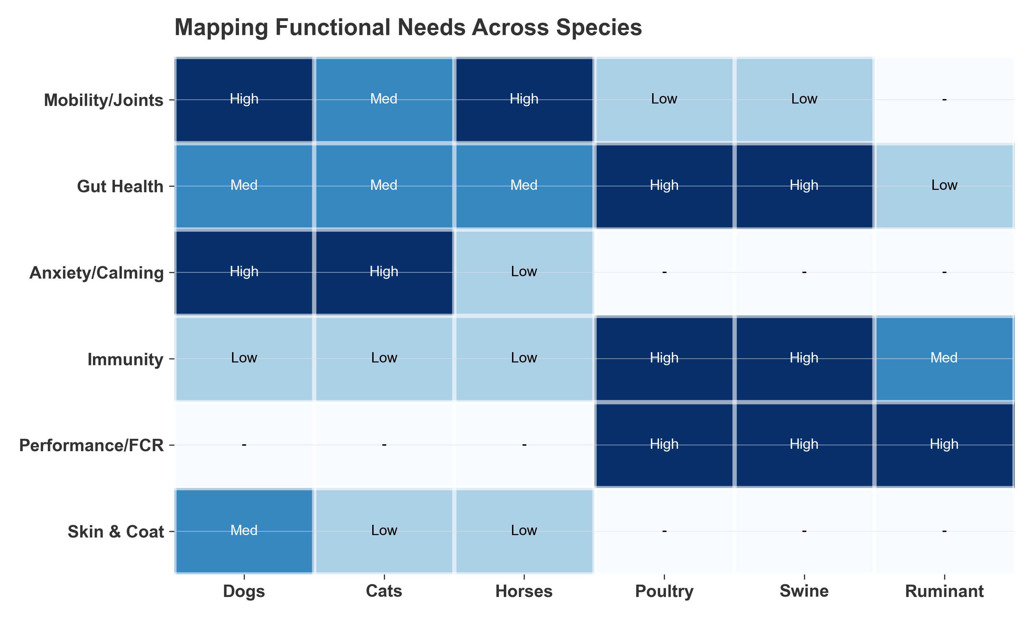

*Figure II.1: Mapping functional needs across companion and production animal species.*

### **II.1. Mobility and Joint Health (Species: Pet)**

Joint health remains the dominant category in the companion animal sector, accounting for approximately 30–34% of the total pet supplement market. The global pet joint health supplements market size reached USD 1.42 billion in 2024, demonstrating robust expansion driven by increasing pet ownership and heightened awareness of animal health. The market is projected to grow at a CAGR of 7.1% from 2025 to 2033, with the total market value expected to reach USD 2.64 billion by 2033. If including the high-value equine sector (~$750M), the broader mobility category exceeds **$2.1 billion** globally.

While glucosamine remains the volume leader due to long-standing consumer awareness and its ubiquitous presence in pet food formulations, revenue growth is primarily driven by high-value, low-volume actives designed to spare NSAID usage. Ingredients such as Undenatured Type II Collagen (UC-II), Omega-3 fatty acids (specifically EPA and DHA), and Green Lipped Mussel (GLM) are capturing market share by offering superior mechanisms of action—such as oral tolerance and direct COX/LOX pathway inhibition—combined with better compliance profiles.

The Glucosamine Paradox (Volume Leader / Low Evidence): The market is currently defined by a “Glucosamine Paradox”—while this ingredient commands a dominant 52% share of the canine joint sector, its position is driven more by consumer habit than strong clinical data. Systematic reviews consistently classify its analgesic efficacy as Level B/C (weak or mixed). Consequently, Glucosamine functions primarily as a low-cost “standard base” for multi-ingredient formulations, with revenue growth flattening as the market shifts toward more potent, evidence-based actives.

**Equine Mobility: A High-Value Niche (Sports Medicine Focus):** Horses represent a distinct, high-consumption category for joint nutraceuticals. Unlike pets, where supplements are often geriatric interventions, equine usage is driven by “Sports Medicine” logic—proactive maintenance for athletic performance. Competitive horses (dressage, jumping, racing) consume joint supplements at rates far exceeding companion animals efficiently to prolong career longevity. This segment is characterized by high daily dosages (e.g., 10g+ of Glucosamine/MSM blends) and a critical demand for “competition-safe” ingredients (free from FEI-banned substances). Consequently, while the equine market is smaller in headcount, the *revenue per animal* is significantly higher: existing estimates place the global equine supplement market at **USD 700–800 million**, with joint health accounting for **~45%** of category revenue. The average annual spend per performance horse ranges from **USD 500–800**, dwarfing the **USD 100–150** average for large breed dogs.

Undenatured Type II Collagen (UC-II) (High Growth / High Efficiency): UC-II represents a major advancement in formulation, moving from the “grams” required for traditional building blocks to the “milligrams” used for immunomodulation. Validated by Level A/B evidence, its mechanism of “oral tolerance” allows for highly compliant low-dose formats (e.g., 40mg/day). With a projected CAGR exceeding 8%, UC-II is rapidly capturing market share as a premium, scientifically superior alternative to legacy ingredients.

Omega-3 Fatty Acids (Revenue Leader / Industry Benchmark): Generating over $1.2 billion globally, EPA/DHA stands as the industry’s “Benchmark” and is the only nutraceutical with Level A evidence for NSAID-sparing effects. Its market position is strengthened by a dual benefit, where its anti-inflammatory properties bridge two massive functional categories: Mobility (pain reduction) and Dermatology (atopy management).

Green Lipped Mussel: This $170 million segment is expanding at a steady 7.9%, yet it remains characterized by high product variability. Clinical efficacy (Level B) is volatile and relies heavily on cold-processing to preserve bioactive lipids. This reality has created a distinct market tiering: premium stabilized lipid extracts that deliver clinical results versus generic defatted powders that function largely as ineffective commodities.

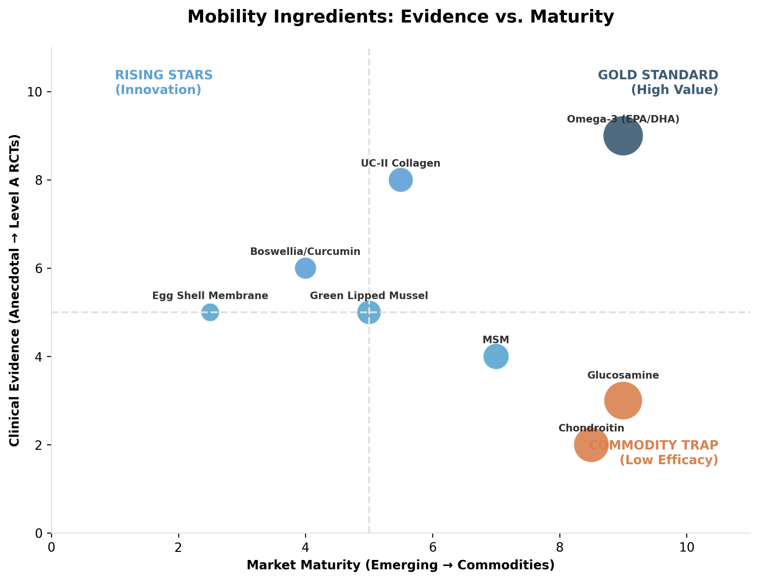

*Figure II.1: Evidence levels and market positioning of key nutraceutical ingredients (Mobility).*

### **Table II.1: Mobility and Joint Health Targets**

| **Nutraceutical family** | **Primary species and use case** | **Drug sparing or adjunct target** | **Results** | **Evidence level and clinical takeaway** | **Key references** | **Est % Use (Within Mobility Segment)** | **Est % Use (General Supplement Market)** | **Est. Global Revenue (Veterinary)** |
| --- | --- | --- | --- | --- | --- | --- | --- | --- |
| Omega 3 (EPA/DHA) | Dogs, cats (OA pain, inflammation); also used in equine performance programs as adjunct anti-inflammatory support | Adjunct to NSAIDs and multimodal OA management | Pain scores, mobility, weight bearing, activity | A: controlled canine OA data supports analgesic and anti inflammatory benefit; typically adjunct rather than replacement in moderate disease | (Roush et al., 2010; Hielm Björkman et al., 2012) | 25 - 30% | 18 - 20% | $1.2 - $1.4 Billion |
| Undenatured type II collagen (UC II) | Dogs, mobility and OA related pain. Occasional equine use. | Adjunct to NSAIDs | Owner reported function, mobility scores, pain measures | B to A: several canine studies support mobility improvement; positioning is “maintenance plus symptom reduction” | (Gupta et al., 2009; Stabile et al., 2024) | 10 - 15% | 3 - 5% | $170 - $250 Million |
| Eggshell membrane (ESM) complexes | Dogs, stiffness and mobility | Adjunct to NSAIDs | Mobility and pain questionnaires, stiffness | B: evidence supports improvements in mobility outcomes in dogs; effect sizes vary by formula | (Ragetly et al., 2025; Stabile et al., 2024) | 2 - 5% |  | $50 - $80 Million |
| Green lipped mussel (Perna canaliculus) | Dogs, joint function support | Adjunct to NSAIDs | Lameness and mobility scoring | B: supportive evidence in dogs, but outcomes depend on dose and product standardization | (Carmona et al., 2009; Vandeweerd et al., 2012) | 8 - 12% | 2 - 4% | $170 - $200 Million |
| Glucosamine and chondroitin | Dogs and horses, legacy joint category | Adjunct to NSAIDs | Mobility and pain scores | B to C: widely used, but systematic reviews and heterogeneity create uncertainty; keep as “legacy category with mixed evidence” | (Vandeweerd et al., 2012); (Kampa et al., 2023) | 45 - 55% | 12 - 15% | $1.1 - $1.3 Billion |
| MSM | Horses and dogs, soreness and mobility | Adjunct to NSAIDs | Comfort, recovery, lameness scoring | C: some supportive equine oriented evidence, but overall veterinary data is thinner than omega 3 or collagen pathways | (Barshick et al., 2025); (Zhang et al., 2022) | 15 - 20% | 4 - 6% | $230 - $250 Million |
| Hyaluronic acid (oral) | Horses and dogs, joint lubrication positioning | Adjunct to OA care | Lameness and performance comfort | C: injectable HA has established use, oral evidence is more variable; keep claims conservative | (Cayzer et al., 2011); (Aguado et al., 2021); (Carmona et al., 2009) | 3 - 5% | < 1% | Niche (<$50M) |
| Boswellia and curcumin | Dogs and horses, inflammation support | Adjunct to OA care | Pain and mobility measures | C: plausible anti inflammatory mechanisms, limited robust veterinary RCT base; acceptable as secondary stack ingredient | (Aguado et al., 2021); (Caterino et al., 2021); (Stabile et al., 2024) | 5 - 8% | 1 - 2% | $100 - $150 Million |

### **II.2. Gut Health and Microbiome Modulation (Species: Multi-Species)**

Driven by the global shift away from antibiotics in livestock, this is the fastest-growing sector in animal nutrition. The goal has shifted from simple digestion to achieving ‘eubiosis’—a stable microbiome that resists pathogen colonization. This category is dominated by ‘biotics’ (pre-, pro-, post-, and synbiotics) and enzymatic tools designed to optimize feed efficiency and replace pharmacological zinc oxide and antibiotics in production systems.

Reflecting this shift, the global gut health probiotic, prebiotic, and postbiotic market size reached USD 62.4 billion in 2024, showing robust expansion driven by increasing consumer awareness and scientific advancements in digestive wellness. The market is set to experience a significant compound annual growth rate (CAGR) of 8.1% from 2025 to 2033. By 2033, the market is forecasted to reach an impressive USD 120.4 billion, propelled by rising demand for functional foods, personalized nutrition, and a growing focus on preventive healthcare.

Within this broad ecosystem, the global animal feed probiotics market alone is valued at $5.6 billion (2024). In companion animals, probiotics now rival joint supplements, holding ~38.4% of the pet supplement market share. The trend is moving rapidly from simple live bacteria to Postbiotics (inanimate microorganisms) due to their stability in extruded feed and consistent immunomodulatory effects.

The Probiotic Super-Category

Probiotics dominate the gut health sector, commanding a 38.4% market share in pets. Their success is driven by a unique consumer feedback loop: owners see immediate improvements in stool quality, which builds strong brand loyalty. Clinical “Benchmarks” like Enterococcus faecium SF68 (Purina) and Bifidobacterium animalis AHC7 are now non-pharmacological staples, proven to shorten acute diarrhea and reduce reliance on metronidazole.

In the $6.9B livestock sector, probiotics function as biological barriers. Through competitive exclusion, they physically occupy receptor sites on the gut epithelium, preventing pathogens like Salmonella or E. coli from attaching. Advanced spore-forming probiotics (e.g., Bacillus subtilis from Novonesis or B. amyloliquefaciens from Evonik) have become essential tools; unlike traditional bacteria, these “dormant” spores survive the high-heat pelleting process and activate only once inside the animal’s gut, ensuring 100% therapeutic delivery.

Prebiotics & Synbiotics: The “Survival Kit” Strategy

While probiotics introduce beneficial species, Prebiotics act as selective “fertilizers.” Advanced prebiotics like Mannan-Oligosaccharides (MOS) and Inulin (Beneo) act as functional decoys; they mimic intestinal receptors to trap harmful bacteria, which are then flushed out harmlessly. Commercially, they are vital as stable, low-cost antibiotic alternatives. The strategic frontier is the Synbiotic—a synergistic pairing of a strain with its specific fuel (e.g., Protexin’s pairing of E. faecium with FOS/Gum Arabic). By providing a “survival kit” for the bacteria, synbiotics bridge the colonization gap, ensuring survival in hostile, acidic environments and allowing brands to command premium “clinical-grade” pricing.

The Economic Imperative of Enzymes

In livestock, enzymes are driven by margins. Phytase is utilized in 90% of global poultry diets to unlock bound phosphorus from grains. This reduces the need for expensive inorganic supplements and lowers environmental phosphorus excretion, making it an inelastic commodity generating $600M+ annually. In companion animals, the $2.1B market focuses on managing pancreatic insufficiency (EPI) and enhancing nutrient density for senior pets.

The Emergence of Postbiotics: Stability Meets Immunology

Postbiotics—defined scientifically as “preparation of inanimate microorganisms and/or their components that confers a health benefit”—have emerged as the rapid-growth solution to the primary flaw of live probiotics: **Survivability**. In the high-stress environment of feed manufacturing, where extrusion temperatures exceed 100°C and pressure destroys fragile vegetative cells, traditional probiotics often suffer significant loss of viability. Postbiotics bypass this entirely. Because they are already non-viable, they are chemically stable, surviving extrusion, pelleting, and long-term warehousing without losing potency.

**Mechanism of Action: The “Immunological Trigger”:** Crucially, the efficacy of a probiotic is not always dependent on metabolic activity but on **Molecular Pattern Recognition**. Postbiotics retain their Microbe-Associated Molecular Patterns (MAMPs), such as peptidoglycans, lipoteichoic acids, and cell surface proteins. These structures bind to Toll-Like Receptors (TLRs) in the gut lining, effectively “signaling” the presence of a commensal bacteria. This primes the immune system—upregulating anti-inflammatory cytokines (IL-10) and reinforcing epithelial tight junctions—without the risk of translocation or sepsis that can occur with live cultures in immunocompromised animals.

**Market Impact:** Representing a **$229M niche in 2024**, this category is rapidly moving from “boutique” to “essential.” For pet food manufacturers, postbiotics solve the “Label Claim Risk.” Unlike live spores which may degrade below guaranteed levels by month 12 of shelf life, postbiotics offer “consistent potency,” ensuring that the 1 billion CFU equivalent claimed on the bag is exactly what the animal consumes, regardless of storage conditions.

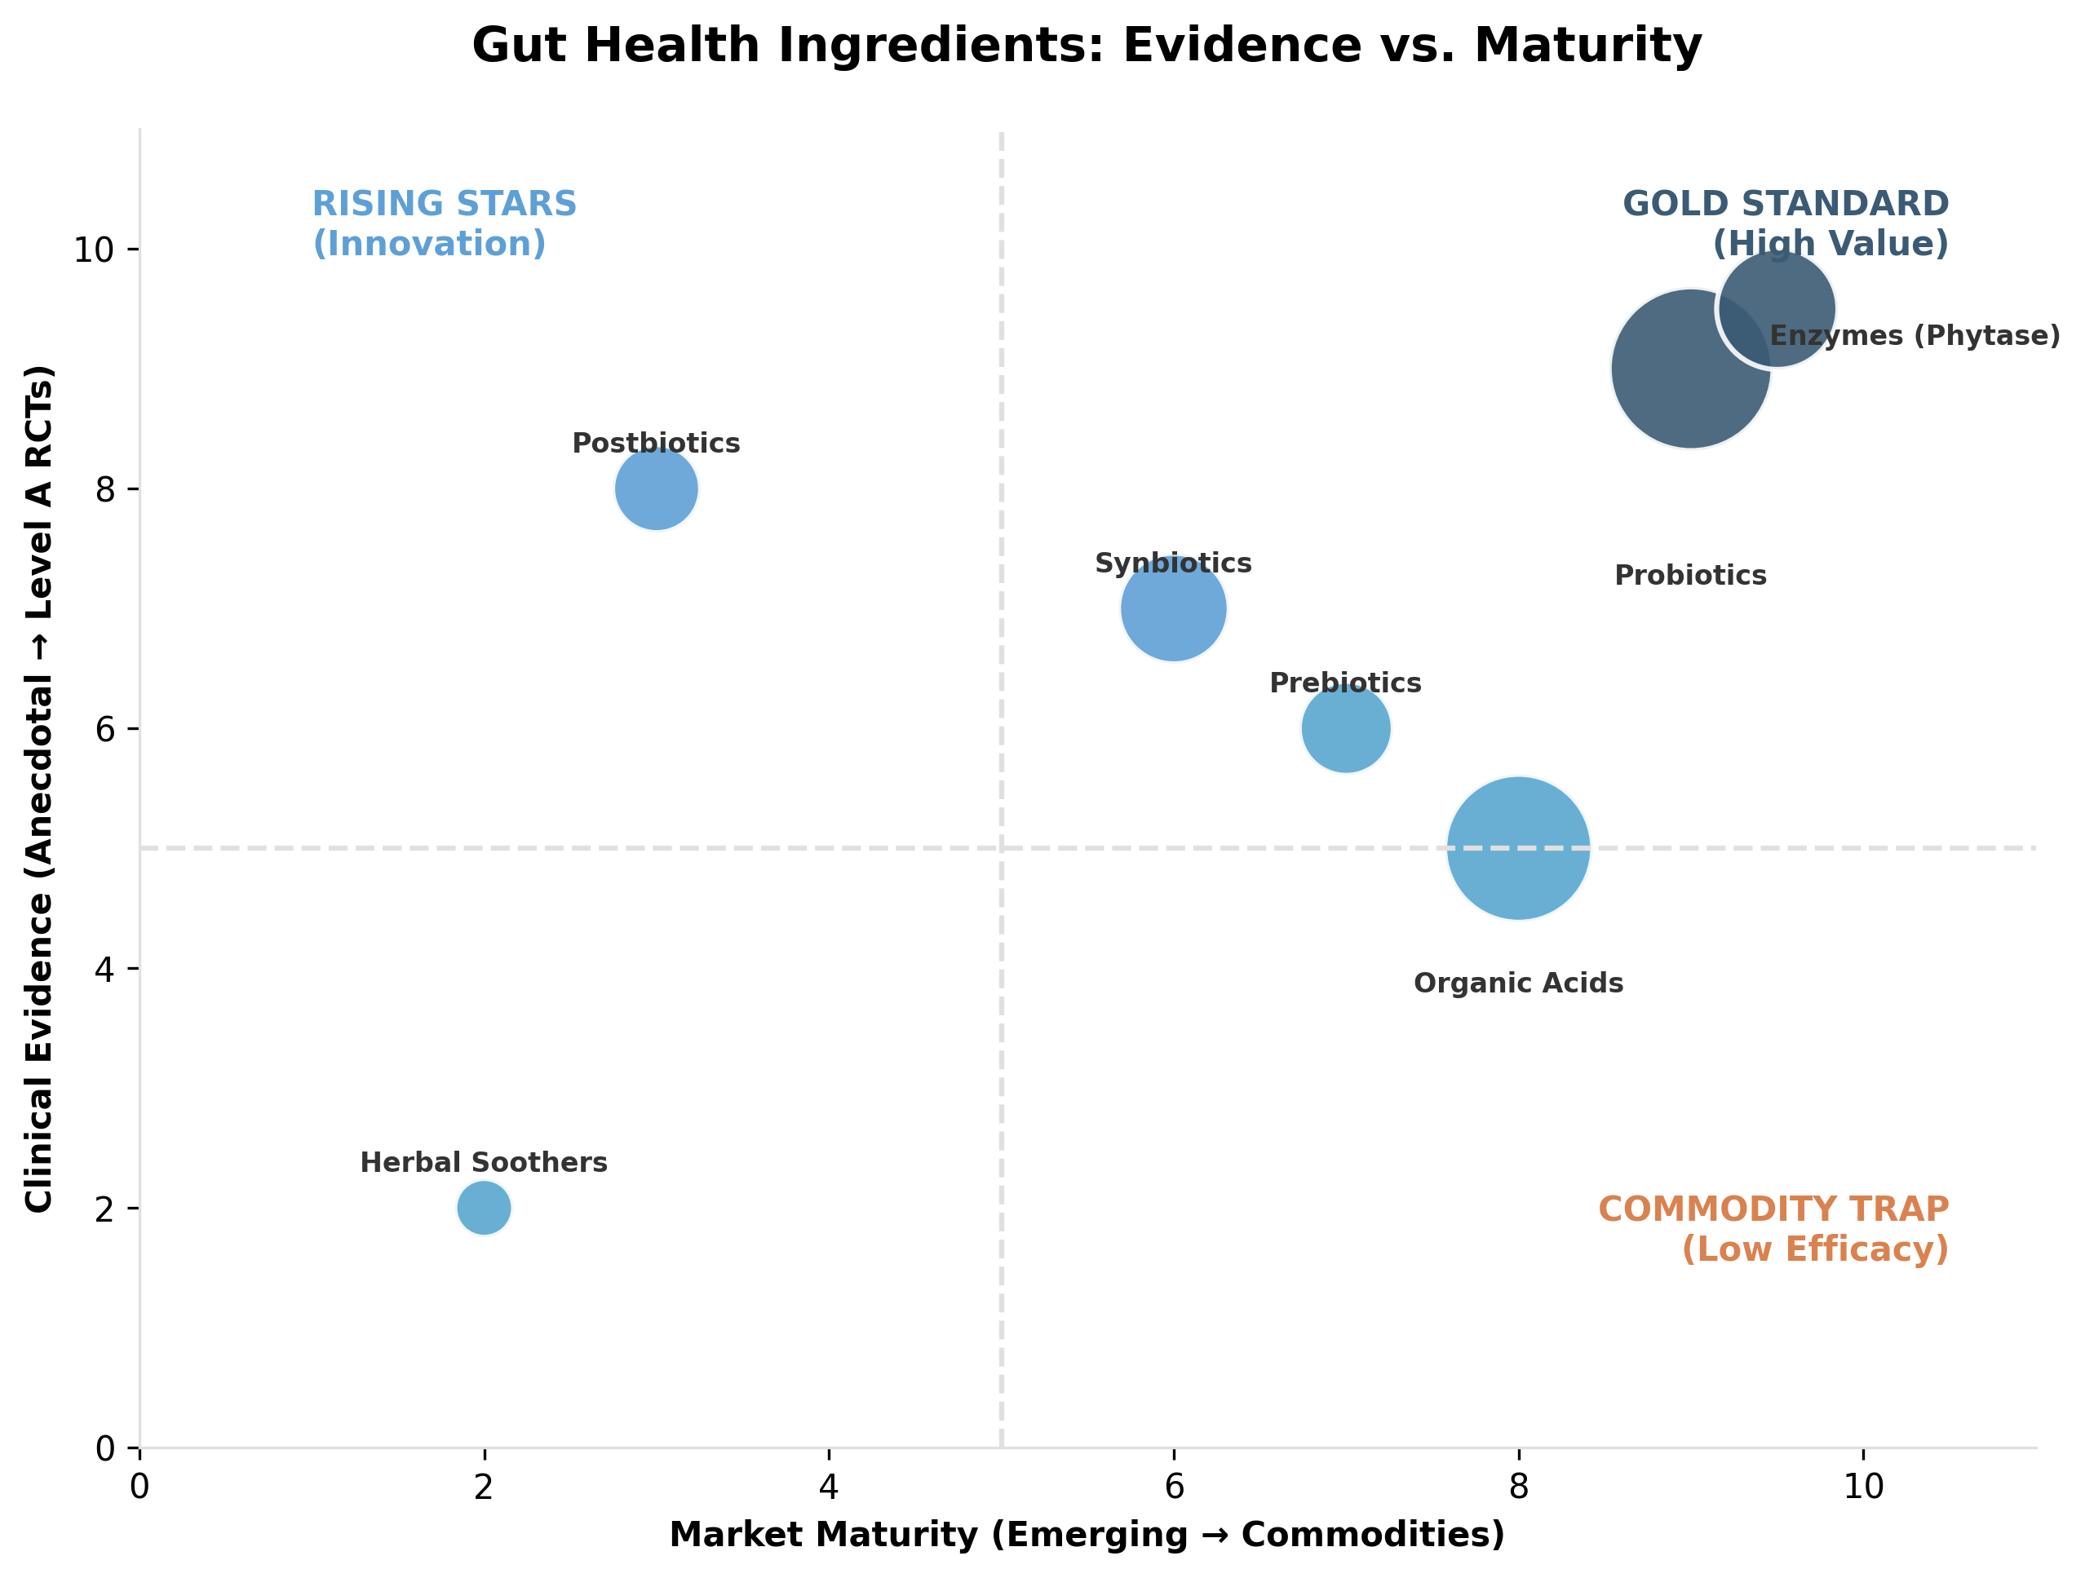

*Figure II.2: Evidence levels and market positioning of key nutraceutical ingredients (Gut Health).*

### **Table II.2: Gut Health and Microbiome Modulation Targets**

| **Nutraceutical family** | **Primary species and use case** | **Drug sparing or adjunct target** | **Results** | **Evidence level and clinical takeaway** | **Key references** | **Est % Use (Within Gut Segment)** | **Est % Use (General Market)** | **Est. Global Revenue (Veterinary)** |
| --- | --- | --- | --- | --- | --- | --- | --- | --- |
| Probiotics (strain specific) | Dogs, acute uncomplicated diarrhea; swine and poultry performance stability | Dog: reduce unnecessary antibiotic use (example metronidazole) in selected cases; livestock: reduce reliance on AGP like functions | Dog: time to normal stool; livestock: ADG, FCR, diarrhea incidence | A: canine RCT supports probiotic credibility in acute diarrhea contexts; swine meta analysis supports performance effects with context dependence | (Shmalberg et al., 2019; Zimmermann et al., 2016) | 40 - 50% | 30 - 38% | $5.6 - $7.5 Billion (Feed + Pet) |
| Prebiotics (MOS, FOS, inulin) | Broilers and swine, pathogen binding and gut architecture | Reduce enteric instability and downstream medication | FCR, lesion scores, morbidity, shedding indicators | B: MOS has production relevant meta analytic support; effects are program and baseline dependent | (Hooge, 2004; Kiarie et al., 2012) | 25 - 35% | 10 - 15% | $500 - $800 Million |
| Synbiotics | Dogs in shelters and high density environments; production systems | Reduce diarrhea incidence and supportive of resilience | Diarrhea incidence, stool quality, performance | B: controlled shelter dog work supports reduced diarrhea incidence; translation depends on setting | (Rose et al., 2017); (Sahoo et al., 2022); (Whittemore et al., 2019) | ~25% | ~8% | $1.25 Billion (Feed + Pet) + Pet) |
| Postbiotics and butyrate donors (tributyrin) | Piglets around weaning stress | Reduce post weaning enteric instability and treatment events | Villus height, gut morphology, growth | B: controlled piglet work supports gut morphology and growth related improvements | (Zeng et al., 2015; Chen et al., 2023) | 10 - 15% | 3 - 5% | $230 - $1,200 Million |
| Organic acids | Swine and poultry, feed hygiene and gut pH modulation | Reduce pathogen pressure and support post AGP programs | FCR, diarrhea incidence, microbial counts | B: broad evidence base, strongly context dependent, typically positioned as “toolbox component” | (Khan & Iqbal, 2016); (Khan et al., 2022) | 60 - 70% (Livestock) | 25 - 30% (Feed) | $10 - $12 Billion |
| Digestive enzymes (phytase, xylanase, protease) | Poultry and swine, digestibility and performance | Reduce digestive inefficiency and downstream disease pressure | FCR, digestibility, litter quality | A: mature evidence base for performance and digestibility; strongest in monogastrics | (Selle and Ravindran, 2007; (Cowieson et al., 2020); ); (Kiarie et al., 2013); (Cowieson et al., 2020) | 80 - 90% (Livestock) | 3 - 5% (Feed Total) | $1.4 - $2.1 Billion |
| Clay binders and toxin adsorbents | Livestock, mycotoxin risk management | Reduce morbidity and productivity loss events | Performance stability, clinical signs, toxin biomarkers when available | B: established category, but binder quality varies greatly by toxin spectrum | (Döll and Dänicke, 2011) (Huwig et al., 2001); (EFSA, 2011) |  |  |  |
| Herbal gut soothers (slippery elm, marshmallow root) | Dogs and cats, mild GI comfort | Adjunct to symptomatic care | Stool comfort, owner reported signs | C: limited veterinary trial base; better treated as low risk supportive ingredients with conservative claims | (Finno, 2020) (Wynn, 2009); (Bonaterra et al., 2020) |  |  | . |

### **II.3. Immunity and Resilience (Species: Multi-Species)**

Driven by the intensification of aquaculture and the global mandate to reduce antibiotic usage in livestock, the Immunity and Resilience sector has emerged as the biological shield of modern animal production. In the companion animal market alone, this sector has reached a valuation of approximately **$2.67 billion** (2025/26), accounting for roughly 25% to 35% of the total pet supplement market. The objective has moved beyond reactive disease treatment to achieving ‘immune competence’—a primed and responsive system capable of resisting pathogen colonization during critical stress windows like weaning and transport.

The broader industrial market is dominated by biological response modifiers—specifically marine polysaccharides, functional proteins, and nucleotides. This segment is currently anchored by Seaweed and Polysaccharides, valued at **$4.46 billion** (2023) globally, which command a massive share of the industrial segment due to their dual role in immune modulation and oxidative stress management. Meanwhile, functional proteins like Spray-Dried Plasma (**$2.20 billion**) have become indispensable in swine production, while precision tools like Nucleotides (**$622 million**) are rapidly gaining traction for their ability to support rapid cell proliferation during growth challenges.

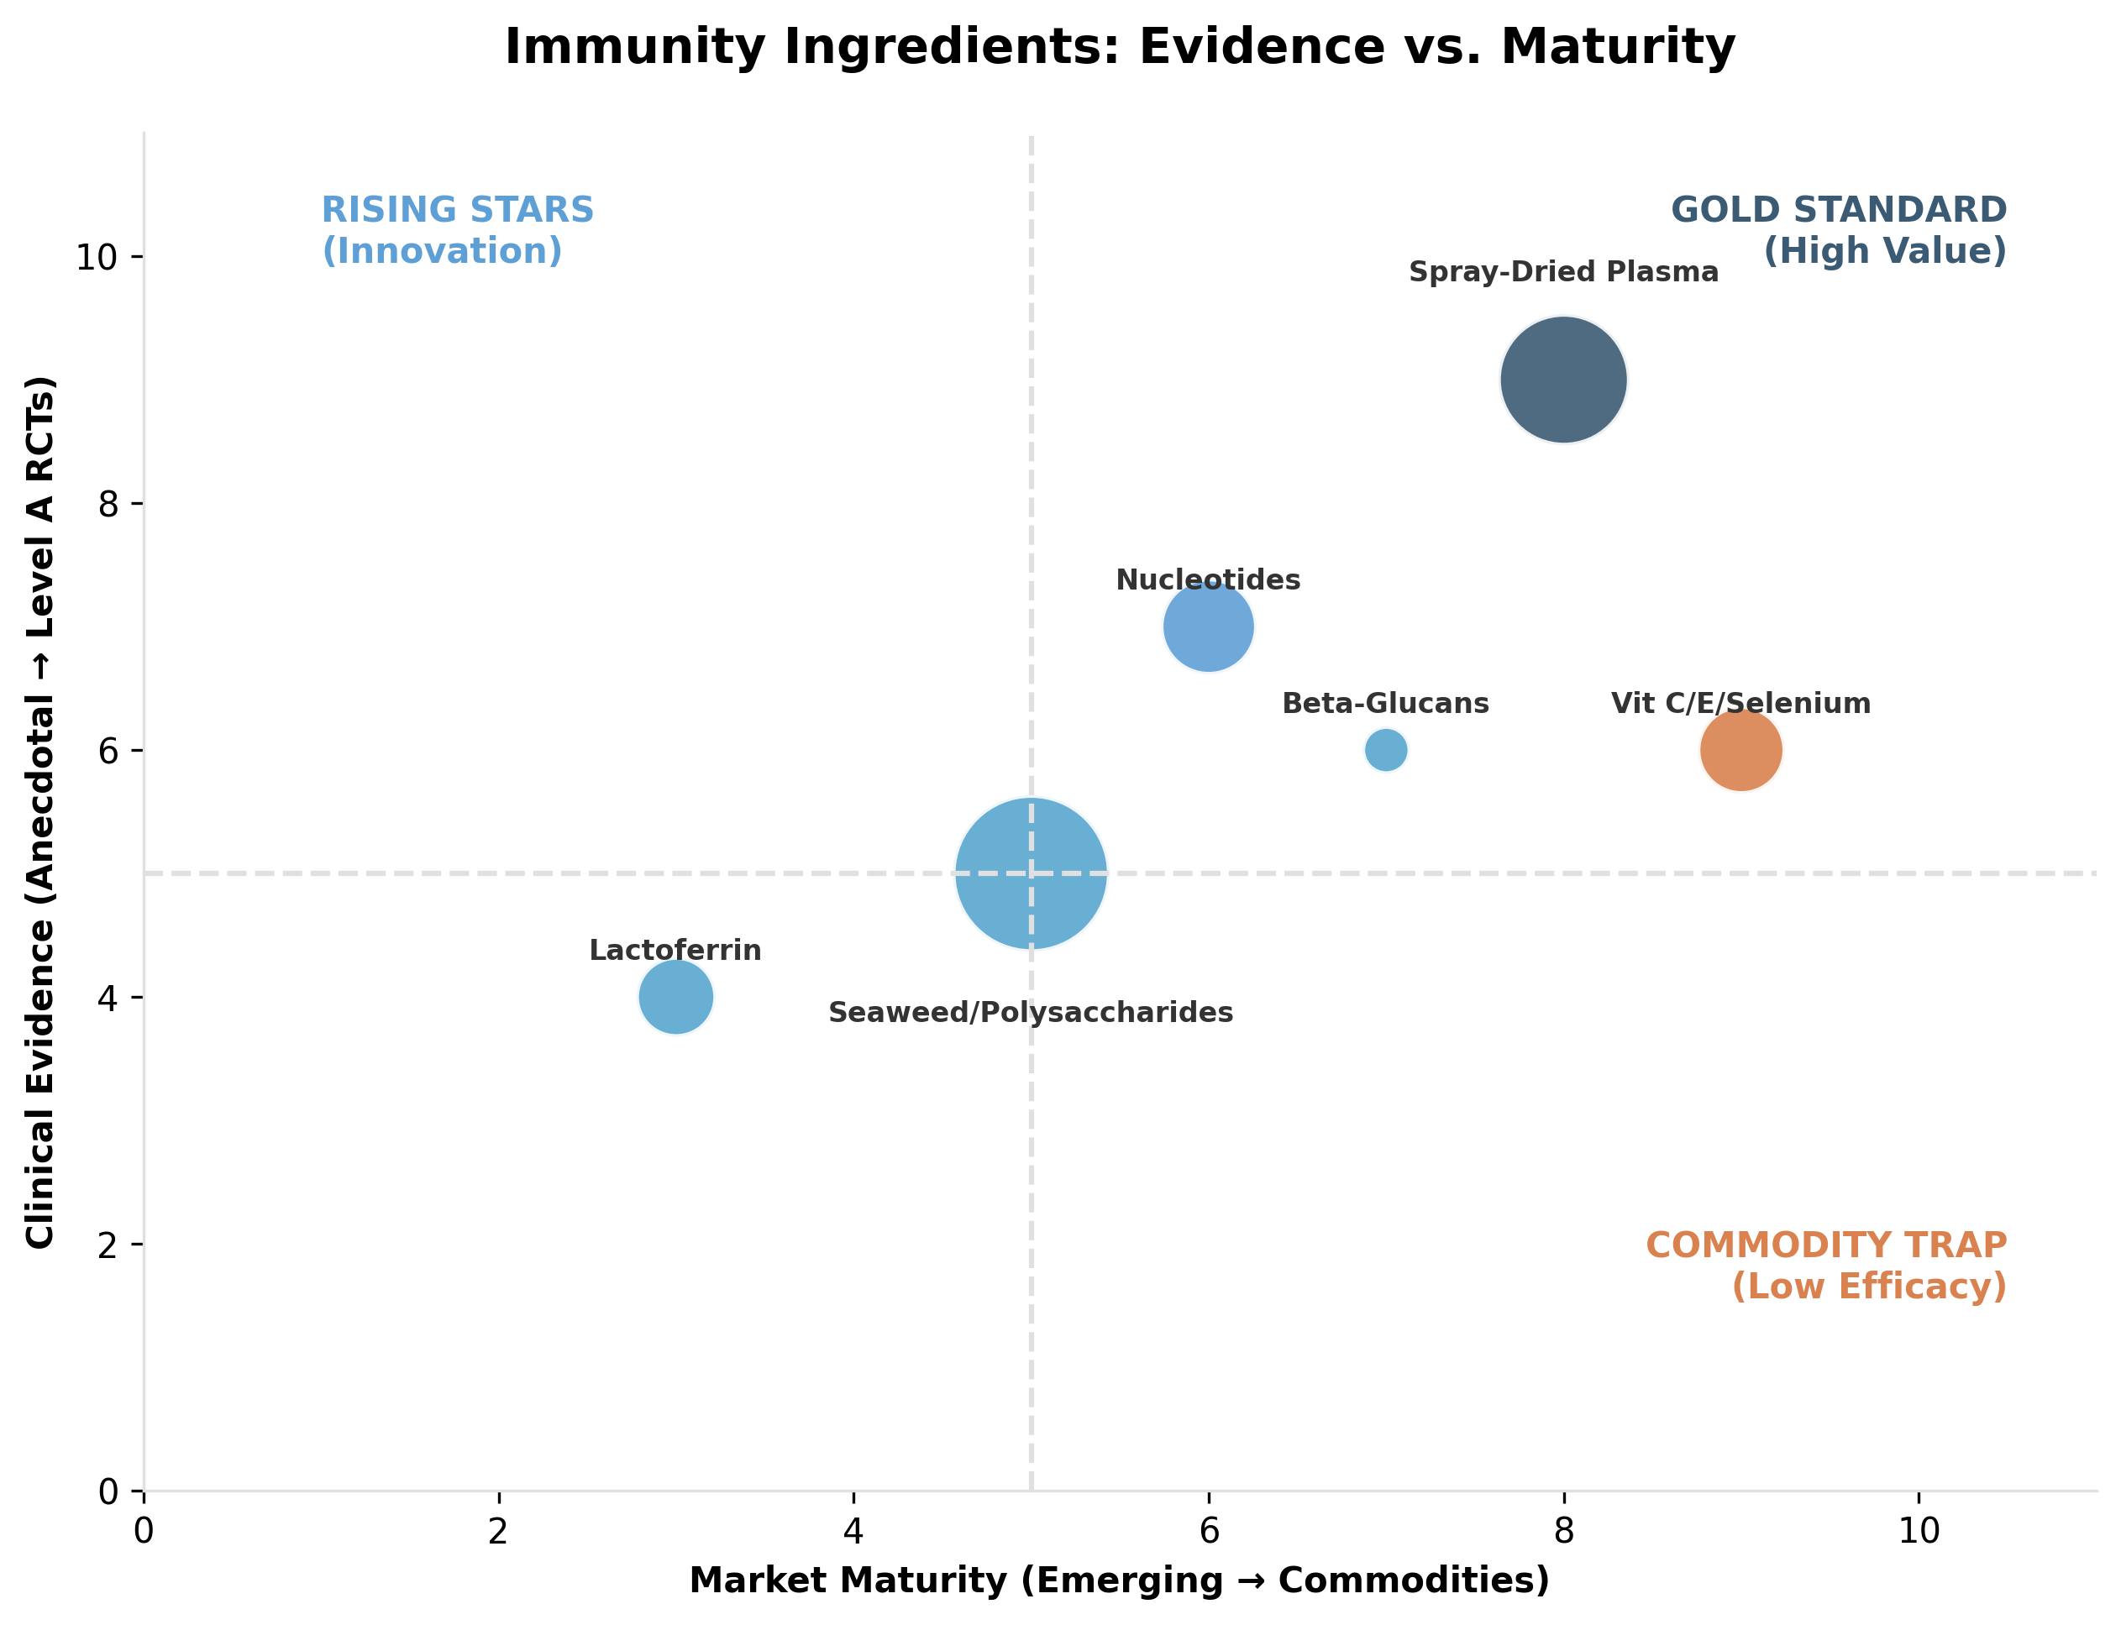

*Figure II.3: Evidence levels and market positioning of key nutraceutical ingredients (Immunity).*

### **Table II.3: Immunity and Resilience Targets**

| **Nutraceutical family** | **Primary species and use case** | **Drug sparing or adjunct target** | **Results** | **Evidence level and clinical takeaway** | **Key references** | **Est % Use (Within Immunity & Resilience Segment)** | **Est % Use (General Market)** | **Est. Global Revenue (Veterinary)** |
| --- | --- | --- | --- | --- | --- | --- | --- | --- |
| Beta 1,3 1,6 glucans (yeast) | Aquaculture, shrimp and fish resilience; poultry stress windows | Reduce infection pressure and mortality, reduce treatment events | Survival, immune markers, challenge outcomes | B: frequently studied immunostimulants in aquaculture; strongest positioning is resilience support | (Meena et al., 2013; Hauton, 2021) | 0.004 | 0.002 | ~USD 38M (2024) |
| Plasma / colostrum & Ig-rich fractions | Piglets around weaning | Reduce diarrhea, improve growth, reduce medication events | ADG, diarrhea incidence, gut integrity | B to A: widely supported in early life pig nutrition literature | (Torrallardona, 2010) | 0.255 | 0.119 | USD 2.20B (2024) |
| Nucleotides (often yeast derived) | Poultry and aquaculture, immune responsiveness | Adjunct to health programs, stress windows | Immune readouts, growth under challenge | B: controlled supplementation studies support immune and growth parameters | (Abdel Moneim et al., 2020) (Jang et al., 2019) | 0.072 | 0.034 | ~USD 622M midpoint (2024) |
| Seaweed and polysaccharides | Ruminants and monogastrics, oxidative stress and immune support | Adjunct to herd health, not a drug replacement | Immune markers, productivity, metabolic indicators | B to C: evidence exists but endpoints and effect sizes are variable | (Sweeney et al., 2022); (Wang et al., 2016) | 0.517 | 0.242 | USD 4.46B (2023) |
| Selenium and vitamin E | Multiple species, antioxidant defense | Reduce deficiency linked risk and oxidative stress burden | Biomarkers, fertility or immune outcomes in deficiency contexts | B: best framed as antioxidant support, especially where baseline status is limiting | (Calik et al., 2022); (Finch & Turner, 1996) | 0.033 | 0.015 | USD 280.7M (2024) |
| Vitamin C | Aquaculture, stress mitigation | Support resilience and survival | Survival, immune markers | B: commonly used, stronger in aquaculture and stress physiology contexts | (Meena et al., 2013) (Tavakolinasab et al., 2025); (Wang et al., 2016) | 0.017 | 0.008 | USD 148.4M (2023) |
| Lactoferrin and functional peptides | Calves and pets, immune and gut support | Adjunct positioning | Immune markers, clinical signs | C: promising but less standardized evidence base in animals | (Ballou et al., 2019) | 0.034 | 0.016 | USD 297.3M (2024) |
| Vaccine synergy positioning | Poultry and aquaculture | Adjunct to vaccination programs | Antibody titers, immune readouts | C to B: supportive concept, effect sizes depend on antigen and baseline nutrition | (Chen et al., 2021) | - | - | - |

### **II.4. Cognitive Support and Aging (Species: Pet)**

Propelled by the ‘humanization’ of companion animals and the unprecedented extension of pet lifespans, the Cognitive Health and Senior Care sector has evolved from palliative geriatric support to proactive neuroprotection. The clinical objective is to delay the onset of Canine Cognitive Dysfunction (CCD) and maintaining social engagement in aging pets. Landmark studies have shown that diets enriched with 6.5% Medium-Chain Triglycerides (MCTs) significantly improve cognitive scores (DISHAA) in senior dogs by providing ketone bodies as an alternative cerebral fuel source (Pan et al., 2010; Pan et al., 2018).

As of 2026, the global market for pet cognitive and anti-aging solutions has reached $1.35 billion, representing approximately 10% to 12% of the total pet supplement market. The market is currently anchored by Medium Chain Triglycerides (MCTs), valued at $450 million, which command a leading 34.9% share of the segment due to their clinically proven role in providing alternative energy sources for the aging brain.

Closely following are DHA ($350 million) and Antioxidant-Enriched Diets ($300 million), which together form the foundational standard of care for neuro-preservation. Meanwhile, specialized compounds like SAMe ($100 million) and Phosphatidylserine remain high-value veterinary tools, primarily deployed for targeted intervention in advanced cases of cognitive decline.

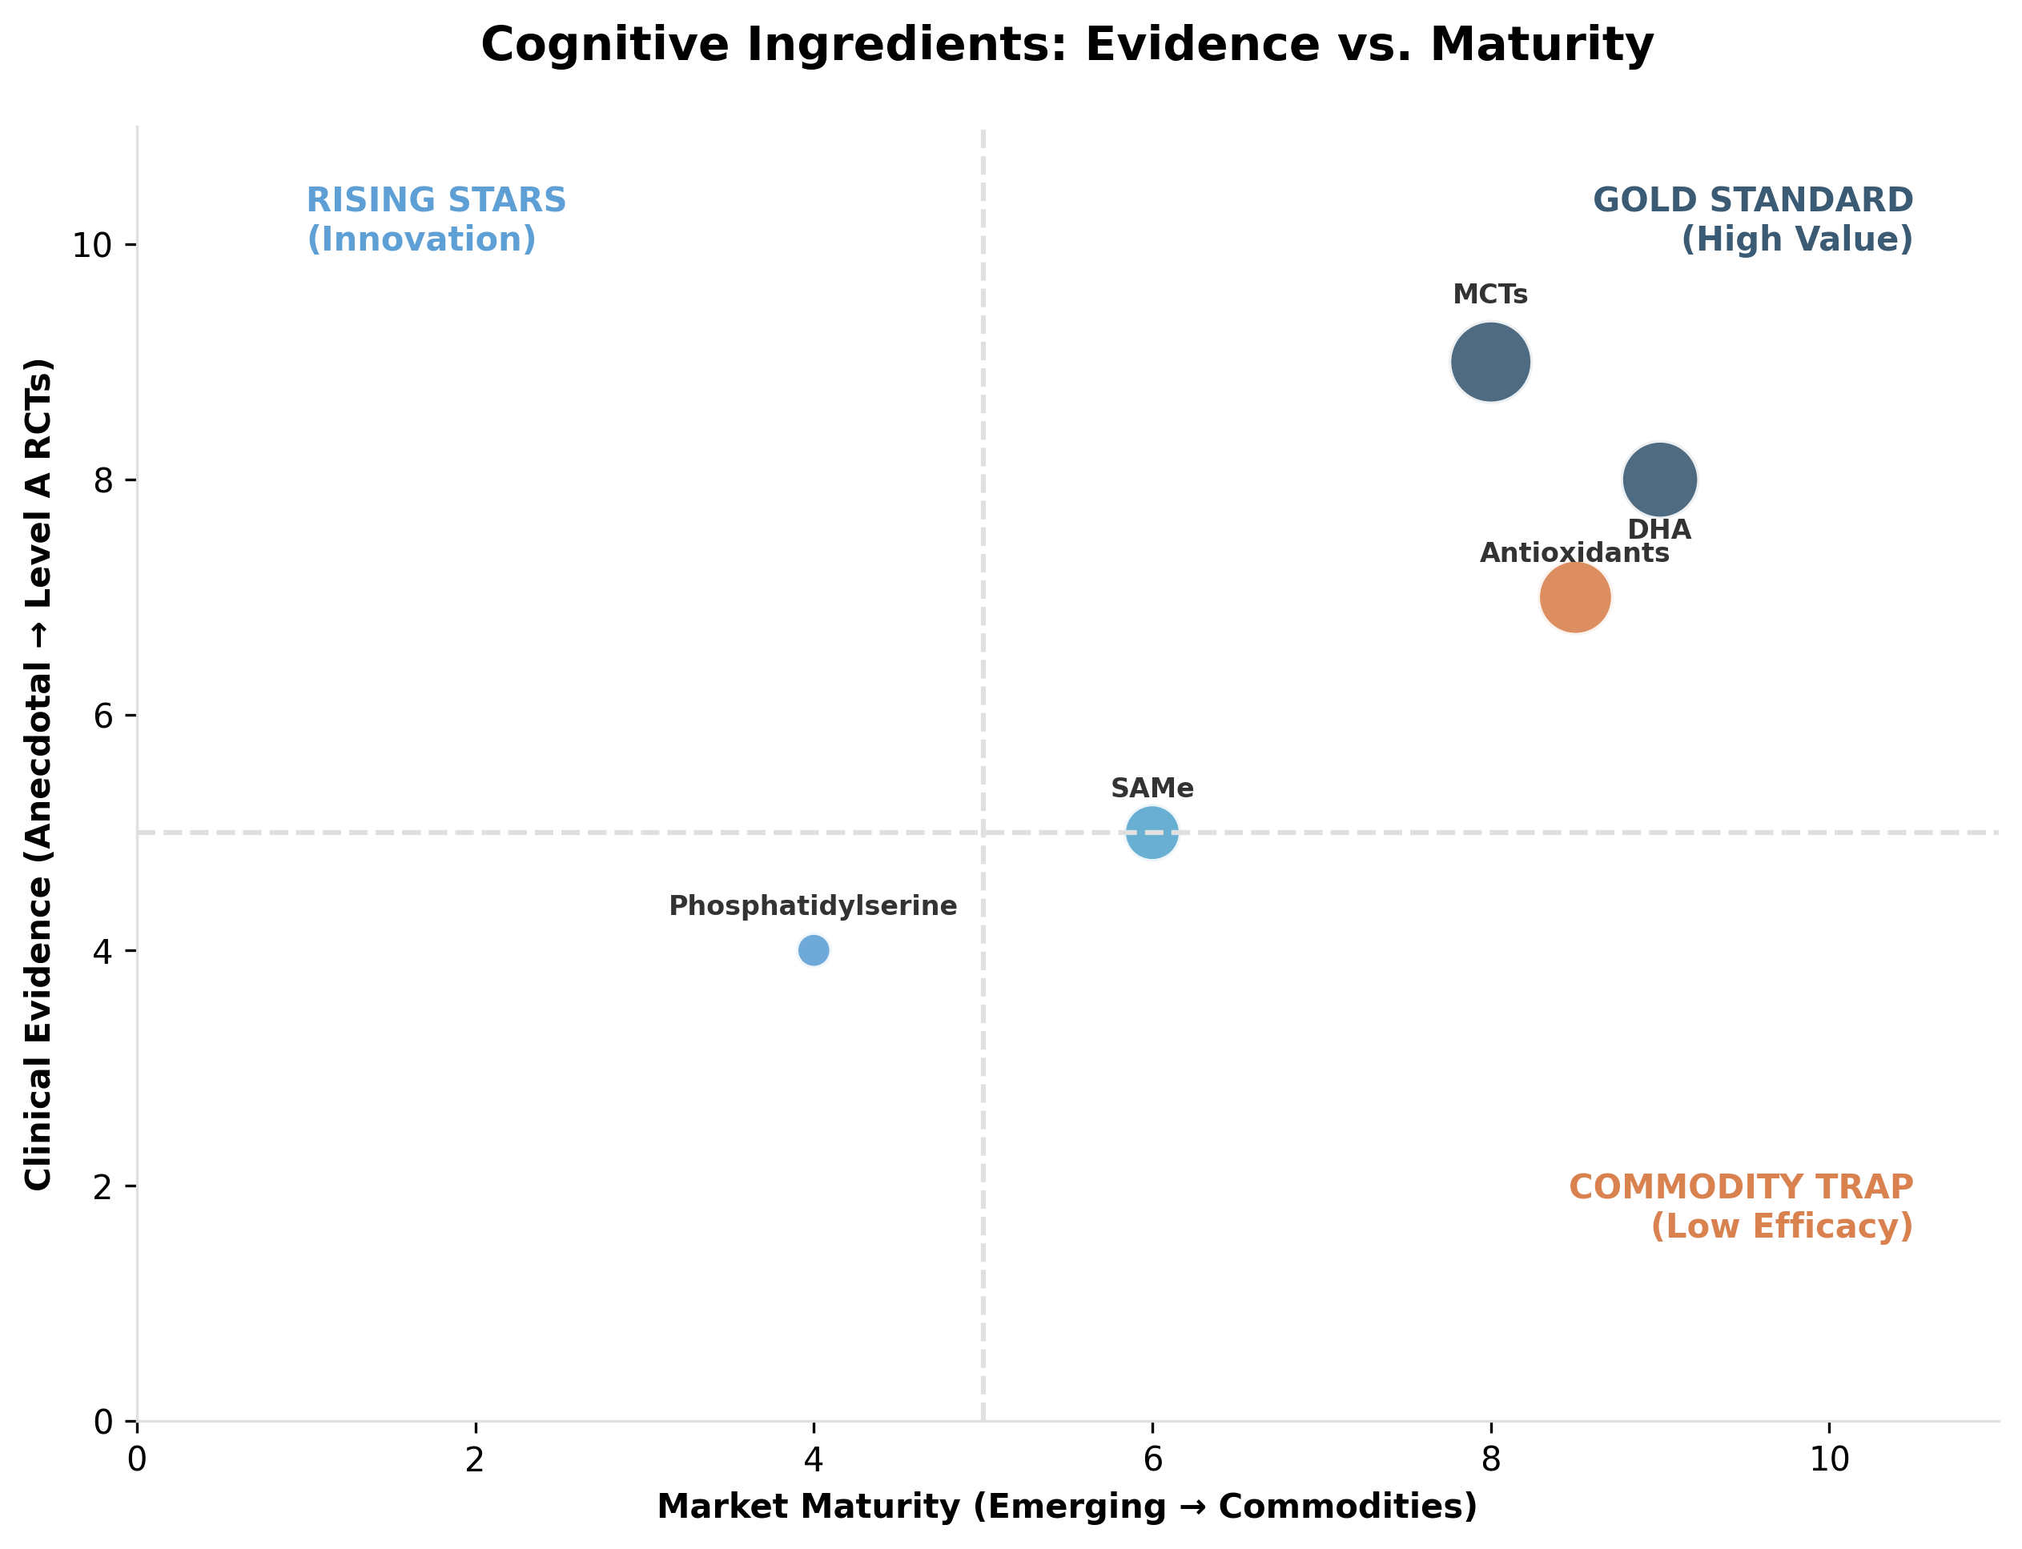

*Figure II.4: Evidence levels and market positioning of key nutraceutical ingredients (Cognition).*

### **Table II.4: Cognitive Support and Aging Targets**

| **Nutraceutical family** | **Primary species and use case** | **Drug sparing or adjunct target** | **Results** | **Evidence level and clinical takeaway** | **Key references** | **Est. % Use (Cognitive Support Segment)** | **Est. % Use (General Market)** | **Est. Global Revenue (Veterinary)** |
| --- | --- | --- | --- | --- | --- | --- | --- | --- |
| MCTs (medium chain triglycerides) | Senior dogs, cognitive dysfunction support | Adjunct to medical management (example selegiline where used) | Cognitive task performance, owner reported behavior | A: controlled evidence supports cognitive benefits in aged dogs | (Pan et al., 2010) (Pan et al., 2024) | 0.349 | 0.023 | $450 Million |
| DHA (docosahexaenoic acid) | Dogs and cats, brain aging support | Adjunct | Cognitive and behavior measures, general neurologic support | B: biologically strong, clinical outcomes depend on design and baseline diet | (Pan et al., 2010) | 0.271 | 0.018 | $350 Million |
| Antioxidant enriched diets and blends | Senior dogs, oxidative stress and cognition | Adjunct | Learning, memory tasks, behavior change | B to A: canine cognitive aging literature supports antioxidant diet interventions | (Cotman et al., 2002); (Milgram et al., 2002) | 0.233 | 0.015 | $300 Million |
| Phosphatidylserine | Senior dogs and cats | Adjunct | Cognitive and behavior endpoints | C: limited veterinary specific trial base | (Finno, 2020) | 0.012 | 0.0008 | $15 Million |
| SAMe | Aging animals, often positioned for liver and brain support | Adjunct | Biomarkers, clinical signs | C: stronger for liver support narratives than cognition | (Finno, 2020); (Reme et al., 2008); (Hackett, 2013) | 0.078 | 0.005 | $100 Million |
| Ginkgo biloba | Senior pets | Adjunct | Behavior and cognition | C: limited veterinary evidence, careful positioning | (Finno, 2020) | 0.004 | 0.0003 | $5 Million |
| B complex vitamins | Senior pets and deficiency risk | Adjunct | Biomarkers and general vitality | C: best treated as baseline adequacy plus targeted deficiency prevention | (Finno, 2020) | 0.054 | 0.004 | $70 Million |

### **II.5. Calming and Behavioral Wellness (Species: Pet)**

Behavioral Wellness is the fastest-growing segment of modern veterinary care, responding directly to the pressures of urbanization and the widespread increase in post-pandemic separation anxiety.”The objective has moved beyond reactive sedation to achieving ‘emotional resilience’—a balanced neurochemical state capable of managing environmental stressors without compromising alertness. This category is dominated by ‘anxiolytic stacks’—specifically multi-ingredient complexes, bioactive peptides, and phytocannabinoids—designed to modulate neurotransmission and replace pharmaceutical sedatives in mild-to-moderate cases.

Underscoring the magnitude of this shift, the broader pet calming product market (including functional treats and hardware) is estimated at over $1.4 billion, reflecting a massive consumer demand for non-pharmaceutical stress solutions. Within this ecosystem, the strict nutraceutical segment alone generates $350–$450 million, accounting for 10–14% of the total pet supplement market. Reflecting the urgent demand for non-pharmaceutical solutions, this therapeutic sector is set to experience a robust compound annual growth rate (CAGR) of 10.7% through 2034, significantly outpacing the broader pet care industry.

The market is currently anchored by Multi-ingredient Calming Complexes ($500 million), which command a massive 45.5% share of the segment due to their convenience and synergistic formulations. Meanwhile, CBD and Hemp derivatives ($330 million) have become a dominant force in pain-anxiety management, while precision tools like Alpha-casozepine and L-Theanine are gaining traction for their clinically validated ability to deliver ‘non-drowsy’ anxiolysis during situational stress.”

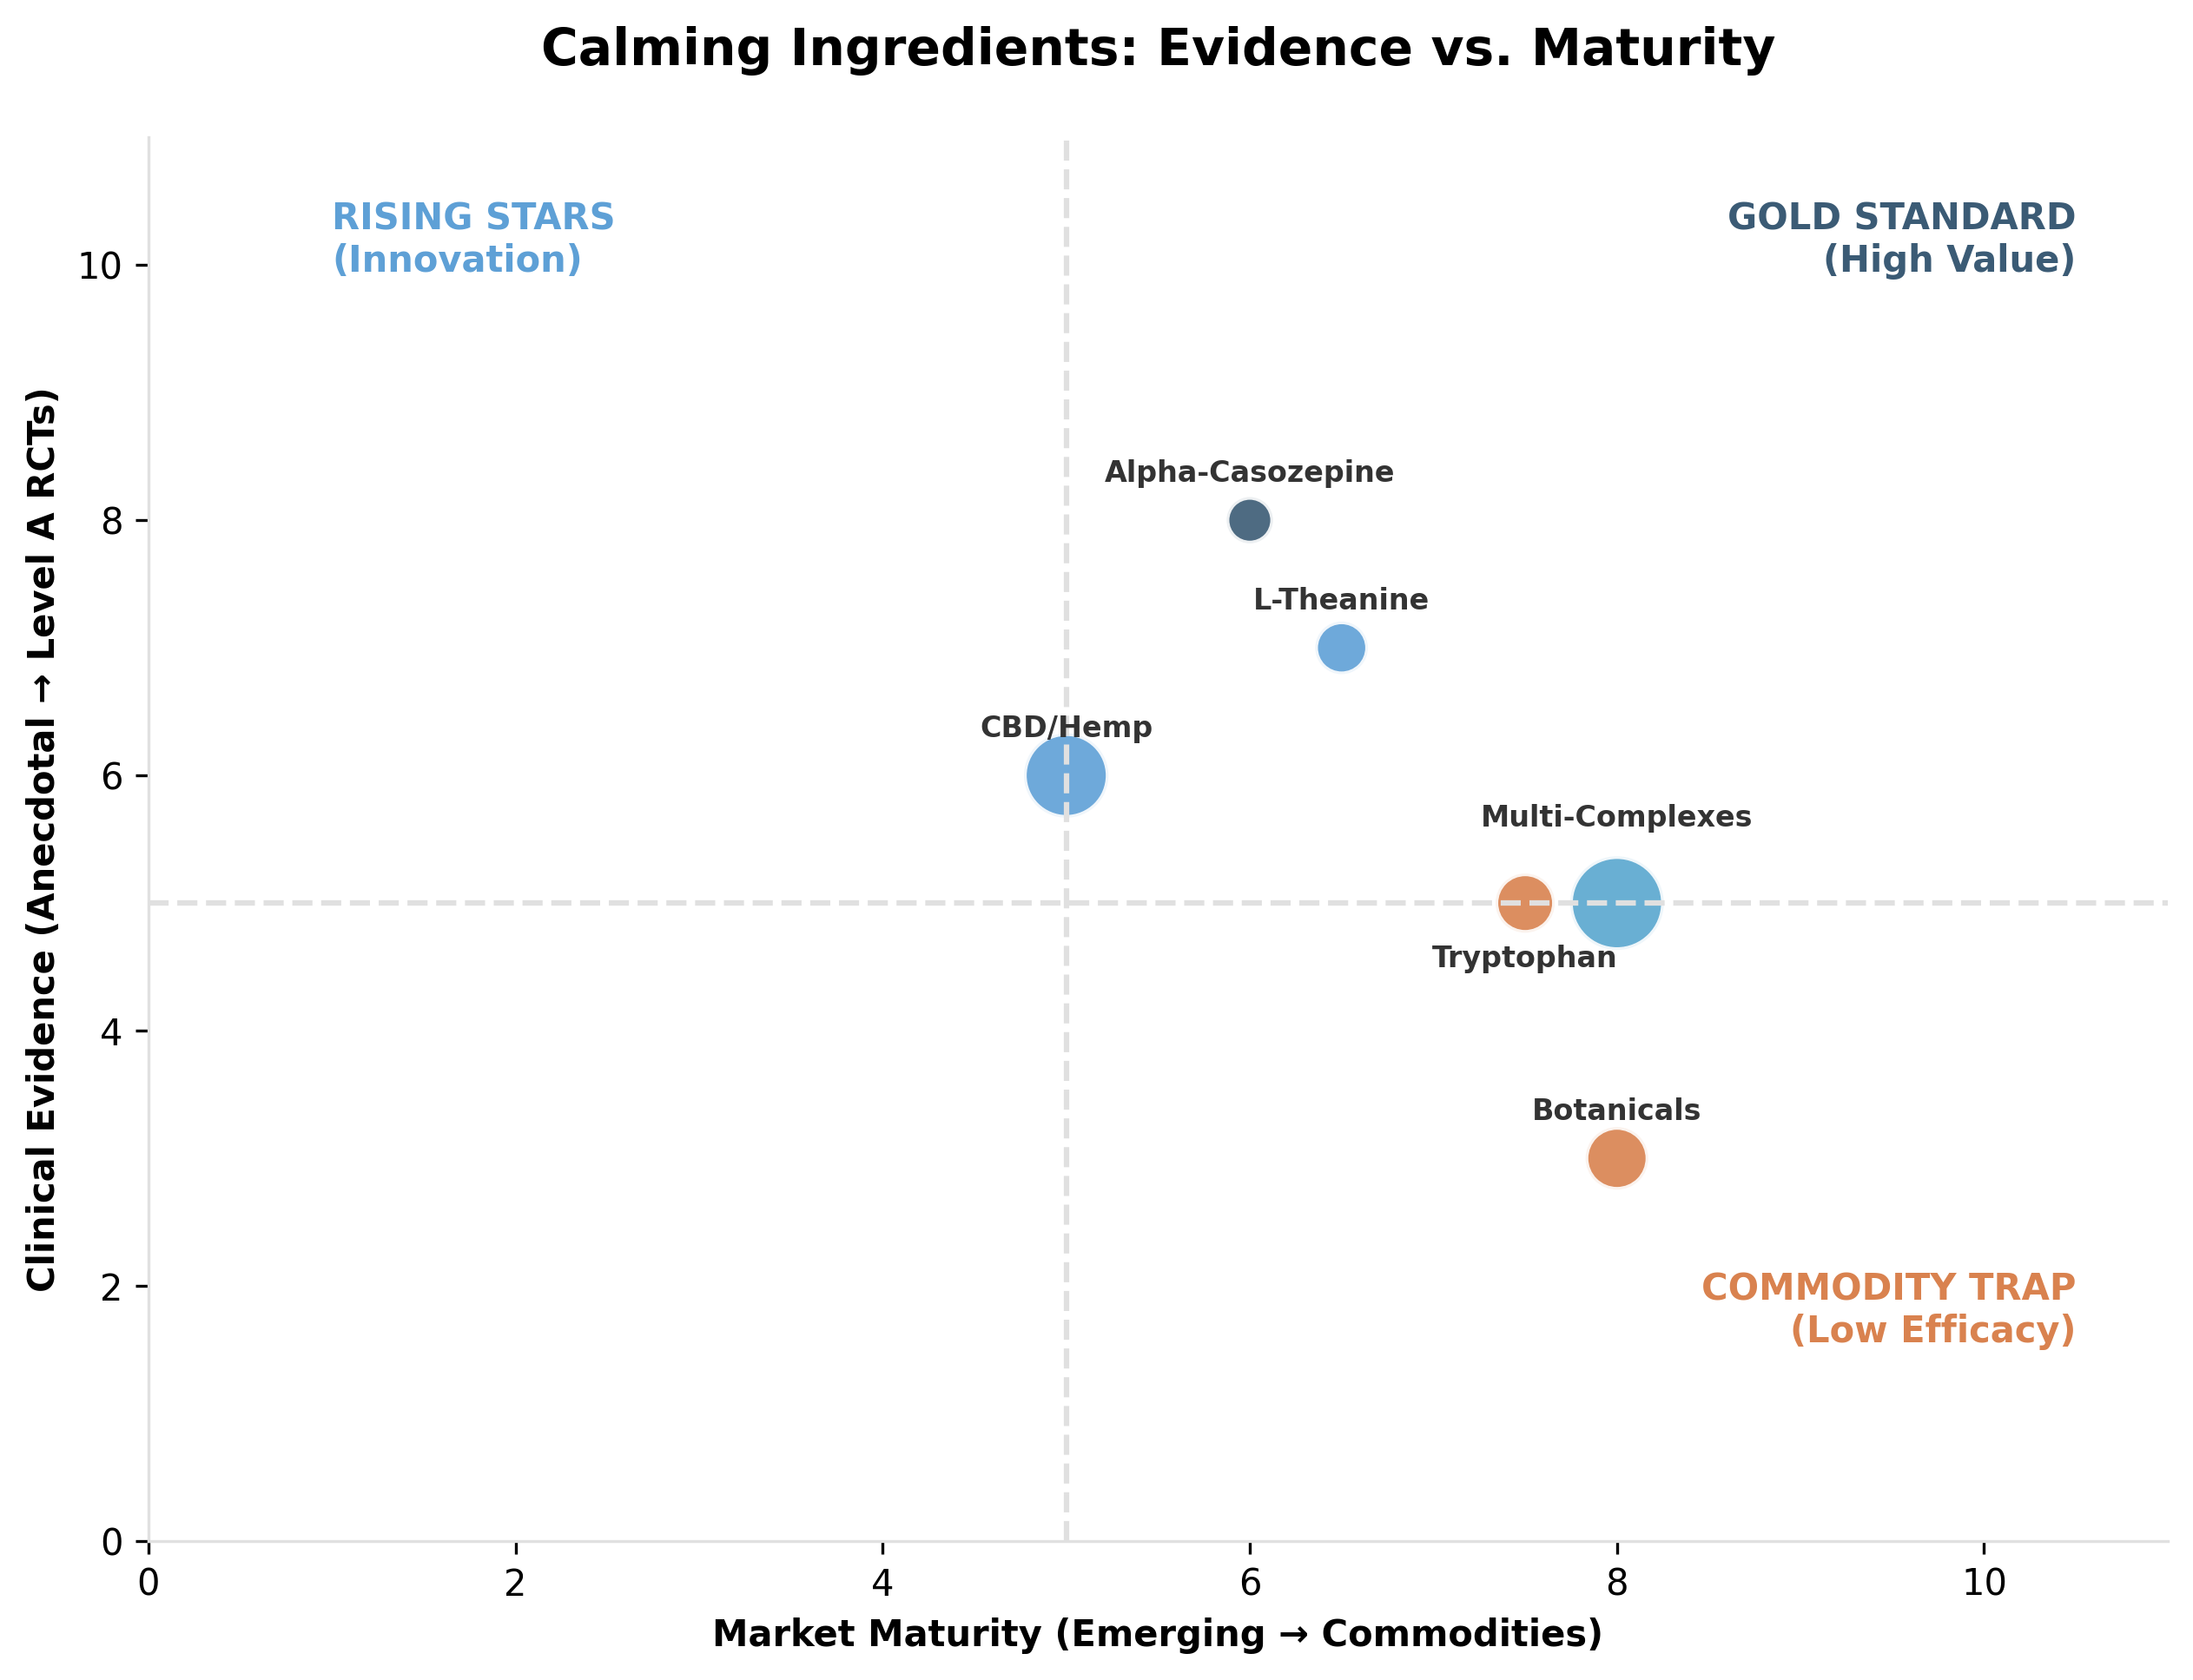

*Figure II.5: Evidence levels and market positioning of key nutraceutical ingredients (Calming).*

### **Table II.5: Calming and Behavioral Wellness Targets**

| **Nutraceutical family** | **Primary species and use case** | **Drug sparing or adjunct target** | **Results** | **Evidence level and clinical takeaway** | **Key references** | **Est % Use (Within Calming Segment)** | **Est % Use (General Market)** | **Est. Global Revenue (Veterinary)** |
| --- | --- | --- | --- | --- | --- | --- | --- | --- |
| L theanine | Dogs and cats, anxiety support | Adjunct to behavioral therapy and anxiolytics (example trazodone, SSRIs in chronic cases) | Owner reported anxiety scales, situational response | B: supportive evidence exists, heterogeneity remains | (Pike et al., 2015); (Eaton et al., 2021) | 0.045 | 0.003 | ~$50 Million |
| Alpha casozepine | Dogs and cats, stress modulation | Adjunct | Anxiety scales, behavior outcomes | B: controlled evidence in companion animals supports calming claims | (Beata et al., 2007); (Palestrini et al., 2010) | 0.027 | 0.002 | ~$30 Million |
| Tryptophan | Dogs, behavioral modulation | Adjunct | Aggression and stress related behavior outcomes | B to C: evidence exists but not uniformly strong, context matters | (DeNapoli et al., 2000);; (Palestrini et al., 2010) | 0.073 | 0.004 | ~$80 Million |
| Magnesium and B vitamins | Dogs and horses, “stress support” stacks | Adjunct | Non specific, subjective measures | C: plausible but limited targeted veterinary RCT base | (Oddoux et al., 2022); (Finno, 2020) | 0.009 | 0.001 | ~$10 Million |
| Botanicals (valerian, passionflower, chamomile) | Dogs, cats, horses | Adjunct | Behavioral outcomes | C: limited and variable; careful claims and safety review needed | (Robinson, 2025) | 0.091 | 0.005 | ~$100 Million |
| CBD and hemp derivatives | Dogs primarily | Adjunct | Pain, anxiety related endpoints depending on product | C to B: growing evidence base, but regulatory and quality variability remains material | (Mulder et al., 2025); (Verrico et al., 2020); (Mejia et al., 2023) | 0.3 | 0.018 | ~$330 Million |
| Multi ingredient calming complexes | Dogs, cats, horses | Adjunct | Owner reported signs, situational tolerance | C: evidence depends on the lead active and product substantiation | (Finno, 2020) | 0.455 | 0.027 | ~$500 Million |

### **II.6. Performance, FCR (Feed Conversion Ratio), and Growth (Species: Livestock)**

Under the twin pressures of volatile raw material costs and stringent environmental regulations, the Performance and Growth sector has undergone a fundamental paradigm shift. The objective has moved beyond simple ‘weight gain’ to achieving Precision Efficiency—extracting maximum nutritional value from every gram of feed to minimize metabolic waste and nitrogen excretion. This category is characterized by the replacement of crude biological accelerators (antibiotic growth promoters) with highly specific enzymatic and nutritional tools that unlock bound nutrients and optimize feed conversion ratios (FCR). The Performance, FCR, and Growth nutraceutical segment is valued at approximately $7.1 billion and is a cornerstone of the specialty feed additives market. Reflecting the industry’s pivot toward high-tech efficiency, this segment is projected to grow at a Compound Annual Growth Rate (CAGR) of 7% through 2034, significantly outpacing the general feed market. The sector is currently anchored by Yeast Culture ($2.00 billion), which commands a leading 28.2% share due to its proven ability to stabilize rumen function.

This is closely followed by Rumen Protected Amino Acids ($1.20 billion) and Xylanase enzymes ($1.00 billion), which have become indispensable for ‘precision nutrition’—ensuring that limiting nutrients are delivered intact to absorption sites, thereby reducing both feed costs and the environmental footprint of production.

**The Ovine (Sheep) Challenge:** Unlike intensive poultry or swine systems, sheep production is largely pasture-based, making consistent daily supplementation difficult. The primary constraint is often **Trace Mineral Deficiency**—specifically **Cobalt** (essential for Vitamin B12 synthesis) and **Zinc** (critical for hoof health and preventing footrot). “Ill-thrift” (failure to thrive) in lambs is frequently treated not with more feed, but with targeted B12/Cobalt interventions to unlock metabolic potential.

Feed Conversion Ratio (FCR) is the definitive metric for production efficiency in animal agriculture, quantifying the exact mass of feed required to produce one unit of output (typically weight gain). Mathematically defined as FCR = Total Feed Intake / Total Weight Gain, a lower ratio indicates superior performance, signifying that the animal is converting raw ingredients into protein with minimal metabolic waste. In the modern nutraceutical landscape, FCR has evolved from a simple cost-control metric to a primary sustainability benchmark; tools like enzymes and probiotics are specifically engineered to lower this ratio, ensuring that expensive feed nutrients are biologically utilized rather than excreted into the environment.

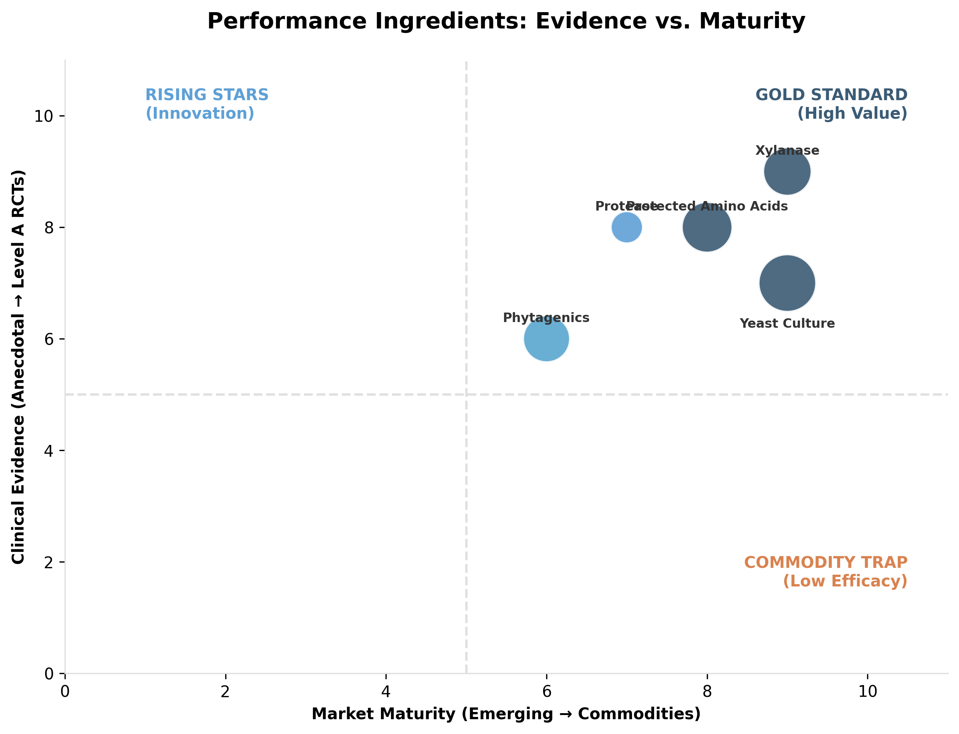

*Figure II.6: Evidence levels and market positioning of key nutraceutical ingredients (Performance).*

### **Table II.6: Performance and Efficiency Targets**

| **Nutraceutical family** | **Primary species and use case** | **Drug sparing or adjunct target** | **Results** | **Evidence level and clinical takeaway** | **Key references** | **Est % Use (Within Performance Segment)** | **Est % Use (General Market)** | **Est. Global Revenue (Veterinary)** |
| --- | --- | --- | --- | --- | --- | --- | --- | --- |
| Phytase | Poultry and swine, phosphorus digestibility | Reduces nutrient waste and supports gut efficiency | Digestibility, FCR, P excretion | A: established performance tool with deep evidence base | (Selle and Ravindran, 2007; Afsharmanesh et al., 2023) | 0.085 | 0.014 | ~$600 Million |
| Xylanase and carbohydrases | Poultry and swine | Supports digestibility and performance stability | FCR, ADG, litter quality | A: mature evidence base, strong ROI logic | (Selle and Ravindran, 2007) | 0.141 | 0.023 | ~$1.00 Billion |
| Protease | Poultry, protein utilization | Supports digestibility, reduces nitrogen waste | Digestibility, FCR | A to B: meta analysis level support exists | (Cowieson et al., 2020) | 0.028 | 0.005 | ~$200 Million |
| Phytogenics (essential oils, thymol, carvacrol, cinnamaldehyde) | Poultry and swine, gut stability and performance | Part of post AGP toolbox | FCR, lesion scores, microbial outcomes | B: broad but heterogeneous; formulation and delivery matter | (Murugesan et al., 2015; Abdelli et al., 2021) | 0.125 | 0.021 | ~$890 Million |
| Yeast culture (S. cerevisiae) | Ruminants and monogastrics | Supports rumen and gut efficiency | Milk yield or FCR depending on species | B: meta analysis support, context sensitive | (Desnoyers et al., 2009); (Poppy et al., 2012) | 0.282 | 0.046 | ~$2.00 Billion* |
| Organic trace minerals (chelated Zn, Cu, Mn) | Poultry and swine, hoof and skin integrity, performance | Adjunct | Growth, integrity metrics | B: supportive evidence; economics depend on baseline mineral program | (Ballou et al., 2019); (Gomez et al., 2022); (Ding et al., 2024) |  |  |  |
| Electrolytes | Poultry heat stress, horses performance days | Adjunct to management | Hydration markers, performance stability | B: strong practical rationale, clinical trial density varies | (Ballou et al., 2019) | 0.118 | 0.019 | ~$840 Million |
| Amino acid blends and rumen protected amino acids | Ruminants and swine | Improves efficiency, reduces waste | Yield, FCR, nitrogen efficiency | B: mature for protected AA in ruminants, but “nutraceutical” framing depends on claims | (Fleming et al., 2019); (Zanton et al., 2014); (Lee et al., 2019) | 0.169 | 0.028 | ~$1.20 Billion |
| Carnitine, CLA, creatine, beta alanine | Pets and horses niche | Adjunct | lean mass, energy metabolism; mainly livestock performance | C: limited veterinary specific RCT base, best framed as niche | (Finno, 2020); (Owen et al., 1996); (Ramanau et al., 2004) | 0.008 | 0.001 | ~$55 Million |

### **II.7. Special Niches (Species: Multi-Species)**

Fueled by the demand for ‘functional aesthetics’ in aquaculture and ‘visible vitality’ in pets, the Special Niches sector targets precise phenotypic outcomes rather than generic health. Valued at approximately **$1.75 billion**, this category is overwhelmingly anchored by Astaxanthin (**$1.35 billion**), which commands a 77.1% share due to its critical role in aquaculture pigmentation. In the companion animal sector, the market is defined by high-value dermatology inputs—specifically Zinc Methionine ($175M), Omega-6 ($120M), and Biotin ($56M)—which serve as the primary adjuncts for managing skin barrier integrity. Reflecting the persistent demand for these observable results, the sector is projected to sustain a stable compound annual growth rate (CAGR) of ~7.5% through 2034.

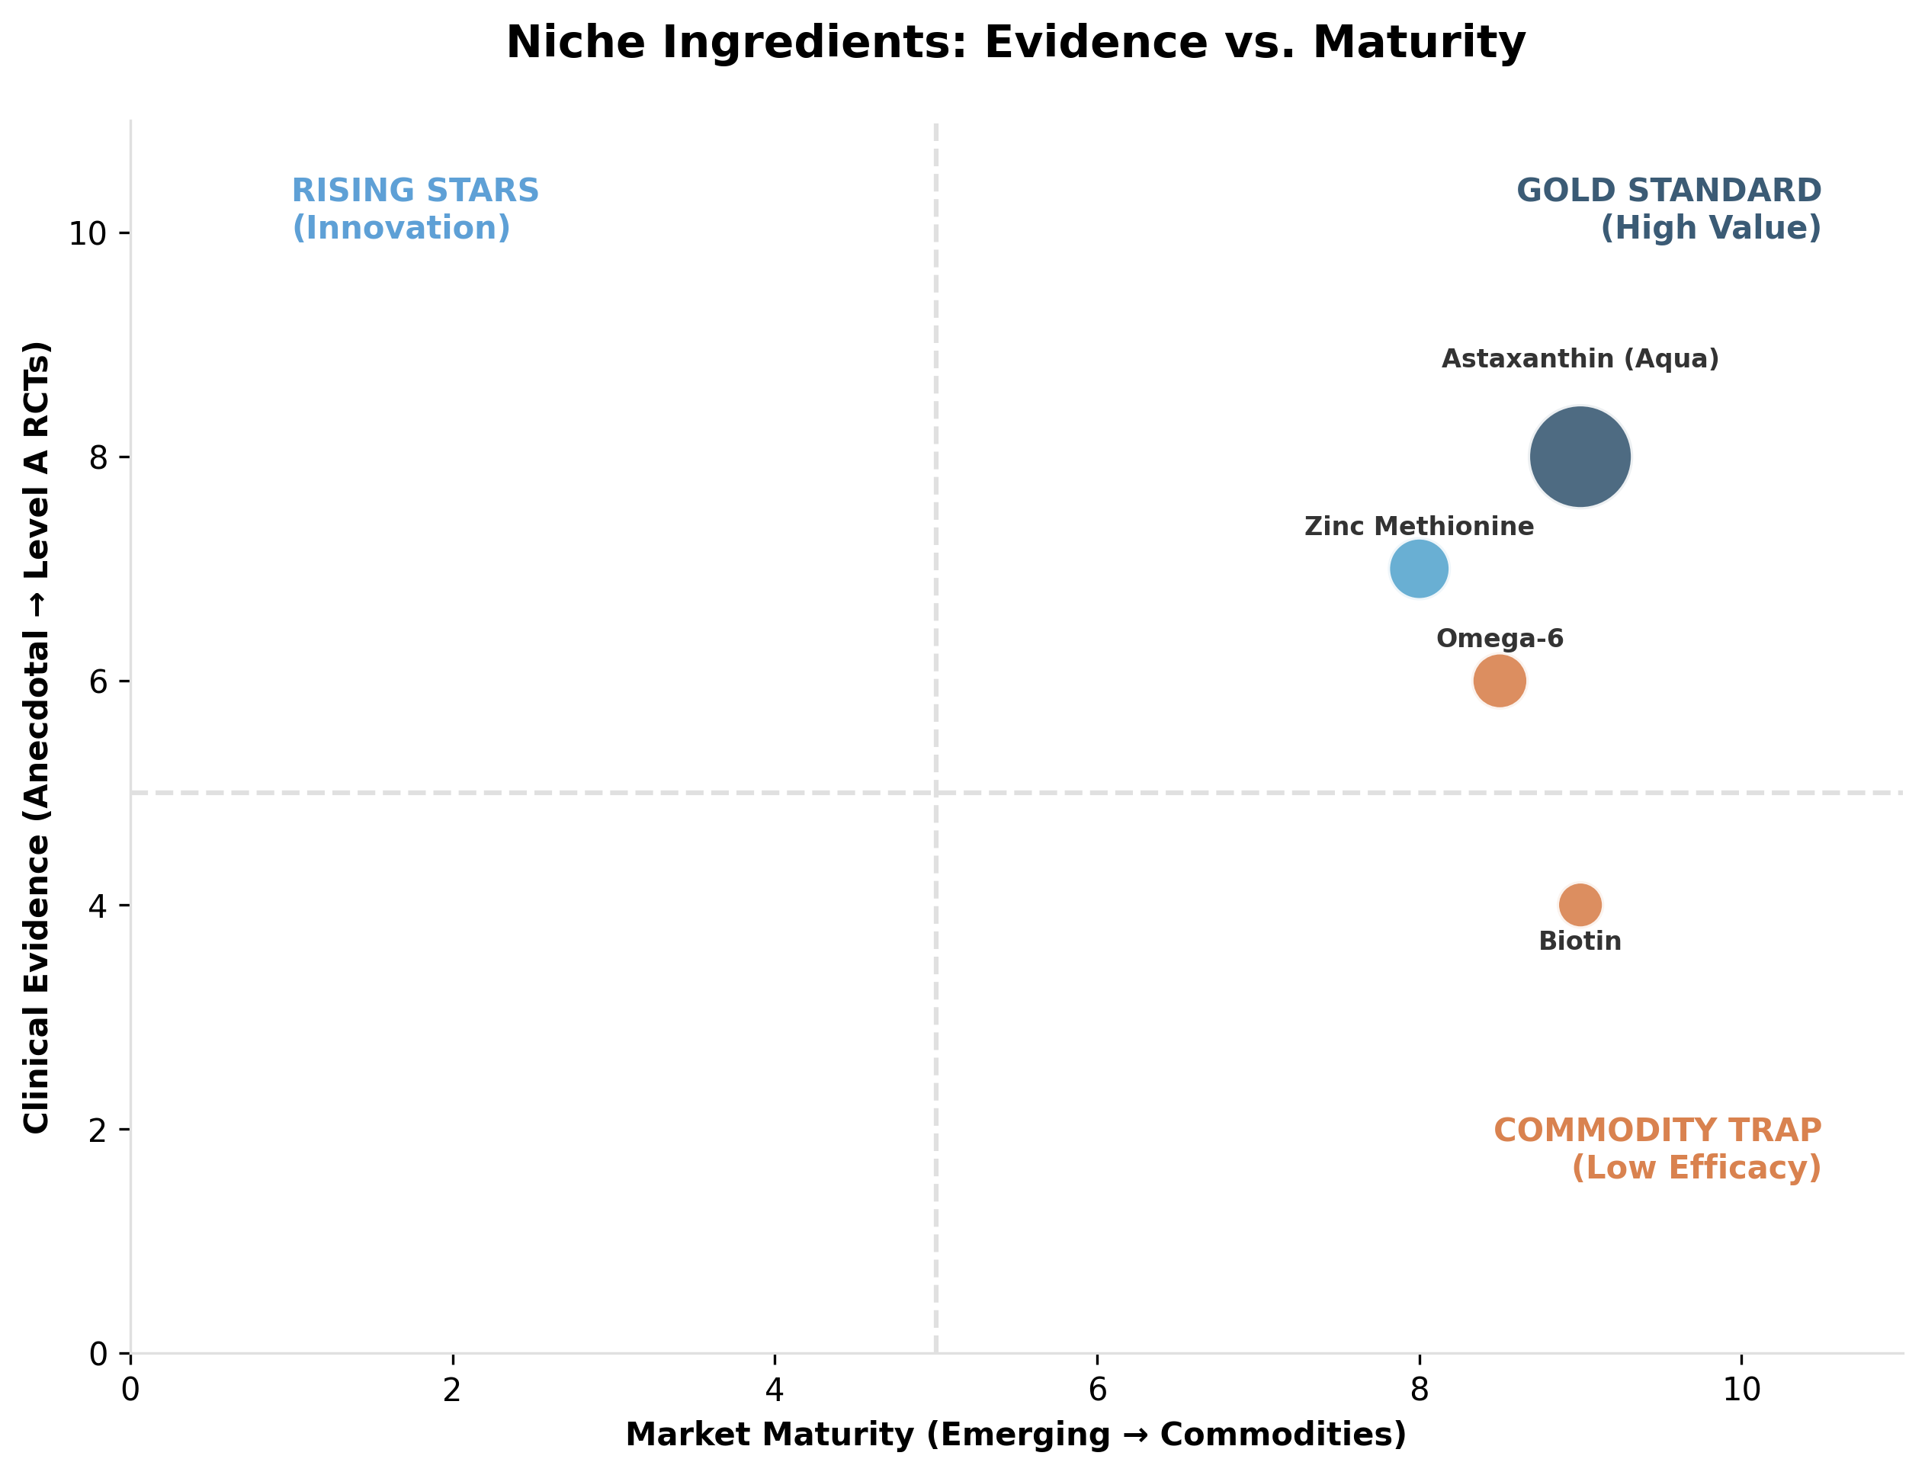

*Figure II.7: Evidence levels and market positioning of key nutraceutical ingredients (Niches).*

### **Table II.7: Special Niches Targets**

| **Niche** | **Primary species and use case** | **Drug sparing or adjunct target** | **Results** | **Evidence level and clinical takeaway** | **Key references** | **Est % Use (Within Niches Segment)** | **Est % Use (General Market)** | **Est. Global Revenue (Veterinary)** |
| --- | --- | --- | --- | --- | --- | --- | --- | --- |
| Dermatology: omega 6, linoleic acid | Dogs and cats, skin barrier support | Adjunct to anti pruritic drugs and topical care | Coat, pruritus scores, skin barrier outcomes | B: strongest when addressing barrier and deficiency like states | (Finno, 2020); (Saevik et al., 2004); (Popa et al., 2024) | 0.068 | 0.006 | ~$120 Million |
| Dermatology: biotin | Dogs and horses, hoof and coat | Adjunct | Hoof quality, coat quality | C: commonly used, mixed strength | (Finno, 2020); (Buffa et al., 1992); (Reilly et al., 2010) | 0.032 | 0.003 | ~$56 Million |
| Dermatology: zinc methionine | Dogs, coat and skin | Adjunct | Skin integrity outcomes | B to C: supportive evidence, baseline status matters | (Finno, 2020) | 0.1 | 0.009 | ~$175 Million |
| Urinary tract: cranberry | Dogs and cats | Adjunct | Recurrence of urinary signs, biomarkers | C: mixed evidence, careful positioning | (Finno, 2020) | 0.029 | 0.003 | ~$50 Million |
| Pigmentation: astaxanthin | Aquaculture and poultry | Adjunct | Flesh color, antioxidant outcomes | B: well established in aquaculture pigmentation economics | (Shah et al., 2016) | 0.771 | 0.07 | ~$1.35 Billion |

### **II.8. Natural Ectoparasite Defense (Species: Multi-Species)**

Propelled by escalating consumer caution regarding chemical inputs—specifically the neurologic risks associated with isoxazolines—the Natural Ectoparasite Defense sector has secured a significant foothold in the veterinary landscape. The total segment is now estimated at approximately **$1.0 billion**, projected to grow at a CAGR of ~8-10% as producers and pet owners alike seek to reduce their reliance on conventional pesticides. However, because definitive parasite eradication is strictly regulated as a pharmaceutical claim, this market is defined by a sharp strategic divergence between species.

In the livestock sector, the strategy is indirect population management, utilizing Feed-Through IGRs (**$200 million**) such as S-methoprene. Conversely, the companion animal sector prioritizes individual avoidance, relying on Natural Repellents (**$550 million**) to create a ‘safe’ deterrent barrier, often accepting that clinical efficacy may be uneven compared to pharmaceutical standards.

The Natural Ectoparasite sector operates on a distinct ‘safety-first’ logic, defining its value proposition primarily by what it excludes: synthetic pesticides. This market leverages specific regulatory pathways to ensure speed-to-market, most notably the USA’s EPA 25(b) Exemption. This critical mechanism allows brands utilizing recognized botanicals—such as cedar oil, peppermint, or geraniol—to bypass the multimillion-dollar registration hurdles that define the EU’s stricter Biocidal Products Regulation (BPR).

However, this regulatory freedom comes with a specific ceiling on claims: while brands can aggressively market immediate utility like ‘kills by contact’ or ‘safe for use around children,’ they are strictly prohibited from making medical public health claims—such as ‘prevents Lyme Disease’—which remain the domain of FDA-regulated drugs. Consequently, market leadership is not driven by medical guarantees, but by a ‘No-Neurotoxin’ differentiation strategy.

Winning brands explicitly position themselves against the side-effect profiles of systemic isoxazolines (e.g., ‘No Seizures’), while simultaneously bridging the historic ‘efficacy gap’ by producing white papers that validate >90% repellency. In a crowded shelf, the final differentiator is often sensory; brands that can deliver this high efficacy without the harsh solvent smell typical of essential oils effectively solve the consumer’s compliance barrier.

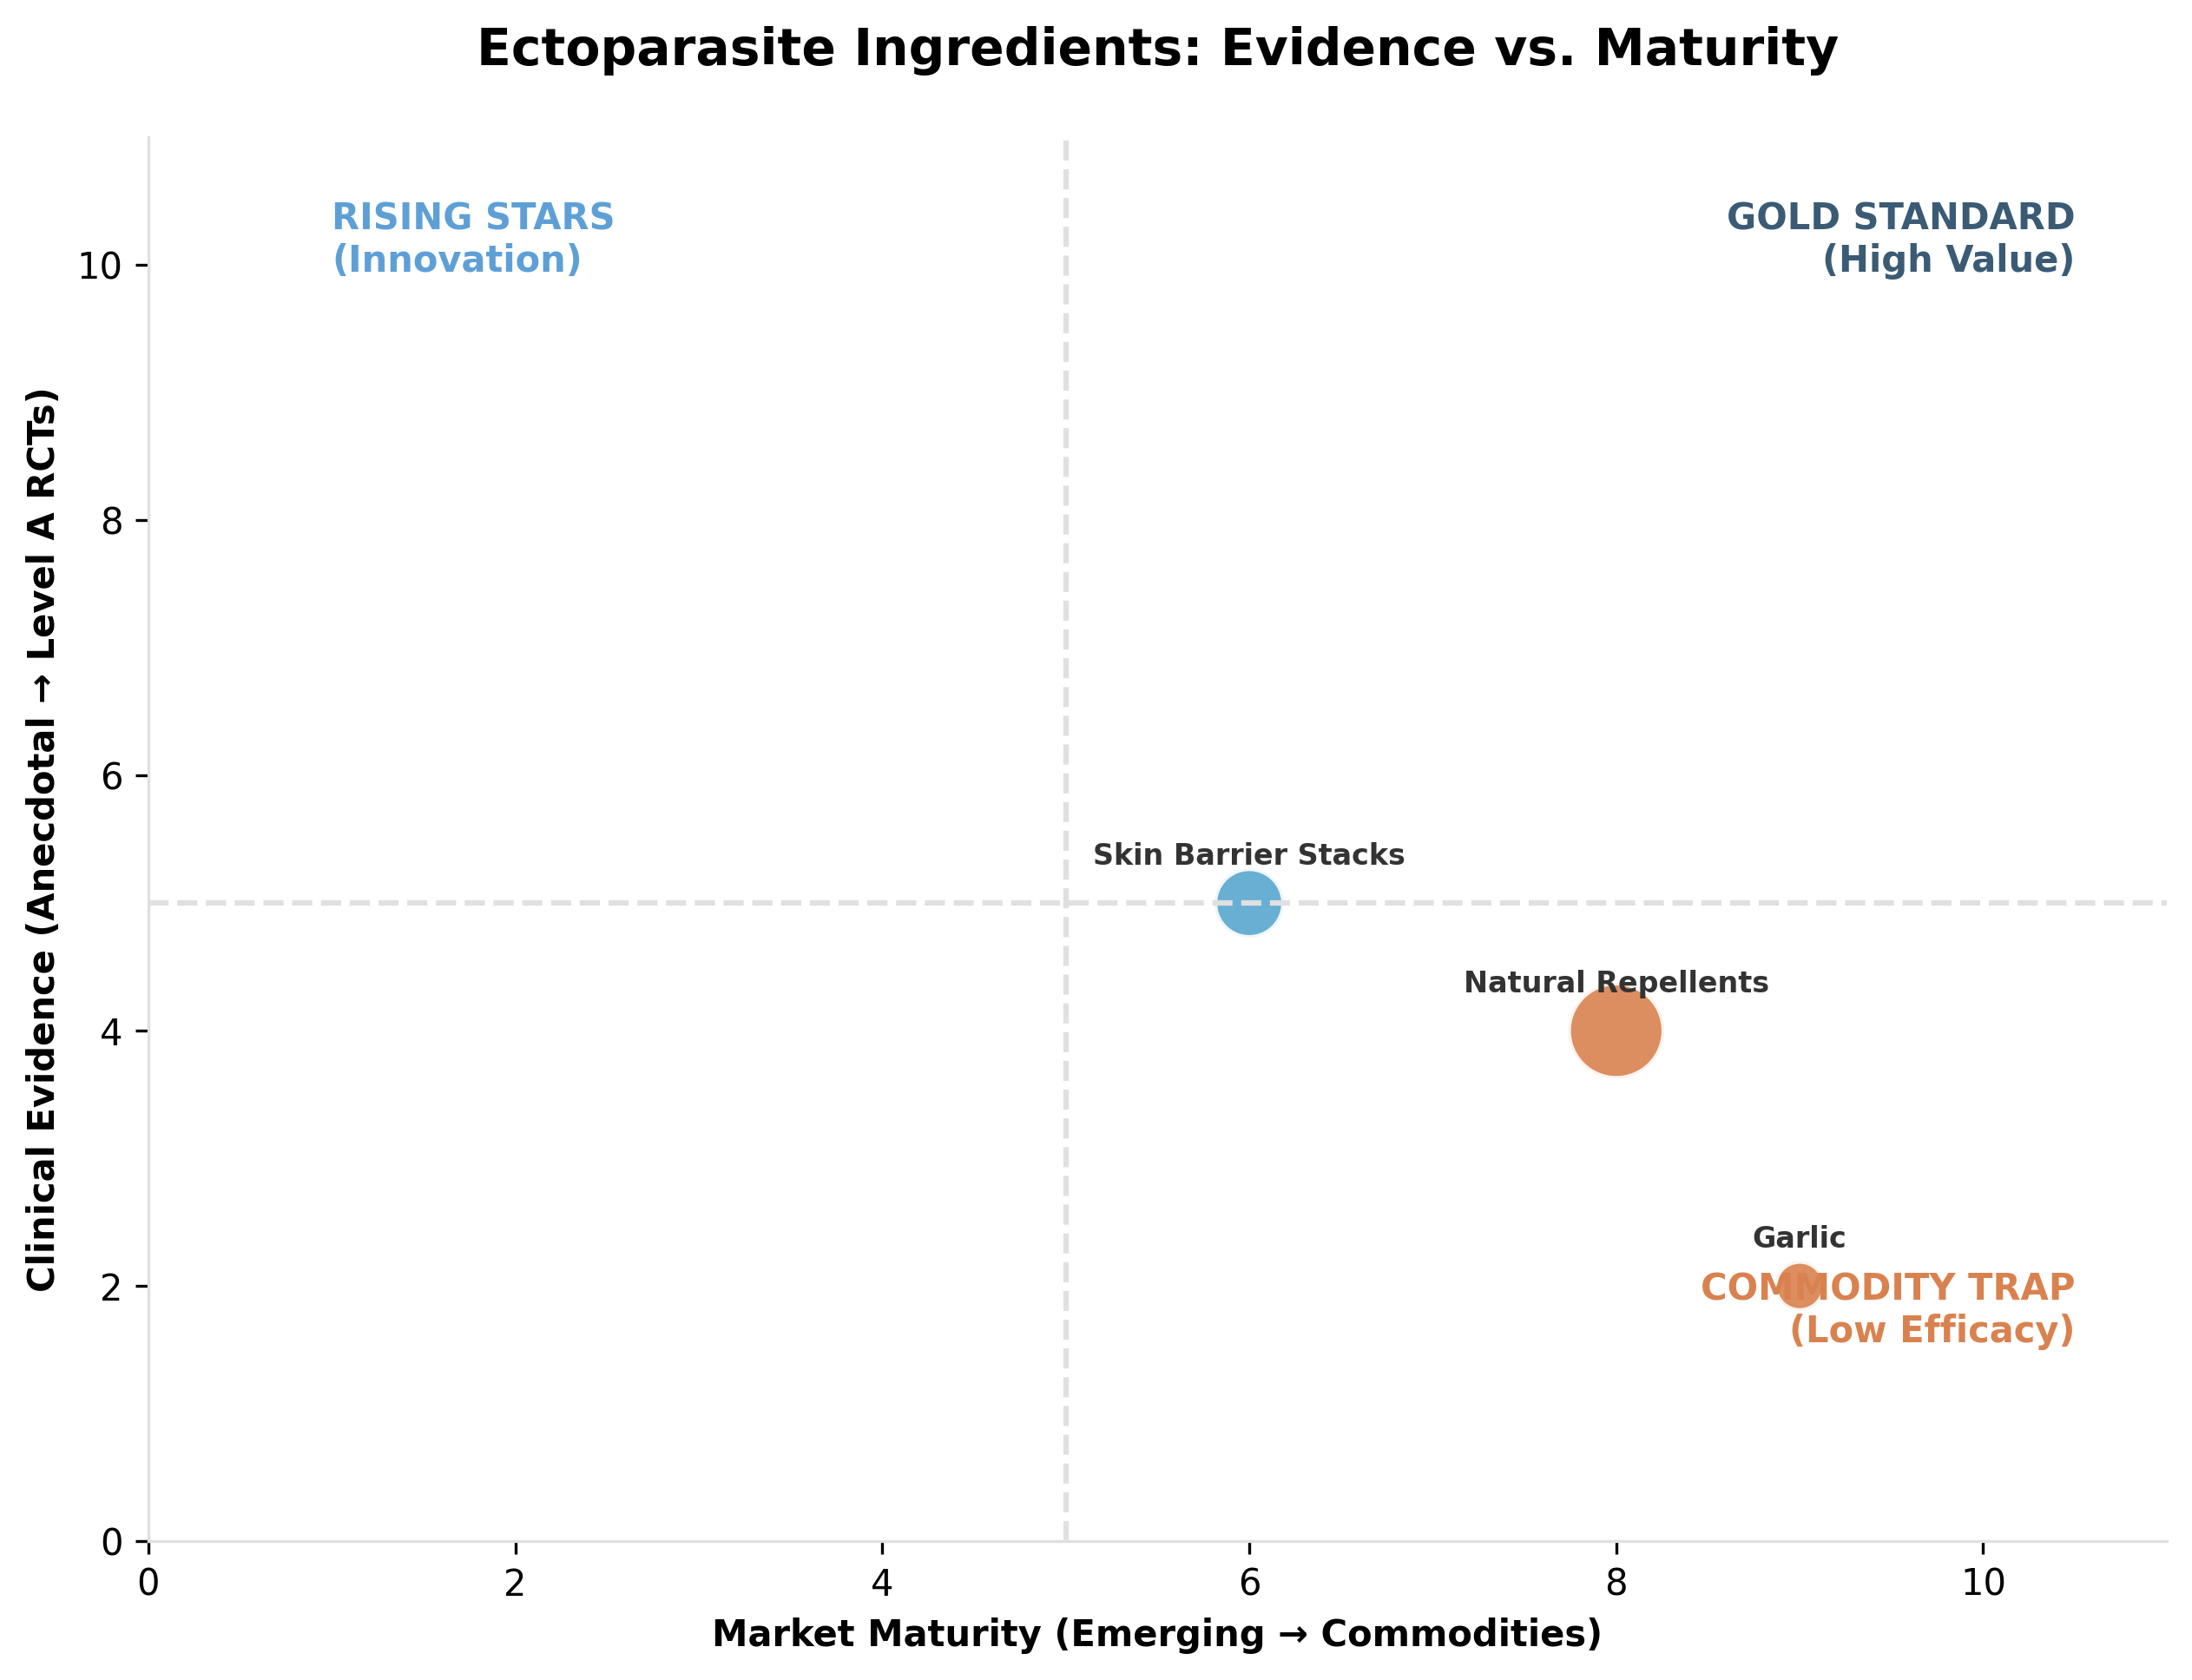

*Figure II.8: Evidence levels and market positioning of key nutraceutical ingredients (Ectoparasite).*

### **Table II.8: Natural Ectoparasite Defense Targets**

| **Strategy** | **Primary species and use case** | **Drug sparing or adjunct target** | **Results** | **Evidence level and clinical takeaway** | **Key references** | **Est % Use (Within Ectoparasite Segment)** | **Est % Use (General Market)** | **Est. Global Revenue (Veterinary)** |
| --- | --- | --- | --- | --- | --- | --- | --- | --- |
| Natural repellents (essential oils) | Dogs, “natural” flea and tick positioning | Competes with isoxazoline class in consumer mindshare | Parasite counts, bite incidence | C: efficacy variability plus safety and regulatory risk make this a high risk category | (Robinson, 2025) | 0.55 | 0.028 | ~$550 Million |
| Garlic based approaches | Dogs and cats | Competes with proven parasiticides | Parasite counts | C: efficacy is anecdotal and safety is a concern at higher dosing | (Part II 8 11 internal notes; Robinson, 2025) | 0.04 | 0.002 | ~$40 Million |
| Skin barrier support stacks (omega 3, quercetin blends) | Dogs with flea allergy dermatitis positioning | Adjunct | Pruritus and skin outcomes | C: more defensible as dermatitis support than as parasite control | (Finno, 2020) | 0.15 | 0.008 | ~$150 Million |

### **II.9. Nutrigenomics and Systemic Prevention (Species: Multi-Species)**

Moving beyond simple nutrient sufficiency, the Nutrigenomics and Systemic Prevention sector represents the ‘precision frontier’ of animal health. Crucially, Nutrigenomics is not a standalone product category, but a differentiation logic: it utilizes omics and biomarkers to build ‘pharma-like’ evidence packages, creating commercial defensibility for non-patentable ingredients. The clinical objective is to signal the genome—activating defense pathways like Nrf2—to transform nutrition into a ‘biological firewall’ that replaces reactive antibiotics with proactive physiological infrastructure.

Underscoring this high-tech shift, the bio-defense segment is valued at approximately $3.5 billion. The market is anchored by Gut Integrity Infrastructure ($2.17 billion), which acts as the central ‘control point’ for resilience; utilizing tools like butyrate to reinforce tight junctions and MOS to modulate pathogen interactions during high-stress windows like weaning. In parallel, the Vaccine Adjunct & Immune space ($300 million) is particularly vital in aquaculture, where species like shrimp rely heavily on innate immunity (boosted by beta-glucans) because conventional vaccination is often impractical.

Binding these strategies together is the Nutrigenomics & Biomarker sector ($613 million), growing at an explosive 17.5% CAGR. While traditionally anchored in livestock ROI, this sector is rapidly expanding into the companion animal market. In the pet sector, nutrigenomics is fueling the “Hyper-Personalization” trend, where DNA testing kits (e.g., Wisdom Panel, Embark) are paired with breed-specific nutrition plans to mitigate genetic predispositions—transforming “generic wellness” into “individualized preventive medicine.”

Operating in a regulatory gray zone, ‘Nutrigenomics’ is not an official government category but a high-value B2B distinction used to separate precision science from commodity additives. While these products must technically register under generic regulatory nomenclature—such as ‘Gut Flora Stabilizers’ (EU) or ‘Direct-Fed Microbials’ (USA)—their true seal of quality is the ‘Invisible Label’ of peer-reviewed validation.

Because suppliers are strictly forbidden from making medical promises (e.g., ‘Cures Necrotic Enteritis’) or claiming direct ‘Antibiotic Replacement,’ the marketing strategy pivots entirely from clinical outcome to Mode of Action (MoA). Leaders in this space distinguish themselves from generic ‘yeast soup’ competitors by proving precision: rather than promising a cure, they demonstrate exactly which antioxidant genes (such as Nrf2) are upregulated by their technology.

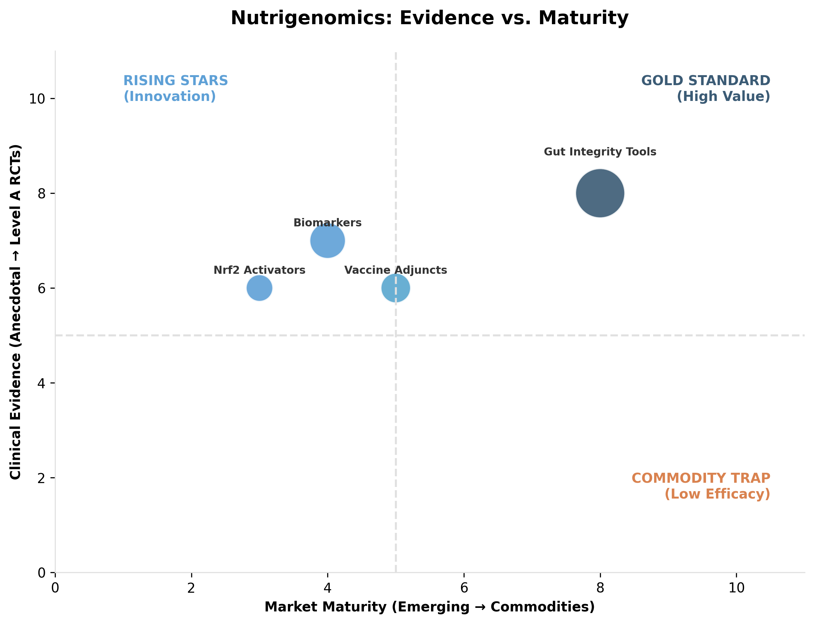

*Figure II.9: Evidence levels and market positioning of key nutraceutical ingredients (Nutrigenomics).*

### **Table II.9: Nutrigenomics Targets**

| **Concept** | **Where it shows up** | **Why investors care** | **Results** | **Evidence level and clinical takeaway** | **Key references** | **Est % Use (Within Nutrigenomics Segment)** | **Est % Use (General Market)** | **Est. Global Revenue (Veterinary)** |
| --- | --- | --- | --- | --- | --- | --- | --- | --- |
| Biomarker substantiation (omics, gene expression) | Livestock and premium pet brands | Creates defensibility when ingredients are not patentable | Biomarker movement plus downstream performance or clinical endpoints | B: best treated as a substantiation and differentiation layer, not a product category | (Asmelash et al., 2018; ul Haq et al., 2022) | 0.175 | 0.032 | ~$613 Million |
| Nrf2 and polyphenol pathways | Multiple species | Mechanism narrative for antioxidant and resilience claims | Biomarkers of oxidative stress and inflammation | C to B: mechanistic base is strong, but direct claims need species specific data | (Deon et al., 2025) | 0.057 | 0.01 | ~$200 Million |
| Gut integrity as antibiotic alternative infrastructure | Swine, poultry, aquaculture | Links gut tools to medication reduction and ROI | Diarrhea incidence, lesion scores, treatment incidence | B to A: strongest where it ties to field outcomes | (Kiarie et al., 2012; Zimmermann et al., 2016) | 0.62 | 0.112 | ~$2.17 Billion |
| Vaccine interaction positioning | Poultry, aquaculture | Adjunct logic without overclaiming | Antibody readouts, survival under challenge | C to B: supportive, context dependent | (Chen et al., 2021; Meena et al., 2013) | 0.086 | 0.015 | ~$300 Million |

This scientific rigor allows them to sell consistency—claiming that every batch is ‘genomically verified’ to possess the same biological potency—and ultimately positions their product not merely as an ingredient, but as a comprehensive ‘Blueprint’ for predictable production capability.

### **II.10. Advanced Formulations and Delivery Systems (Species: Multi-Species)**

Delivery format is not merely packaging; it is the definitive differentiator between a commodity ingredient and a scalable, defensible product. The clinical objective in this sector is to solve the physical constraints of biology: ensuring an active ingredient survives processing and harsh digestive environments (Protection), or guaranteeing voluntary consumption by the animal (Compliance). Consequently, the Advanced Formulations and Delivery Systems market has evolved into a massive $7.7 billion infrastructure layer.

The sector is sharply bifurcated by species-specific needs. In production animals, the priority is Protection and Site-Specific Release; this segment is dominated by Rumen Protection Technologies ($3.80 billion), which utilize sophisticated lipid matrices to bypass fermentation and deliver amino acids to the small intestine—a mature yet evolving category growing at a CAGR of ~7%. **Rumen-Retained Boluses** are the dominant technology for grazing ruminants (especially sheep/cattle), utilizing high density (sintered metal/minerals) to remain in the reticulum for months, slowly eluting critical trace elements (Cobalt, Selenium, Iodine) that strictly grass-fed animals would otherwise lack. Conversely, the companion animal sector is driven by Compliance Economics, where Soft Chews and Flavored Formats ($2.45 billion) command the market by ensuring “treat-like” palatability and repeat purchase.

Specialized niches like Aquafeed Coatings ($1.12 billion) and emerging Nanoscale/Microencapsulation technologies ($180 million, growing at 10.5%) further illustrate the industry’s shift toward precision—ensuring that expensive nutrients are not lost to leaching, oxidation, or premature degradation.

In the Delivery Technology sector, value is defined by the Engineering of Survival. Here, the “Label” relies on rigorous process standards like GMP+ and FAMI-QS rather than consumer categories. The strategic claims pivot entirely on Stability and Bioavailability: ranging from “Rumen Bypass” technologies that protect expensive livestock nutrients, to Lipid Nanocarriers that “stealth” molecules into the bloodstream.

Ultimately, differentiation is achieved through Pharmacokinetic (PK) Proof—where market leaders validate their premium pricing not with marketing slogans, but with comparative blood curves. By demonstrating a superior active payload over the raw alternative, these technologies allow for Dose Sparing (reducing raw material costs by up to 70%), protecting gross margins against commodity volatility and establishing a technical moat that is difficult for generic competitors to replicate.

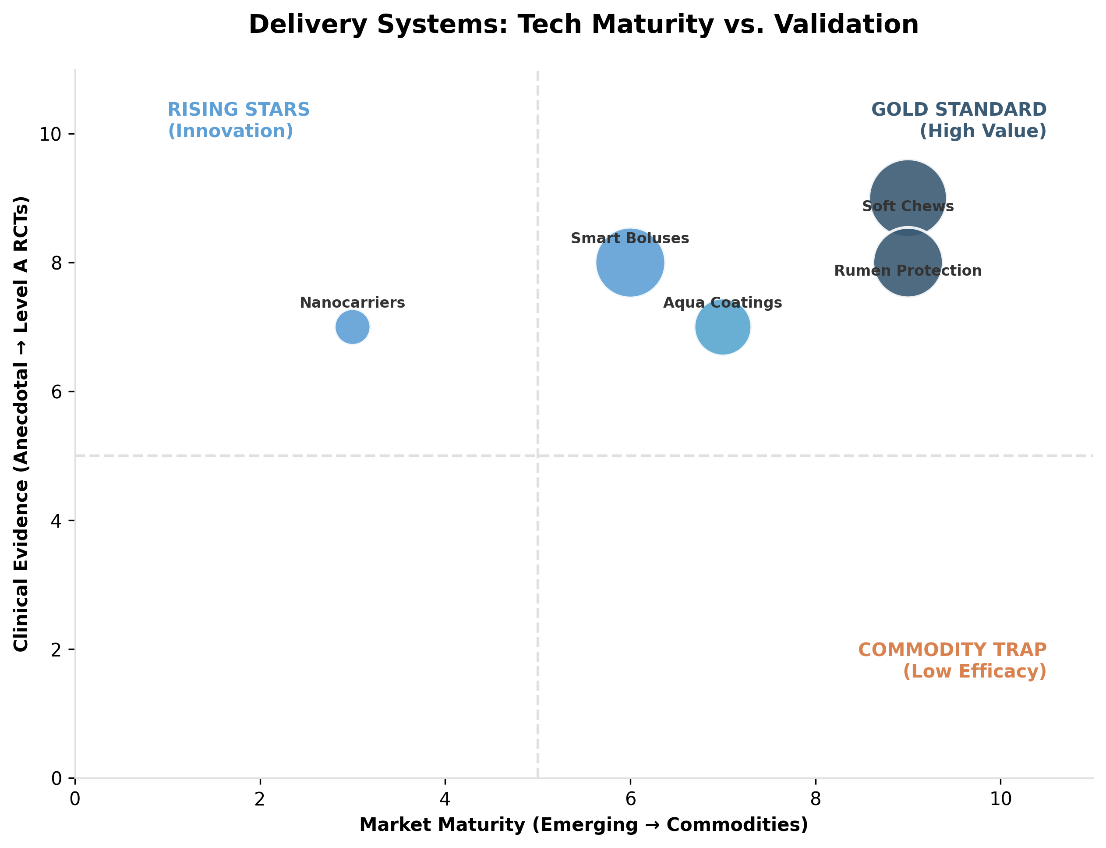

*Figure II.10: Technology maturity vs. Validation (Delivery Systems).*

### **Table II.10: Advanced Delivery Systems**

| **Delivery Technology** | **Best Fit Species** | **What Problem it Solves** | **Results** | **Evidence Level & Clinical Takeaway** | **Key References** | **Est. % Use (Adv. Form)** | **Est. % Use (Gen. Market)** | **Est. Global Revenue** |
| --- | --- | --- | --- | --- | --- | --- | --- | --- |
| Powders & Top Dress | Horses, Dogs | Precise dosing integrated into feeding routine | Intake reliability | High practical relevance; baseline format for performance | (Finno, 2020) | 0.039 | 0.015 | ~$300M |
| Nanocarriers & Microencapsulation | Poultry, Swine, Aqua | Heat stability, oxidation, and bioavailability | Dose Sparing; 85% absorption vs 15% raw | Level B: Enabling tech; critical for heat-sensitive biotics | (Noreen, 2026; Almassri, 2024) | 0.025 | 0.011 | ~$180M |
| Rumen Protection Matrices | Ruminants | Bypasses rumen; targets small intestine | Optimized yield; amino acid digestibility | Level B: Mature for AA; expanding to specialized bioactives | (Fleming, 2019; Inô, 2024) | 0.492 | 0.196 | ~$3.80B |
| Smart Monitoring Boluses | Cattle (Dairy/Beef) | Early disease & SARA detection; precision intervention | 52% reduction in antibiotics; 15hr calving alert | Level B: High clinical utility; enables “individualized” nutrition | (smaXtec, 2025; Sensors, 2024) | 0.042 | 0.021 | ~$2.58 Billion |
| Soft Chews (Premium) | Dogs, Cats | Compliance Wall and repeat purchase ritual | SaaS-like retention; reduced “pill burden” | Commercially Critical: Palatability is the binding constraint | (Finno, 2020; Sirio, 2026) | 0.317 | 0.126 | ~$2.45B |
| 3D-Printed “Printlets” | Horses, Senior Dogs | Poly-pharmacy; customized dosing | 99.9% precision; combined actives (Polypill) | Emerging: High LTV through data-driven customization | (PectaSol, 2026; Crafty Apes) | 0.008 | 0.004 | ~$120M |
| Aquafeed Coatings | Aquaculture | Prevents leaching; ensures water stability | Growth & biomass preservation under challenge | Level B: Key constraint is delivery stability in water | (Hauton, 2021) | 0.145 | 0.058 | ~$1.12B |
| Biofilm-Carrier Probiotics | Dogs, Poultry | Manufacturing heat & extrusion loss | 92% CFU survival vs. <10% in standard kibble | Level B: Solves the “viability problem” in dry feed | (Kathayat, 2022; Rabetafika, 2023) | 0.021 | 0.009 | ~$165 Million |
| Liposomal Transdermal Gels | Cats | “Pilling” non-compliance & oral rejection | 10.7% CAGR; avoids GI-tract degradation | Level B: Critical for chronic care and stress-sensitive pets | (CPHI, 2025; Nova One, 2024) | 0.018 | 0.006 | ~$110 Million |

### **II.11. Sustainability and the “Green Claim” Economy (Species: Livestock)**

Sustainability in animal agriculture is rapidly transitioning from a soft marketing differentiator to a hard procurement logic, driven by the imperative for large integrators to track Scope 3 emissions and secure supply chain resilience. The clinical objective here shifts from pure ‘performance’ to the management of measurable externalities—specifically the reduction of nitrogen excretion, phosphorus runoff, and enteric methane.

Consequently, the ‘Green Claim’ Economy has materialized as a distinct $3.35 billion market segment, projected to grow at a CAGR of 7.7% as environmental metrics become standard procurement requirements. Currently, this sector is overwhelmingly anchored by established Nutrient Efficiency Infrastructure: Nitrogen Efficiency tools ($2.25 billion) and Phytase ($640 million) dominate the landscape, serving as the primary operational levers for reducing metabolic waste and footpad dermatitis.

Emerging alongside these giants are high-profile Carbon Compliance Tools—such as 3-NOP and Asparagopsis—which, despite capturing headlines for their methane-mitigation potential, currently represent a nascent ~$200 million niche focused on regulatory alignment. **Small Ruminants (Sheep)** are a secondary but vital target here; trials with red seaweed (*Asparagopsis*) have demonstrated massive methane reductions (>80%) in sheep, yet the “Pasture Paradox” remains: how to deliver a daily volatile compound to free-grazing flocks without daily handling. Completing this ecosystem is the Supply Chain Resilience sector, where Algal DHA ($250 million) is replacing volatile marine ingredients to future-proof aquaculture against climate risks.

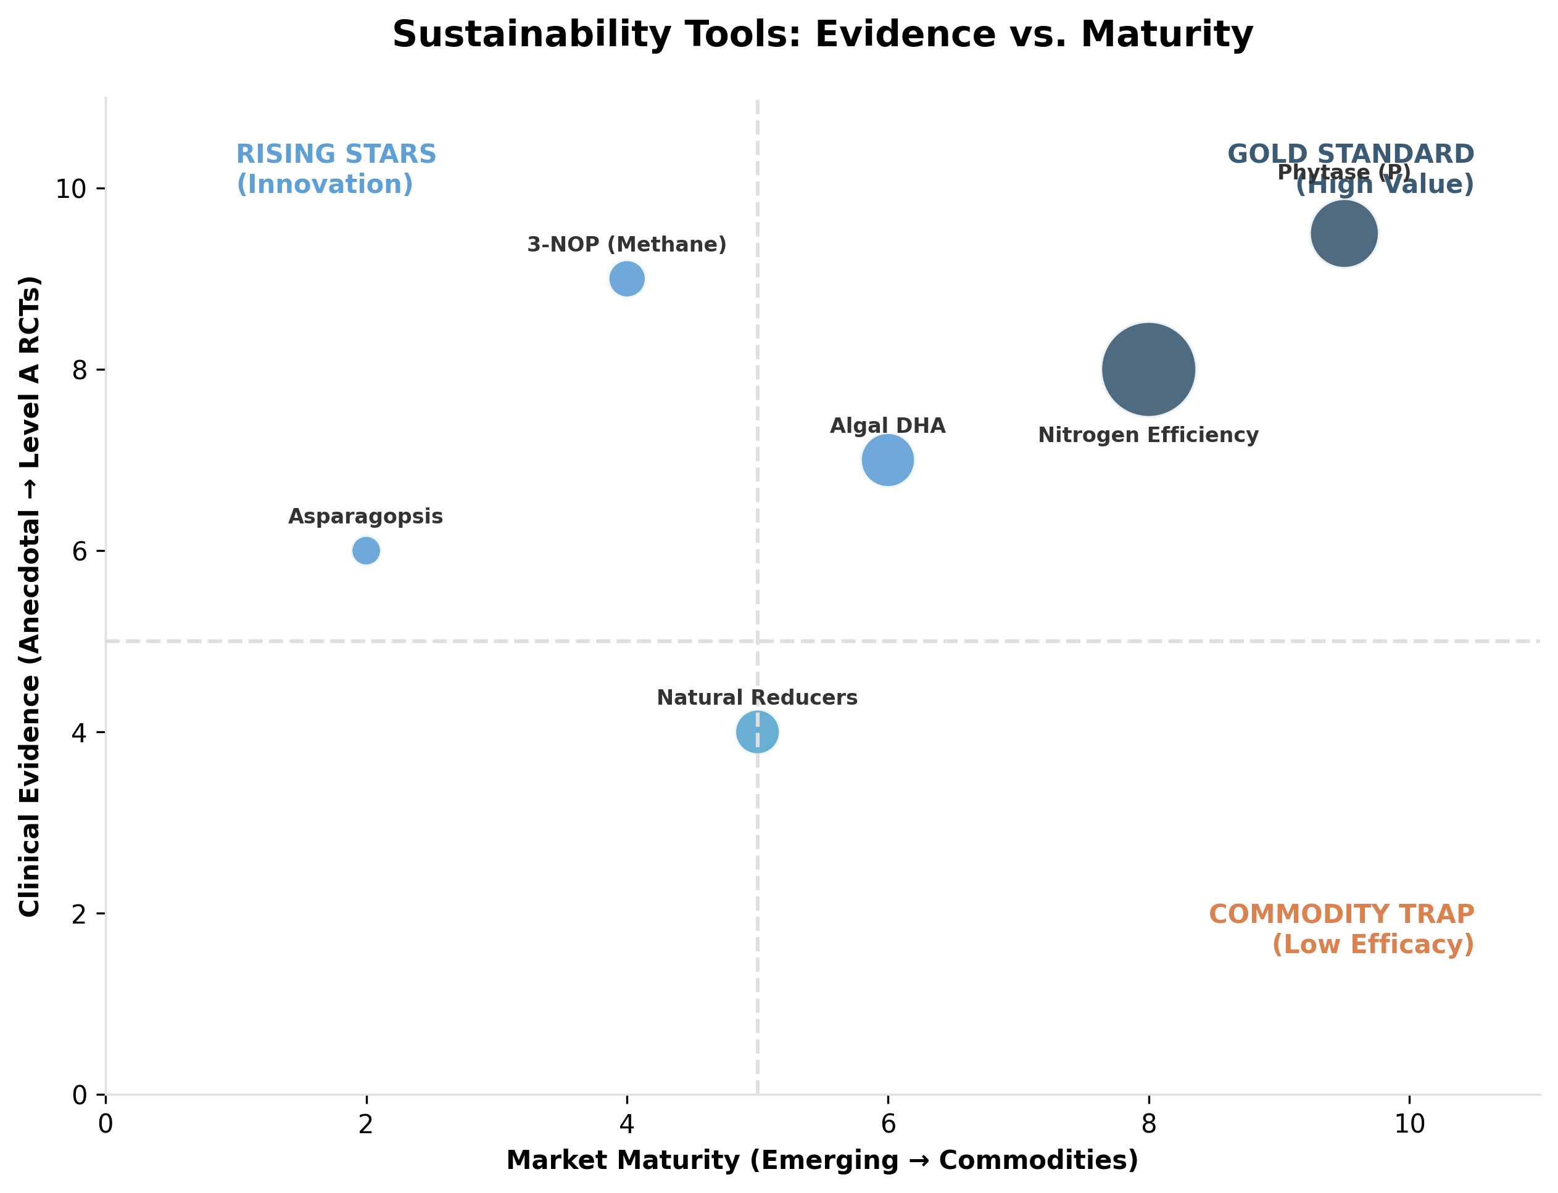

*Figure II.11: Evidence levels and market positioning of key nutraceutical ingredients (Sustainability).*

### **Table II.11: Sustainability and Green Claim Targets**

| **Sustainability wedge** | **Species** | **Additive family** | **Typical measurable KPI** | **Evidence level and clinical takeaway** | **Key references** | **Estimated % Use (Within Green Segment)** | **Estimated % Use (General Market)** | **Est. Global Revenue (Veterinary)** |
| --- | --- | --- | --- | --- | --- | --- | --- | --- |
| Methane mitigation | Ruminants | Asparagopsis | Methane reduction, diet dependent | B: large reductions reported in controlled settings, scalability and economics remain gating | (IPCC, 2021; Roque et al., 2021) | 0.008 | <0.1% | ~$25 Million |
| Methane mitigation | Ruminants | 3 NOP | Methane reduction, production neutrality | A to B: consistent reductions reported, often around high 20 percent range; adoption depends on who pays | (Hristov et al., 2015; Pupo et al., 2025) | 0.019 | 0.001 | ~$60 Million |
| Natural methane reducers | Ruminants | Tannins and essential oils | Methane reduction | B to C: smaller reductions but practical for some systems | (Pupo et al., 2025) | 0.039 | 0.003 | ~$120 Million |
| Phosphorus excretion management | Monogastrics | Phytase | P excretion reduction | A: established tool; meta analysis support exists | (Afsharmanesh et al., 2023) | 0.207 | 0.015 | ~$640 Million |
| Nitrogen efficiency | Poultry | Protease and amino acid balancing | N excretion proxies, ammonia, litter quality | B: operational route is digestibility improvement; linkage to welfare outcomes such as footpad dermatitis often discussed | (Cowieson et al., 2020; Shepherd and Fairchild, 2010) | 0.727 | 0.052 | ~$2.25 Billion |
| Omega 3 supply chain resilience | Aquaculture and pets | Algae DHA oils (Schizochytrium) | Supply risk reduction, DHA consistency | B: strategic input story supported by aquaculture nutrition literature | (Shah et al., 2023) | 0.075 | 0.006 | ~$250 Million |

## **III. Market Structure and Value Capture**

***In this section:*** *We quantify the “Two-Speed” market dynamic—contrasting the volume-driven livestock sector with the value-driven pet economy. Key analysis includes the “Great Divergence” in herd demographics and the “Palatability Premium” in companion animal formats.*

### **III.1. Global Animal Demographics and Trends: Sizing the Opportunity**

**Methodology Note:** This report employs a dual-sourcing strategy to ensure rigorous market sizing. We triangulate top-down official statistics (Eurostat, USDA, FAO) with a bottom-up aggregation of segment revenues from public leaders (e.g., Zoetis, DSM-Firmenich). Forecasts are modeled on 2019–2024 historical trends, explicitly correcting for the post-pandemic normalization in pet adoption and policy-driven herd contractions in livestock. Financial figures are standardized to USD using average 2024 exchange rates. To maintain data integrity, we strictly prioritize *Tier 1* primary sources (regulatory filings, 10-Ks) over secondary market intelligence.

The global animal health market is undergoing a profound structural shift characterized by a “two-speed” dynamic, creating distinct economic opportunities. The global pet and animal health market is valued at approximately USD 123.8 billion in 2025, projected to reach USD 200.4 billion by 2034, representing a CAGR of 5.5%. Within this broader ecosystem, pet nutraceuticals and supplements represent a high-growth island, valued at USD 5.84–6.22 billion in 2024–2025, with forecasts suggesting growth to USD 8.42–10.5 billion by 2030–2035 (CAGR 6.4–7.6%). In parallel, the livestock probiotics and feed additives market spans USD 7–8 billion presently, expanding toward USD 10–14 billion by the early 2030s (CAGR 6–8%).

The bifurcation of these markets reflects fundamentally different value drivers:

Companion Animals (Pets): The “pet humanization” trend is driving a structural shift from volume to value, where owners perceive animals as integral family members, justifying premium spending on preventive health and longevity.

Livestock and Aquaculture: Markets are navigating a “Great Divergence”—a structural contraction in Western herds driven by policy and climate, contrasted with the relentless expansion of poultry and aquaculture globally to meet protein demand.

#### **III.1.1. Companion Animals (Pets): Regional Dynamics and Market Structure**

The Global Pet Population and Ownership Landscape

The global pet population is estimated to exceed 1 billion individual animals. Developed nations are prioritizing longevity and wellness, while emerging markets are experiencing rapid volume expansion driven by urbanization and the “replacement child” phenomenon. Global pet industry expenditure reached USD 136 billion in 2024, with companion animals accounting for the majority of consumer attention and disposable income.

##### III.1.1.1. North America: The Value Leader

The United States remains the global bellwether for pet economics and nutraceutical adoption.

Household Ownership & Demographics:

94 million households (71% of US population) own at least one pet, demonstrating resilience against economic headwinds and reinforcing pet humanization as a secular trend.

Dogs remain the most popular species: 68 million households own dogs; however, cat ownership is accelerating, reaching 49 million households in 2025, a 22% increase from 2015.

Gen Z as a driver: Gen Z is now the fastest-growing cohort at 20% of pet-owning households and is driving the “multispecies” trend, with simultaneous ownership of both dogs and cats becoming mainstream.

Market Value:

The US pet supplements market alone is valued at USD 1.1–1.3 billion in 2024, with North America representing 48.4% of global pet supplement revenue (USD 2.26 billion global in 2024).

The US pet supplements market is projected to grow at a CAGR of 5.3% from 2024 to 2030, reaching approximately USD 1.4–1.6 billion by 2030.

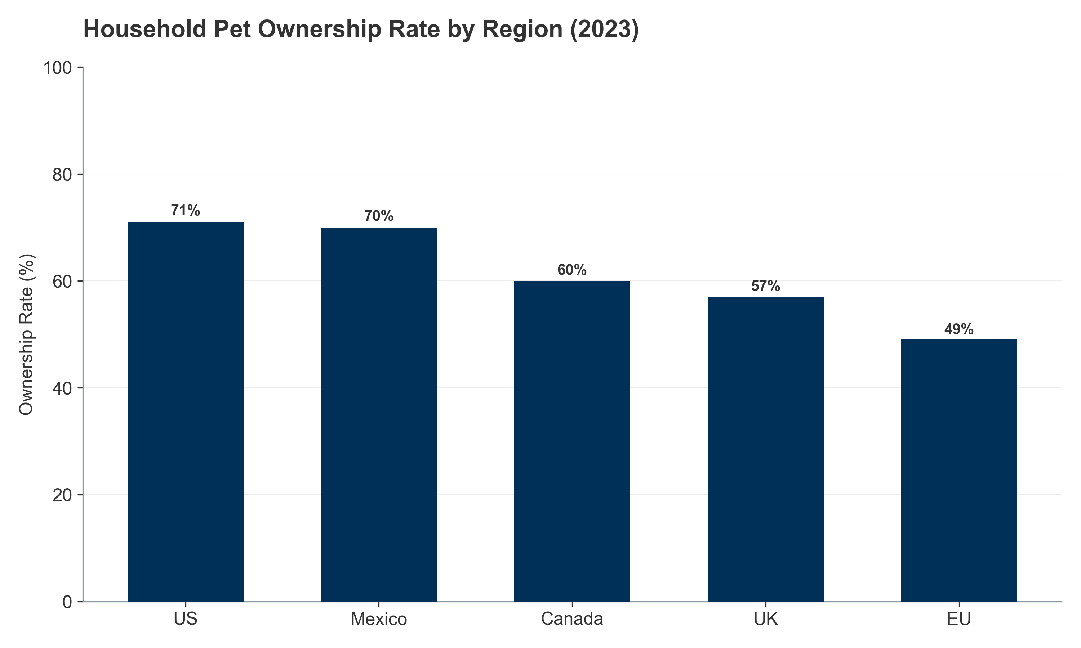

*Figure III.1: Global Pet Ownership Rates by Region (2023).*

##### III.1.1.2. European Union: The Cat Continent

Europe represents a highly diverse, cat-dominant market with significant regulatory frameworks guiding production and welfare.

Pet Population Structure:

According to FEDIAF 2025 data, the total pet population reached 281.5 million animals.

Feline dominance: The European population includes approximately 127 million cats compared to 104 million dogs, with cats representing 45% of the pet population.

Growth divergence (2018–2023): While the dog population has grown modestly by +5%, the cat population has surged by +11%, reflecting the shift toward smaller, apartment-friendly animals suitable for urban living.

Market Value:

Europe accounts for significant share of the global pet nutraceutical market, with market value estimated at USD 1.6–1.9 billion in 2024, growing at CAGR 6.0–6.5%.

The UK represents the largest European pet supplement market, valued at USD 250–300 million, with Germany and France accounting for USD 200–250 million each.

Regional Variance: Germany’s millennial and Gen Z population is driving notable growth in pet supplements, with pet wellness seen as a precursor to family formation.

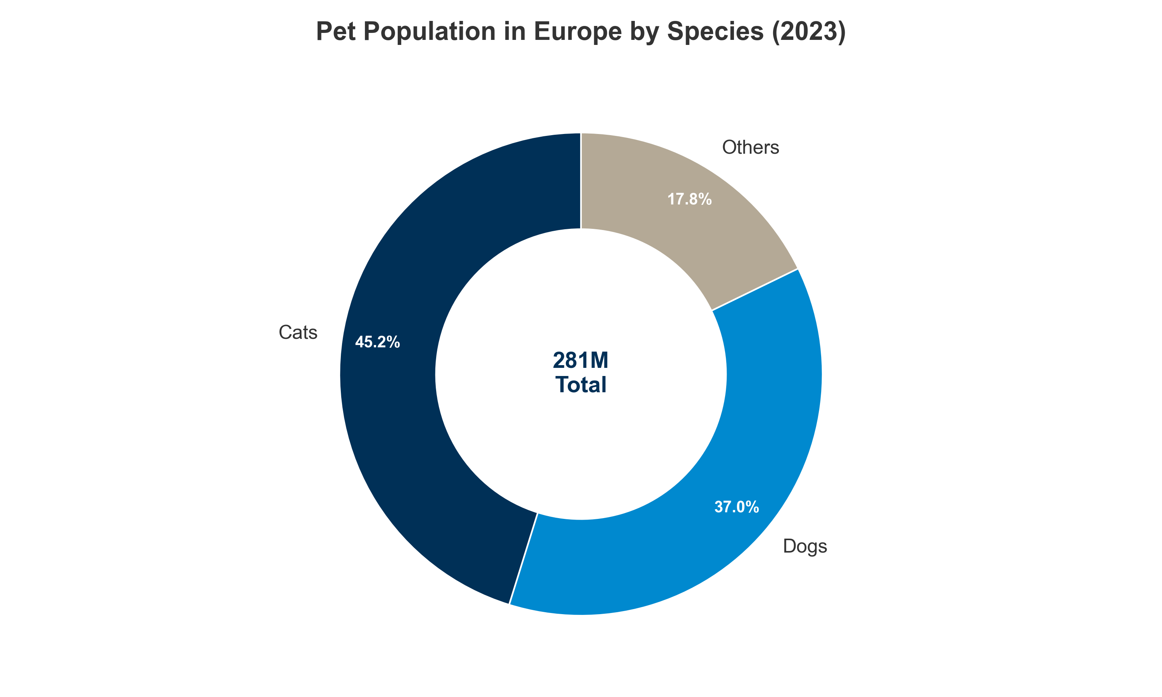

*Figure III.2: European Pet Population Structure: The dominance of cats.*

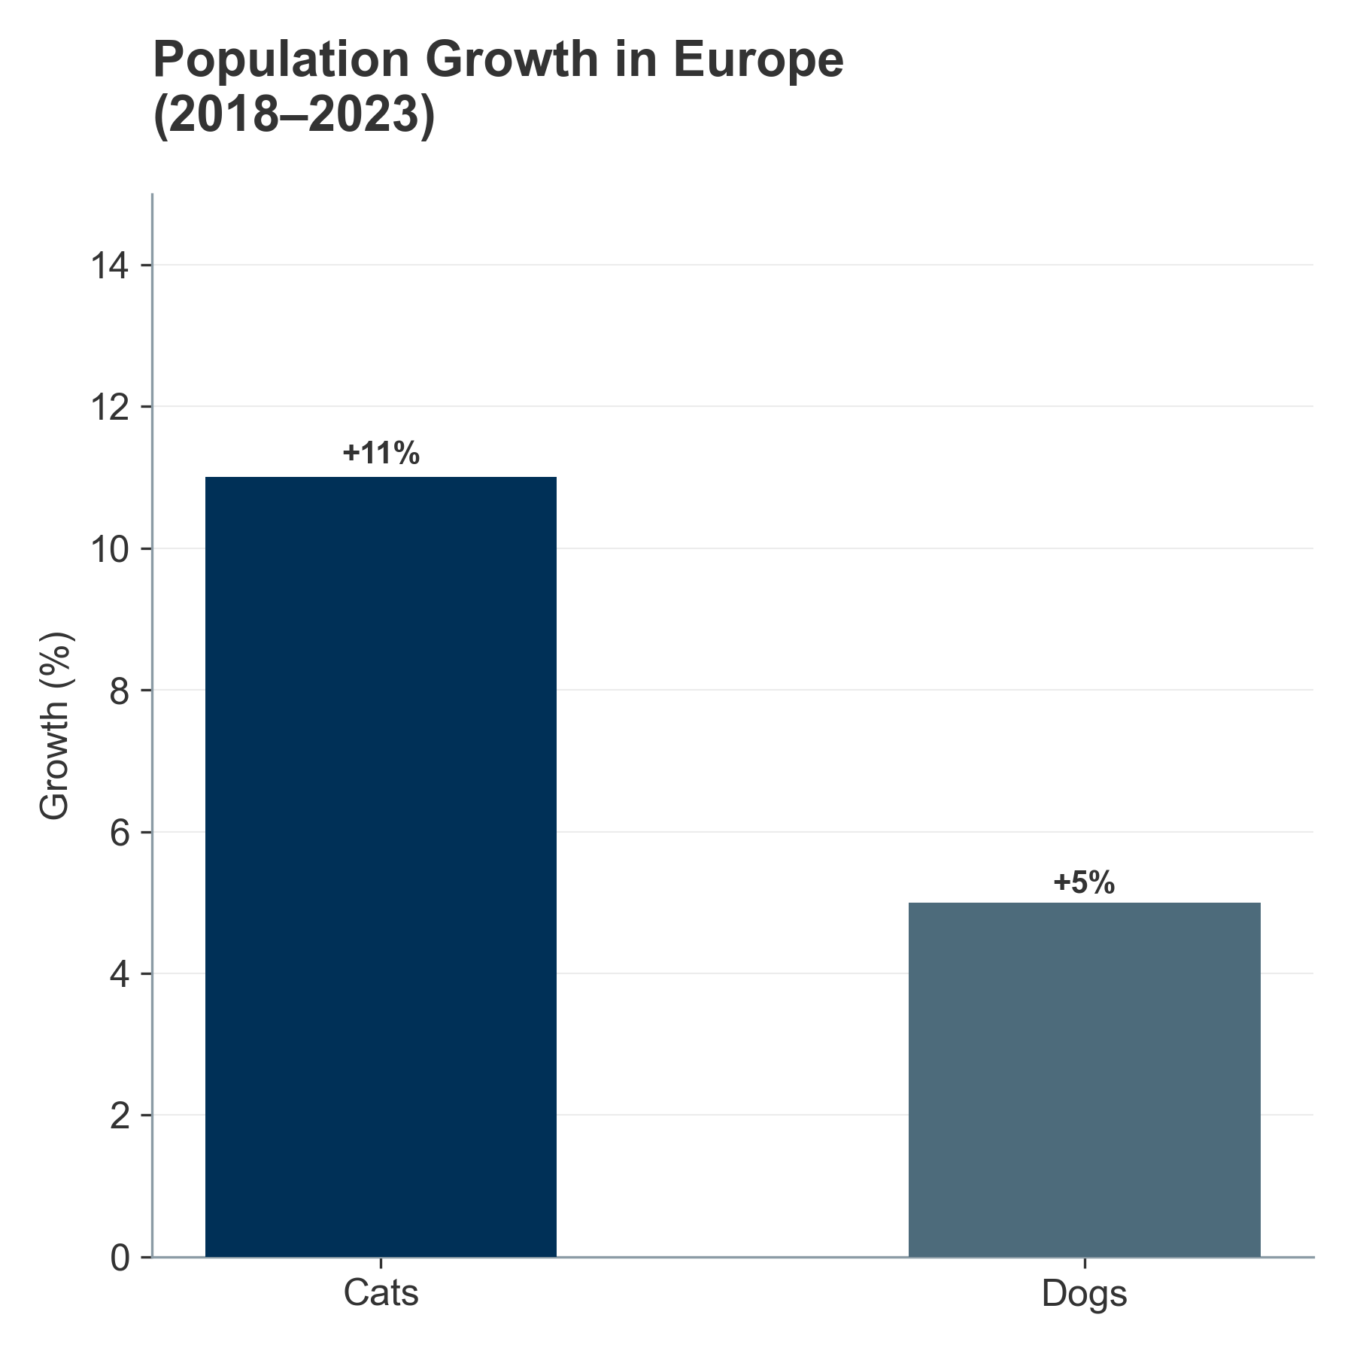

*Figure III.3: Comparative Growth Rates: Cats vs. Dogs (2018-2023).* ##### III.1.1.3. Asia-Pacific: The Growth Engines

APAC is the global engine of volume growth, characterized by rapid urbanization, income growth, and the “replacement child” phenomenon (pets as substitutes for human children in low-fertility environments).

China’s Historic Transformation:

In a historic shift, cats overtook dogs in China in 2024—71.5 million cats vs. 52.6 million dogs—driven by the demanding “996” work culture (9 AM–9 PM, 6 days per week), which favors independent pets that require less active engagement.

China’s pet market is valued at approximately USD 23–25 billion annually, with pet supplements representing USD 1.8–2.1 billion of this total.

The white paper by the China Pet Industry Association reported the combined dog-cat population at 100.8 million in 2020; updated estimates for 2024 suggest 124.1 million animals.

Latin America: Mexico & Brazil as High-Growth Engines:

Brazil: The world’s third-largest pet market with over 160 million pets, including 60 million dogs and a rapidly growing cat population (30 million). Brazil’s pet supplement market is valued at USD 400–500 million, growing at 7.5–8.5% CAGR.

Mexico: High ownership rates (70% of households) with a historically dog-centric market, but the cat population exploded by 41% between 2017 and 2022, signaling rapid modernization. Mexico’s pet supplement market reaches USD 250–300 million, with fastest growth in the urban, high-income segments.

India’s Emerging Opportunity:

India has one of the highest dog populations at 10.2 million, with a notably young demographic driving adoption. The Indian pet supplements market is nascent at USD 50–80 million but growing at 12–15% CAGR, the fastest rate globally.

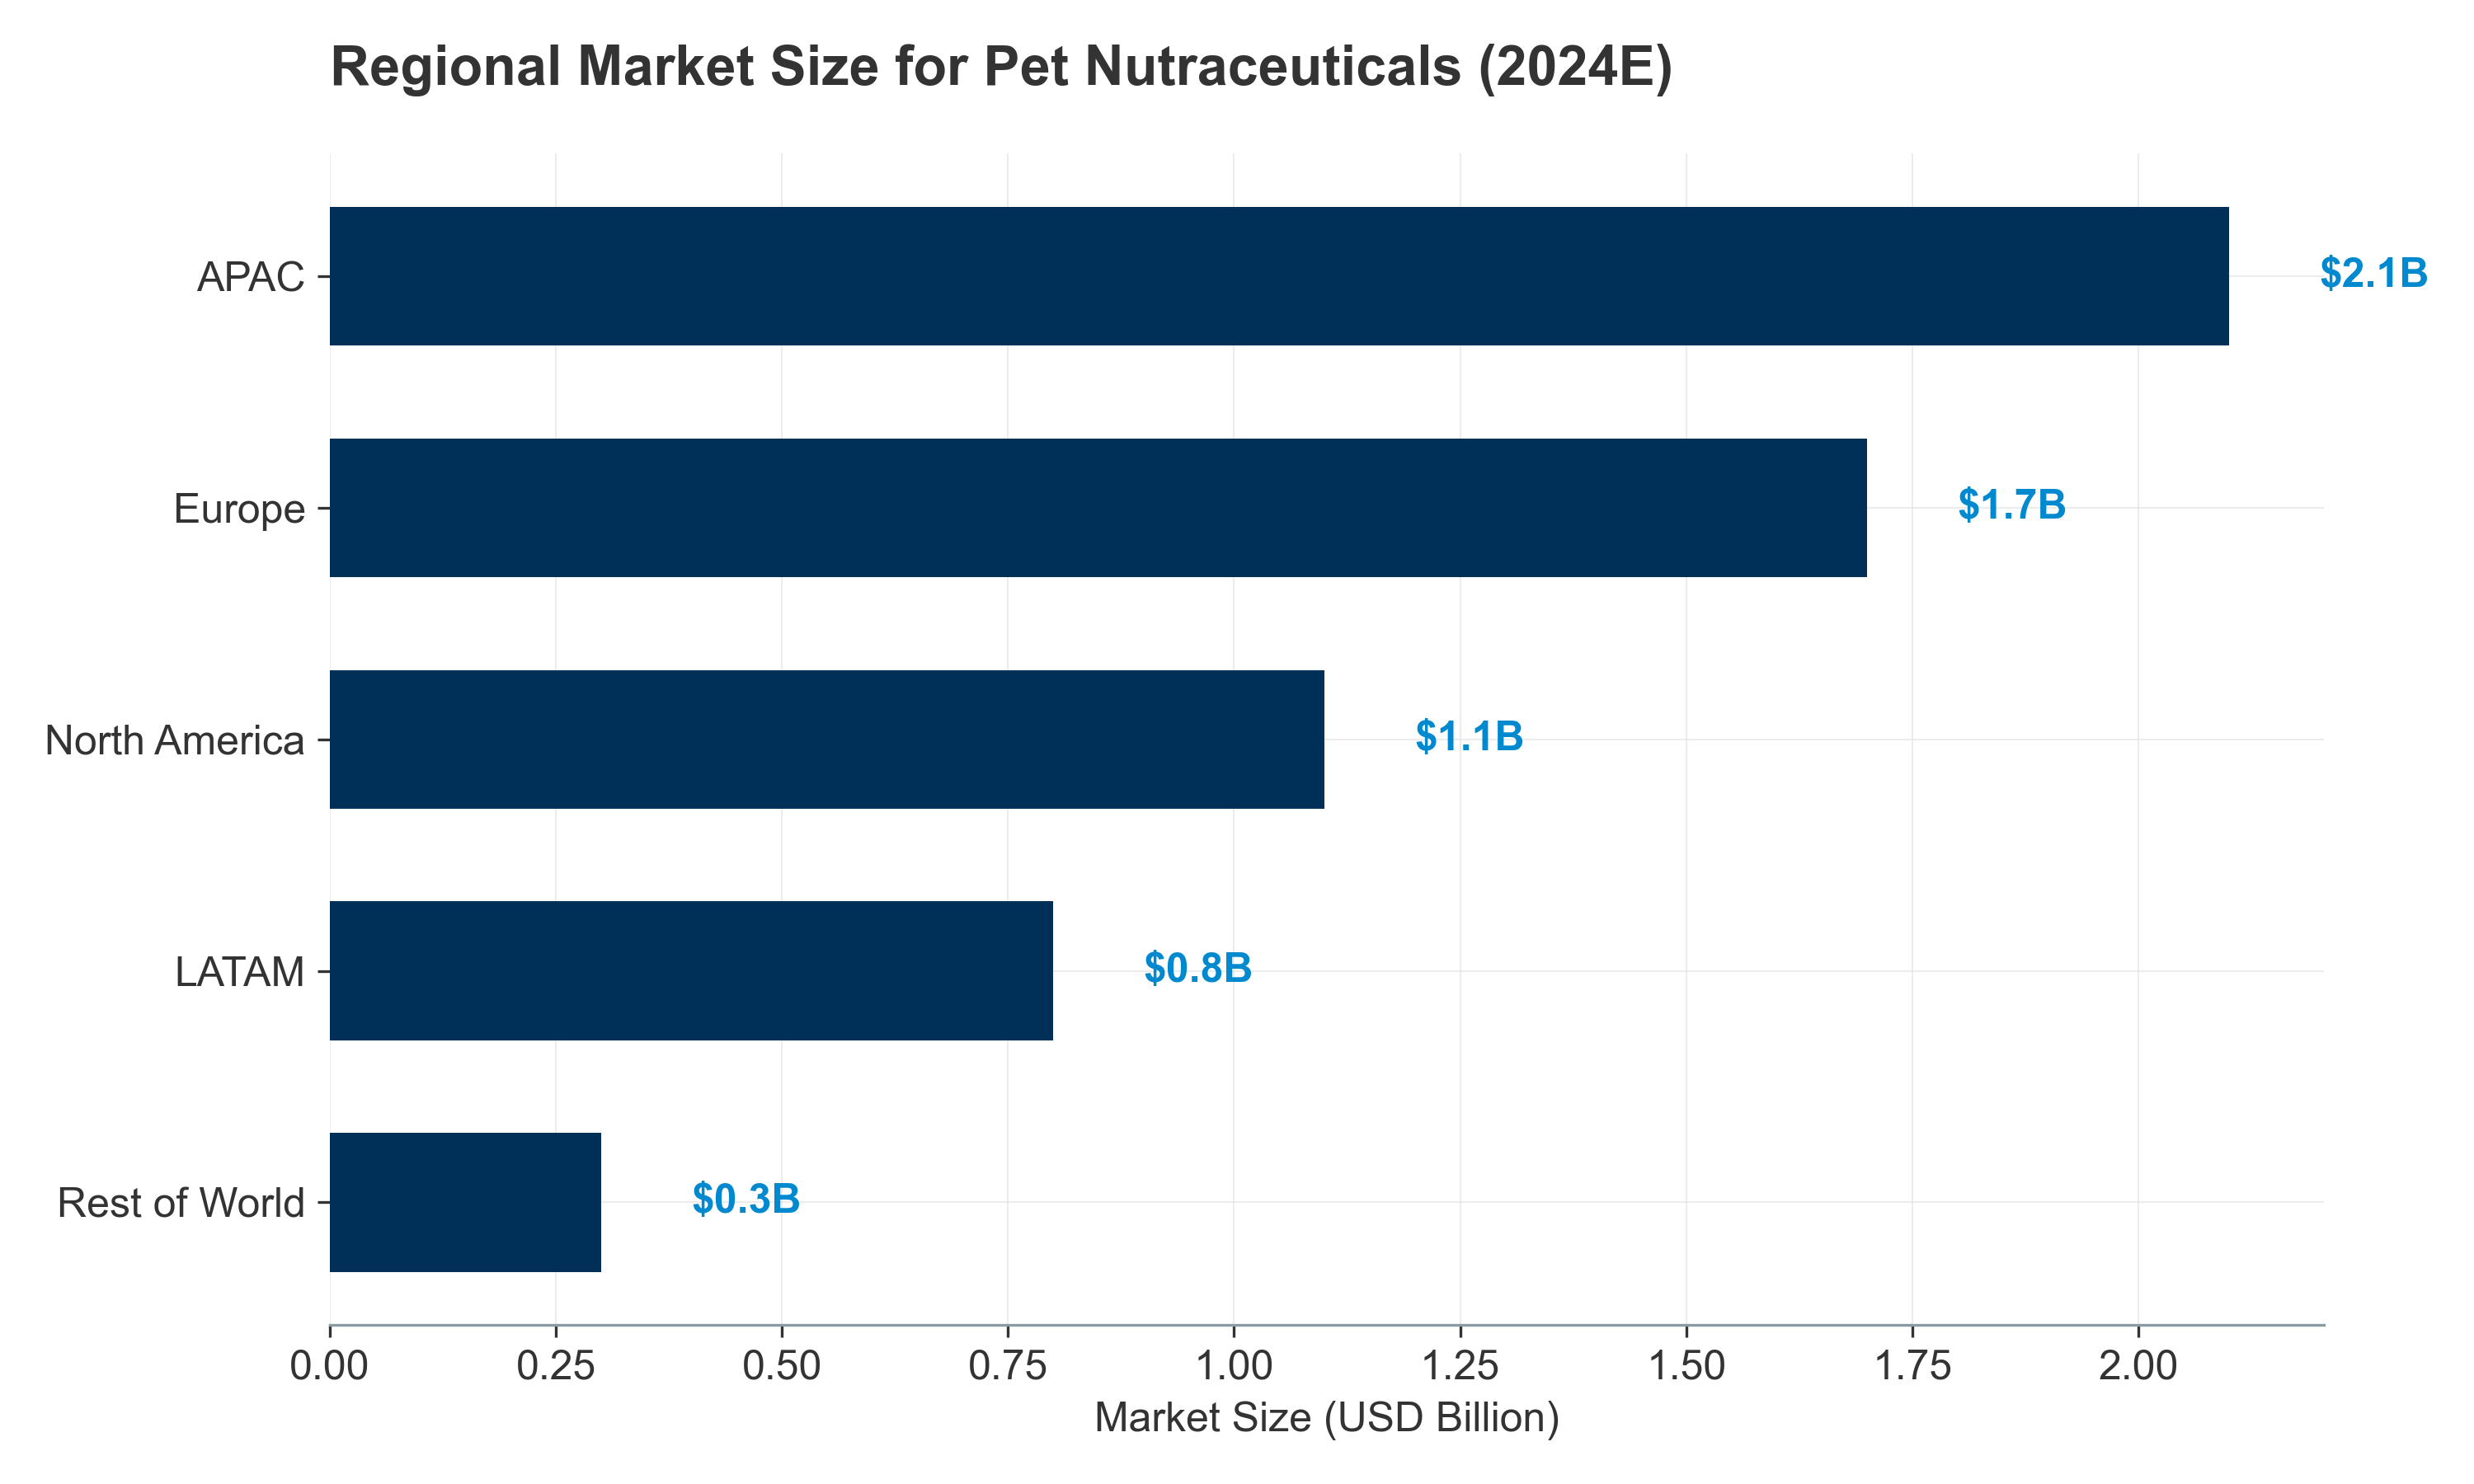

*Figure III.4: Regional Market Value Distribution (2024 Estimates).*

#### **III.1.2. Livestock Headcounts: The “Great Divergence”**

The industrial livestock and aquaculture sectors are navigating a complex bifurcated landscape defined by the “Great Divergence”: a structural contraction in Western herds (EU, US) driven by policy, climate, and input costs, contrasted with the relentless expansion of poultry and aquaculture globally to meet protein demand.

Overview: Species-Level Market Dynamics

In 2024, the largest livestock segment by specialty feed additive revenue was poultry. Within the specific “Feed Probiotics” category:

Poultry: 60% of global volume (~USD 2.4–2.6 billion of USD 4.1 billion market)

Swine: 25% of global volume (~USD 1.0–1.1 billion)

Ruminants: 10% of global volume (~USD 0.4 billion)

Aquaculture: 5% of global volume (~USD 0.2 billion)

The global animal probiotics market was valued at USD 4.1 billion in 2024 and is projected to reach USD 6.9–7.6 billion by 2030–2035, representing a CAGR of 8.0–10.2%.

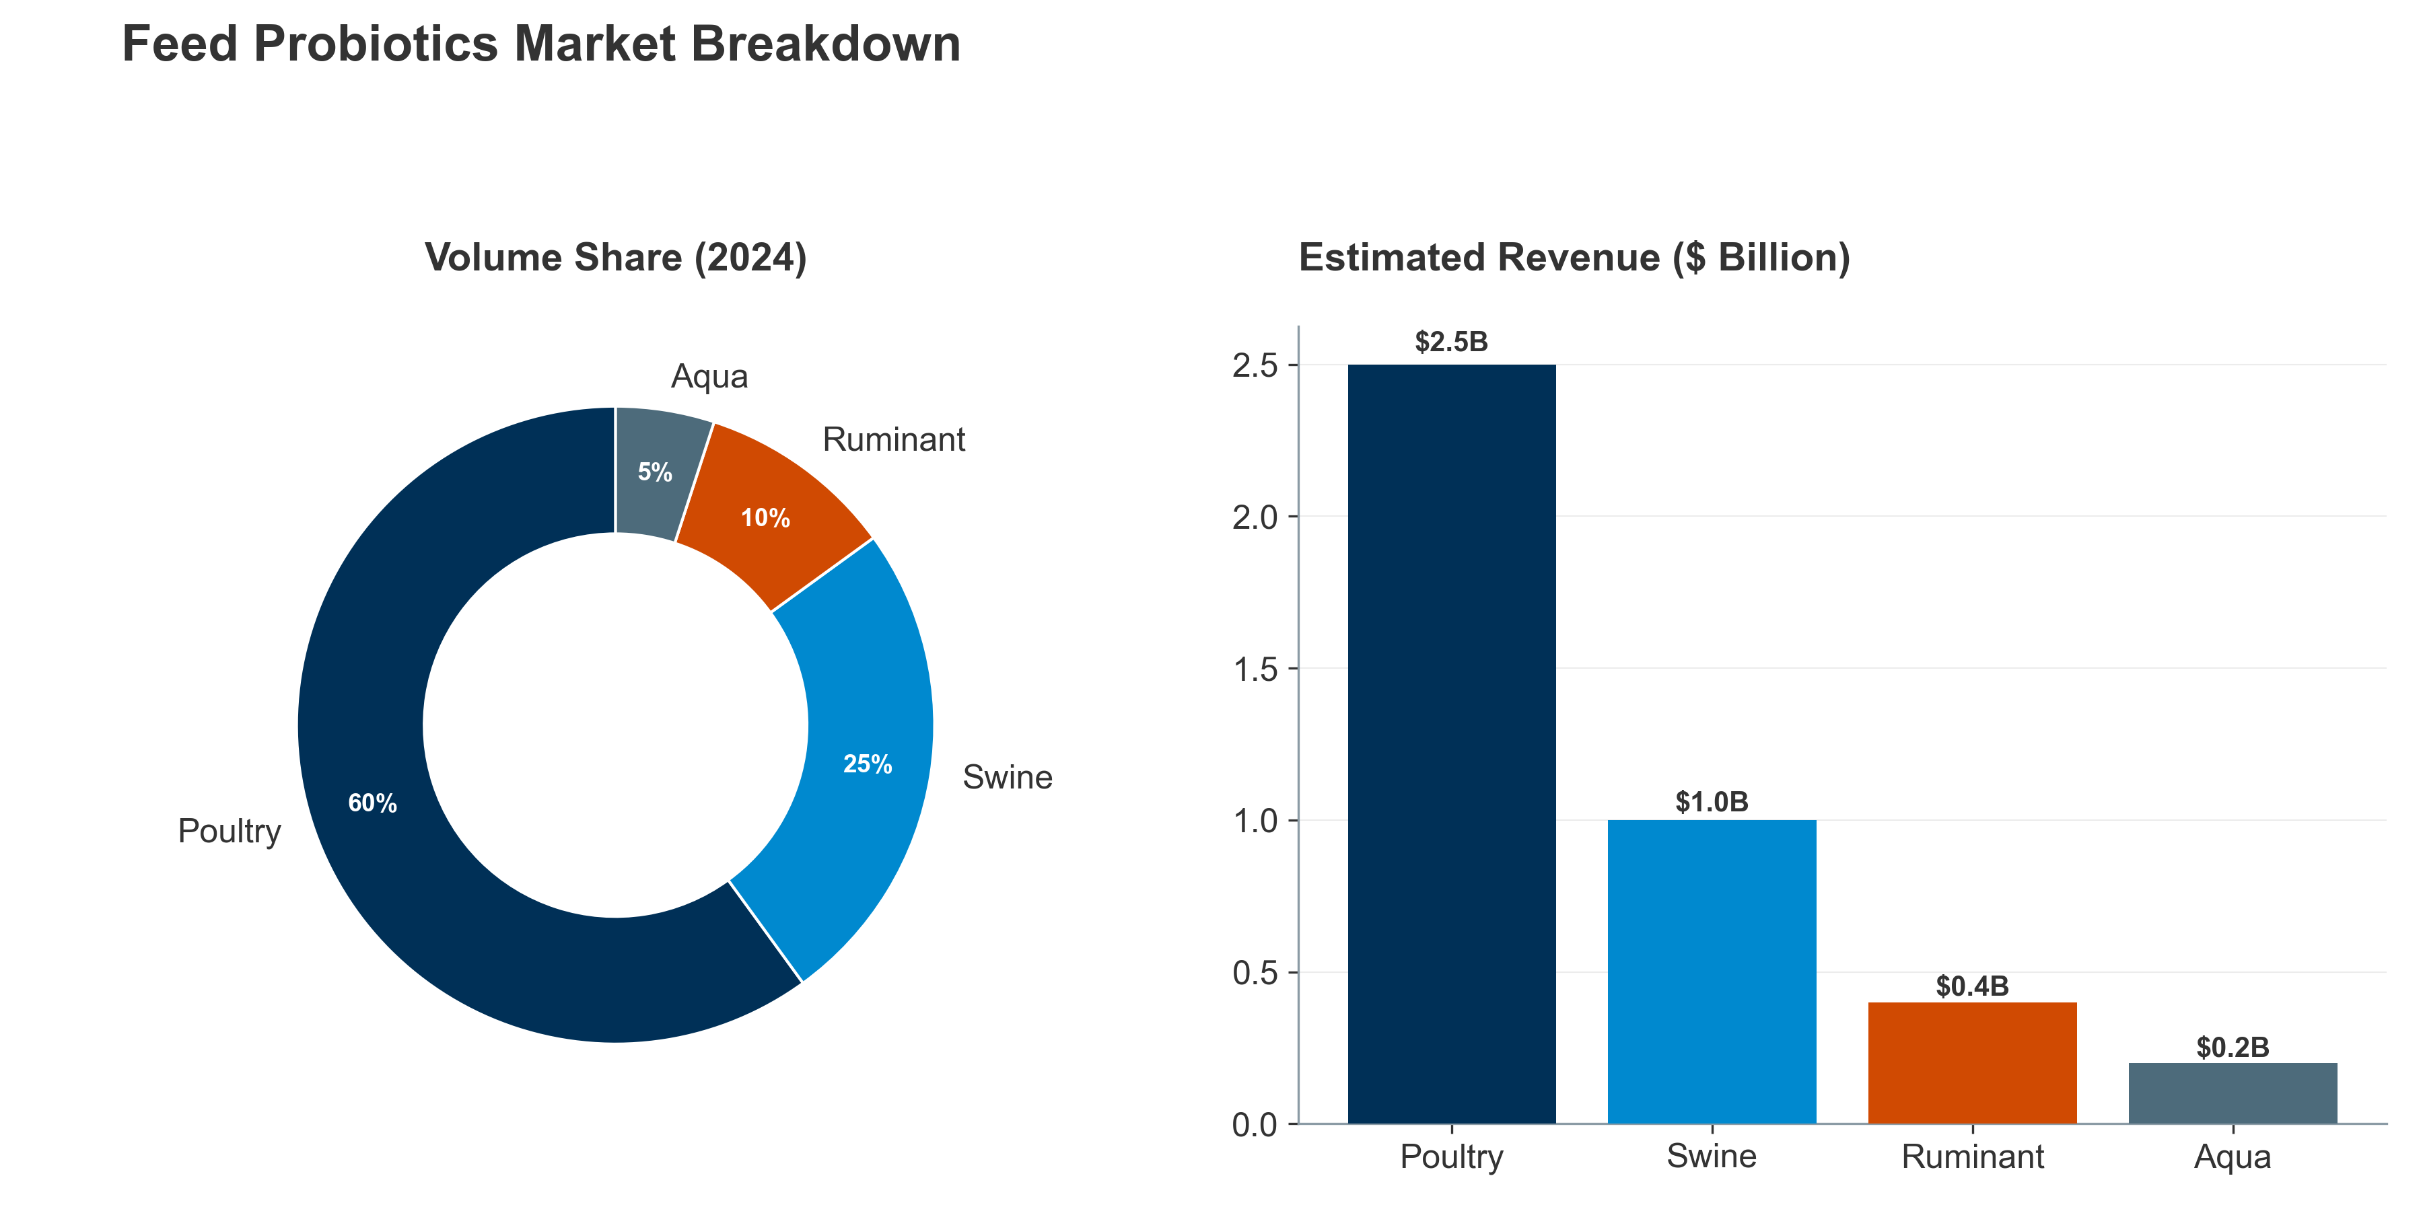

*Figure III.5: Comparative Probiotics Market Share: Volume vs. Revenue.* Poultry: The Engine of Growth

Poultry remains the primary driver of global meat production, which rose by 1.3% to 365 million tonnes in 2024. The sector’s dominance is evidenced by its 43.5% share of the global feed additives market, valued at USD 15.72 billion in 2024.

Market & Production Dynamics:

Global broiler production grows at 1.2–1.5% CAGR, with Asia (particularly China, Vietnam, and Thailand) accounting for 65% of global incremental growth.

The poultry feed additives sub-segment (including probiotics, enzymes, and organic acids) is valued at USD 6.8 billion in 2024, expected to reach USD 9.2 billion by 2030 (CAGR 5.0%).

The HPAI Constraint – A Tail Risk: This expansion faces the viral constraint of Highly Pathogenic Avian Influenza (HPAI). Between 2005 and 2024, HPAI caused the loss of over 633 million poultry globally, creating recurring demand shocks and justifying investment in biosecurity, vaccination, and immune-support probiotics. The 2024 HPAI season alone resulted in culling of 40–50 million birds across major production regions.

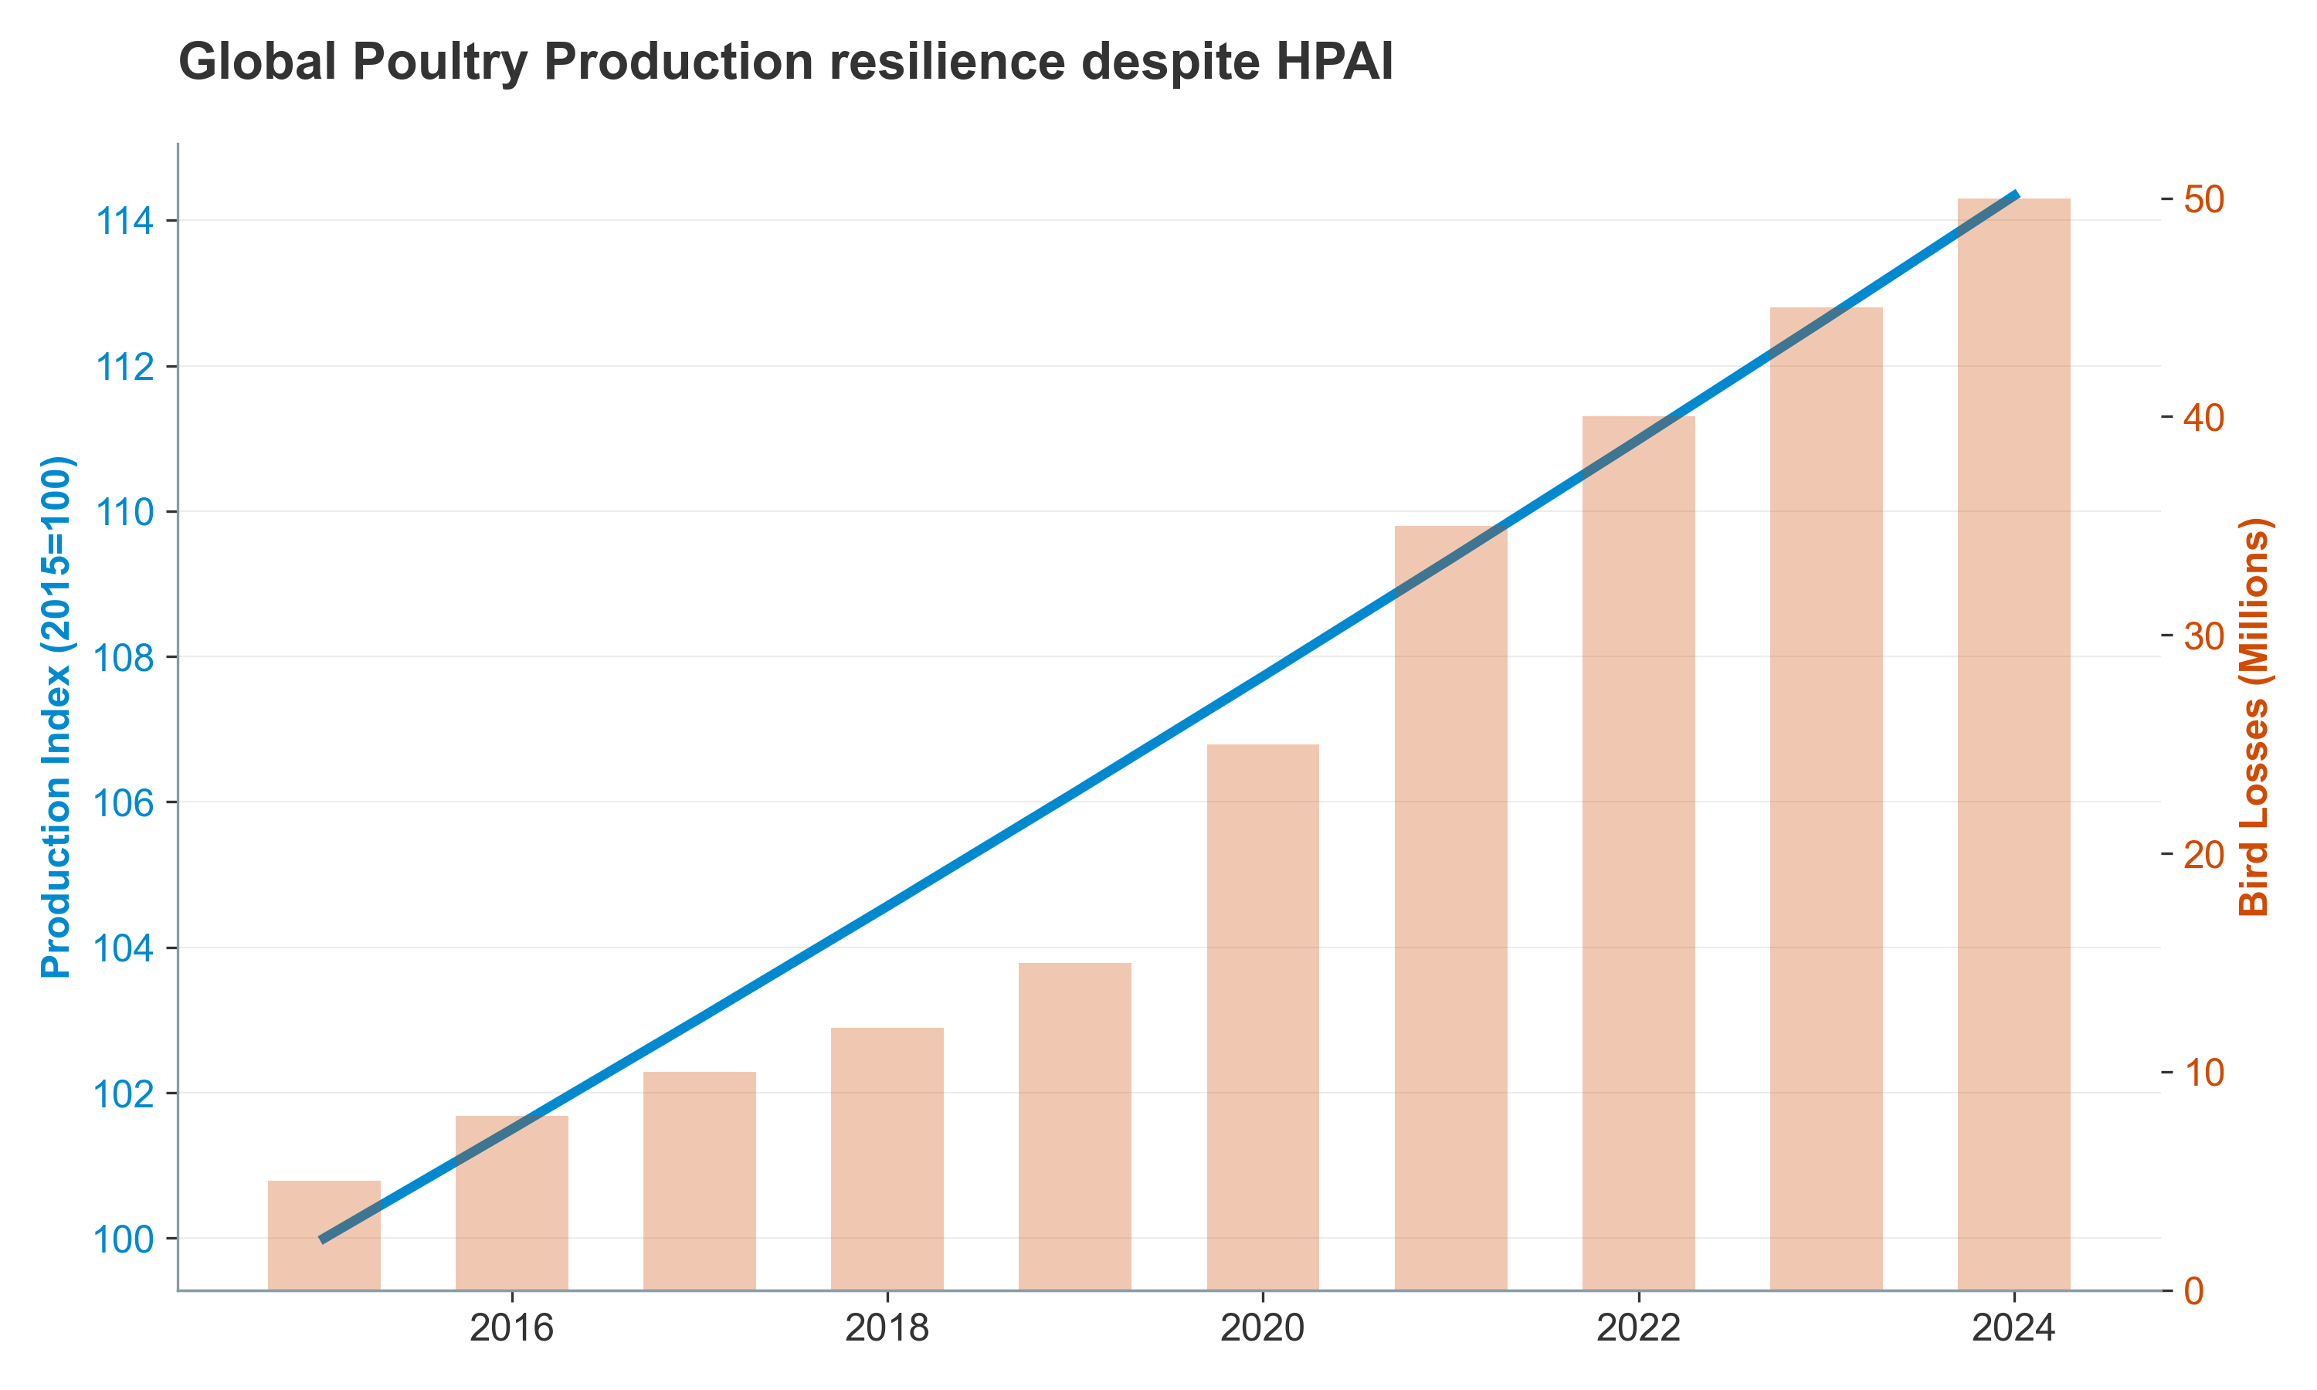

*Figure III.6: The impact of HPAI outbreaks on global poultry production (2015-2024).* Swine: Structural Contraction in the West, Volatility in Asia

The swine sector is characterized by contraction in the West and volatility in Asia.

Western Contraction:

European Union: The EU pig population fell to 132 million head in 2024, a 0.5% annual drop and an 8.1% decline compared to 2014, driven by nitrogen limits under the Nitrates Directive, input cost inflation, and lower feed-conversion margins.

United States: The US swine inventory stands at 74.5 million head, down 3.2% YoY from 2023, reflecting profitability pressures from rising feed costs and lower pork prices.

Economic Impact: The swine feed additives market in Western regions is declining at 0.5–1.0% CAGR, but this is offset by growth in probiotics aimed at post-weaning diarrhea (PWD) prevention, a high-margin application.

Asian Volatility:

China: The swine herd recovered to 405–410 million head by 2024 (up from a low of 300 million in 2018 post-ASF), but volatility remains high due to cyclical dynamics and renewed ASF outbreaks in peripheral regions.

Vietnam & Thailand: Growing producers, expanding at 4–6% annually.

Market Size: The global swine feed additives market is valued at USD 4.2 billion in 2024, expected to grow to USD 5.1 billion by 2030 (CAGR 3.5%), with probiotics and enzymes as the fastest-growing sub-segments.

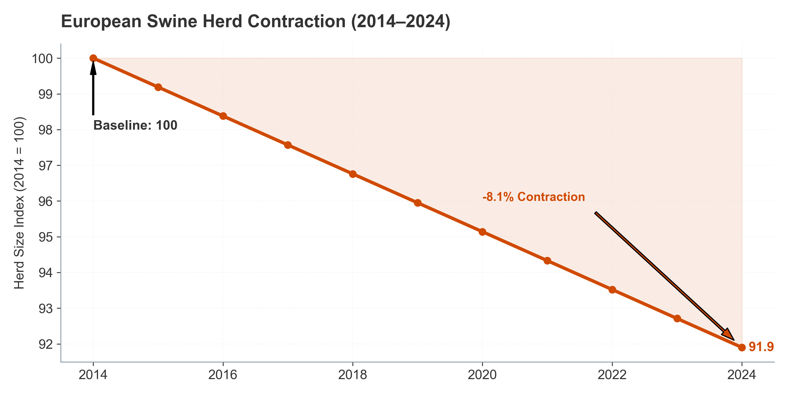

*Figure III.7: Structural decline in EU swine herds driven by regulatory pressure (2014-2024).* Cattle: Historic Liquidations

The cattle sector faces unprecedented liquidation in the West.

United States – A 73-Year Low:

The US cattle inventory collapsed to 87.2 million head on January 1, 2024, the lowest level since 1951.

Heifer retention fell to 4.86 million head, down 1.0% YoY, indicating herd rebuilding has not begun despite strong fed cattle prices.

Causation: Extreme drought in the Western US (2020–2023), high forage costs, and input price inflation drove culling, particularly of breeding females.

Outlook: Herd rebuilding is unlikely before 2026–2027, as profitability remains compressed by high feed costs.

European Union – Persistent Decline:

The EU bovine population dropped to 72 million head in 2024, a 2.8% decrease from the previous year and an 8.7% decline over the last decade.

Causation: EU policies promoting rewilding, peatland restoration, and reduced GHG targets have incentivized herd reduction.

Growth Opportunities in Decline: Despite the contraction, the “value per head” is rising. The industry is pivoting to “Low Carbon Beef” verification, driving demand for: * Methane Reducers: 3-NOP and bromoform (Asparagopsis) to lower enteric emissions. * Ruminal Efficiency Tools: Yeast cultures and essential oils to maximize energy extraction from expensive forage, ensuring profitability even with smaller herds.

Global Implications:

The global beef cattle market contracted by 2.1% in 2024, with developed regions accounting for 95% of the contraction.

Conversely, developing regions (Latin America, India, Sub-Saharan Africa) are experiencing modest growth of 1.5–2.5% CAGR, but from much lower base productivity levels.

Market Size for Cattle Feed Additives & Probiotics:

Valued at USD 2.8 billion globally in 2024, projected to decline slightly to USD 2.6–2.7 billion by 2030 (reflecting Western herd decline), offset partially by modest growth in developing regions.

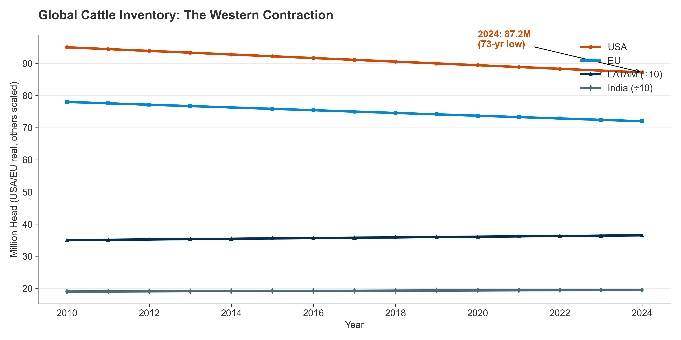

*Figure III.8: The “De-Ruminization” of Europe: Cattle inventory trends.*

The following table and visualization capture the divergent trajectories in Europe, highlighting the “de-ruminization” of the continent—the structural decline of ruminant farming and its replacement by poultry.

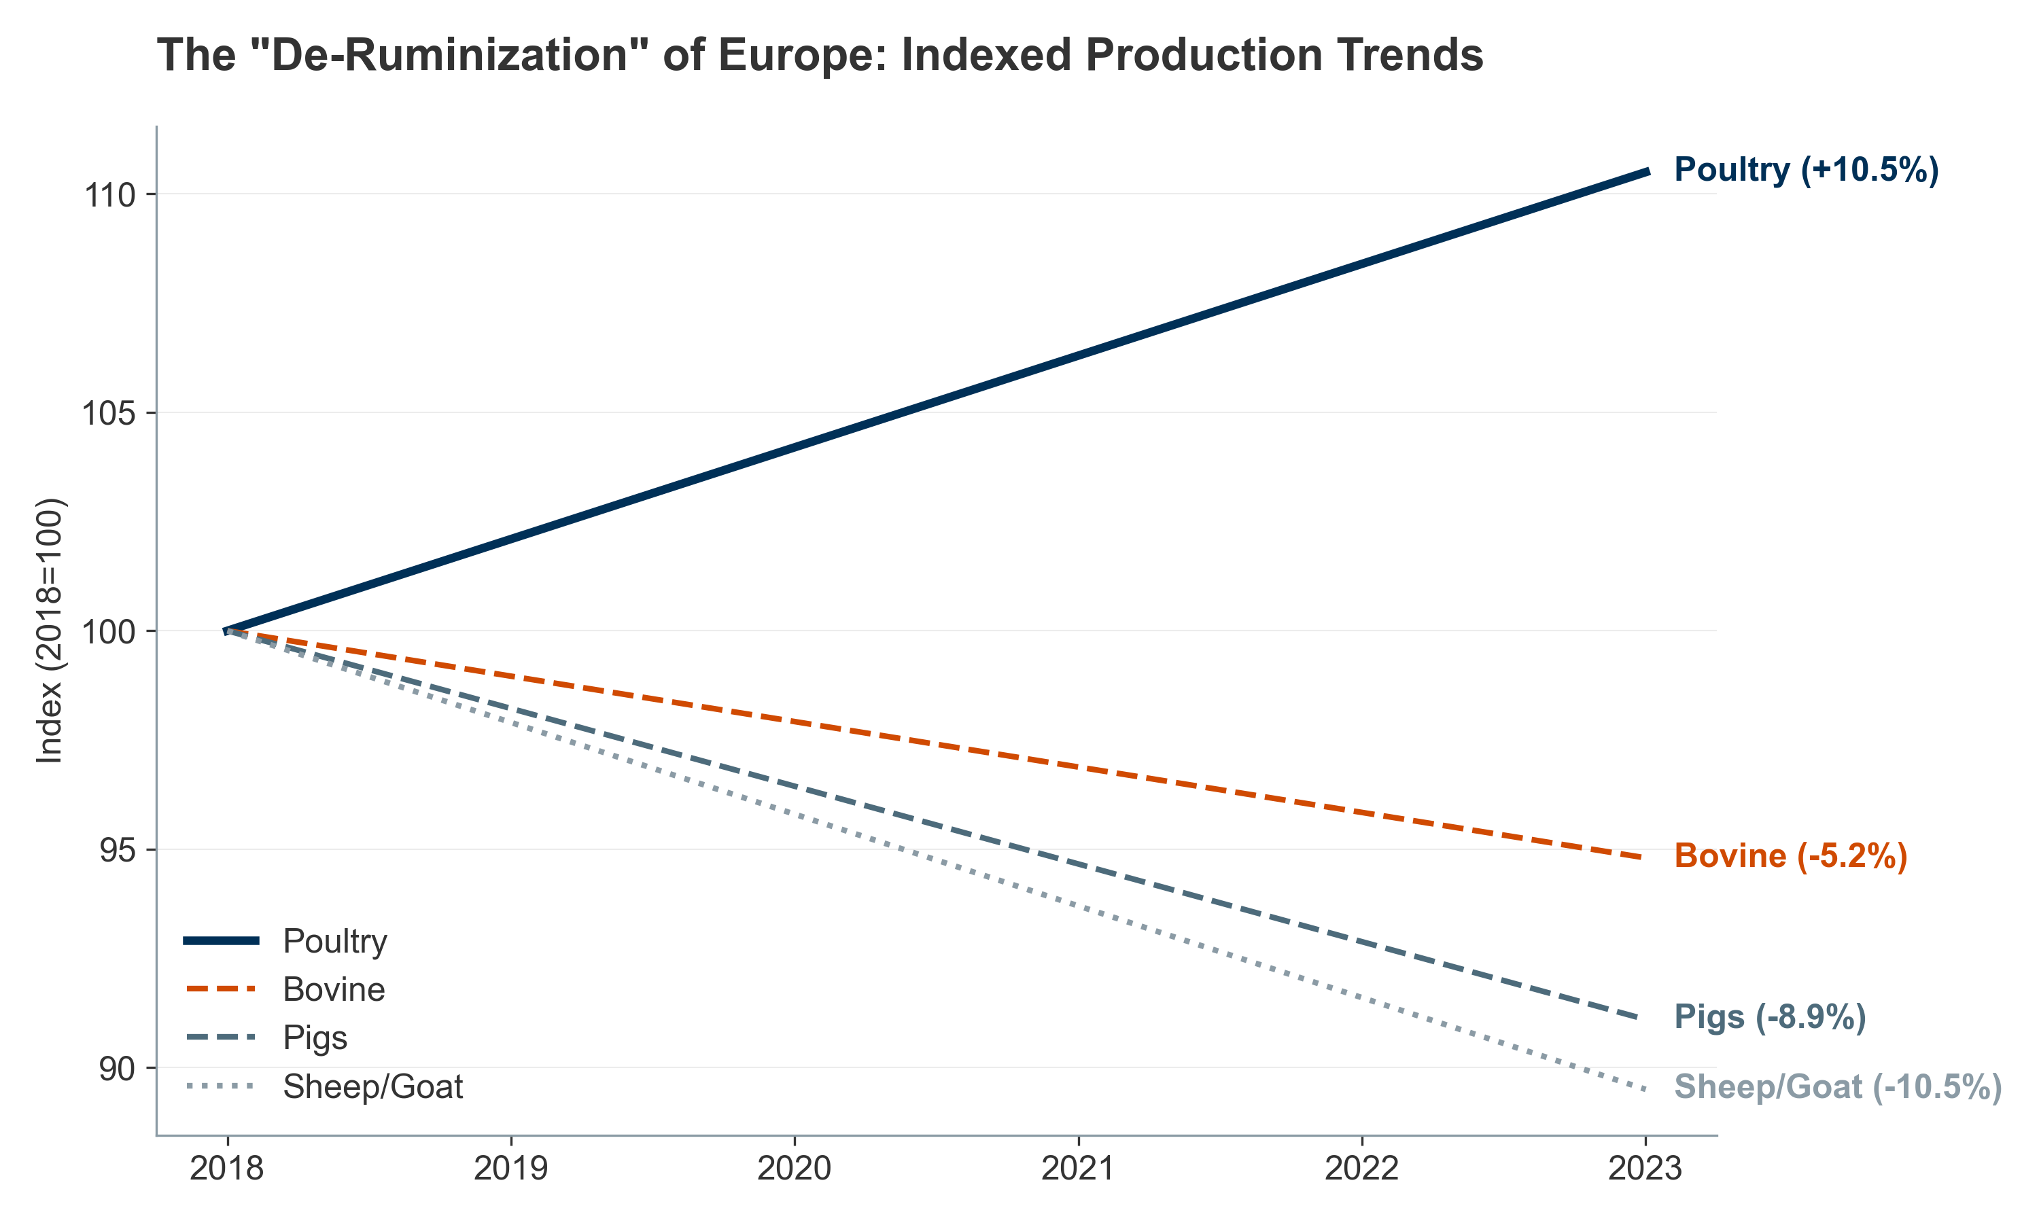

*Figure III.9: Global livestock production trends: The rise of poultry and aquaculture vs. ruminant limits.*

#### **III.1.3. Aquaculture: The “Blue Revolution”**

Aquaculture has officially surpassed capture fisheries as the primary source of aquatic food, a milestone FAO describes as the “Blue Transformation.” This sector is not just growing; it is industrializing, moving from open ponds to high-tech controlled environments.

Species Diversification: Mitigating Monoculture Risk

To mitigate biological risks associated with monocultures (e.g., salmon sea lice, disease outbreaks), the industry is diversifying species and production methods.

Current Production Leaders:

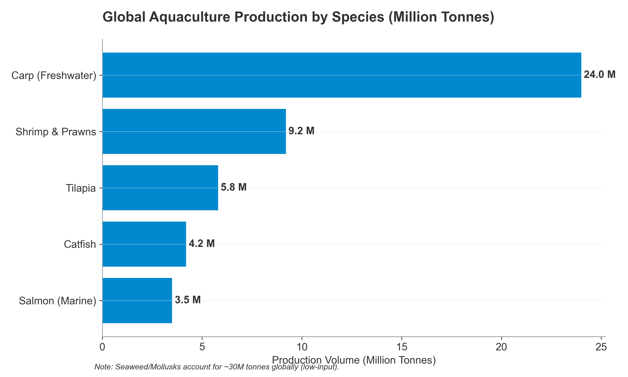

*Figure III.11: Global Aquaculture Production by Key Species (Million Tonnes).*

Emerging Diversification:

Mangrove Red Snapper, Grouper, and Seriola (Yellowtail) are gaining traction as premium species for high-value markets.

Seaweed and mollusk farming (particularly in APAC) are expanding as low-input alternatives, accounting for ~30 million tonnes globally.

Probiotics & Nutraceuticals in Aquaculture:

The aquaculture probiotics sub-segment is valued at USD 200–250 million globally in 2024, growing at 10–12% CAGR, making it the fastest-growing livestock probiotics segment due to high mortality rates and disease sensitivity in high-density systems.

The FAO’s “Blue Transformation” Strategy: The FAO’s strategy underpins this diversification, focusing on:

Alternative feeds to decouple production from wild forage fish (fishmeal and fish oil)

Inland and coastal aquaculture to reduce pressure on capture fisheries

Selective breeding to improve feed conversion and disease resistance

Probiotics and functional feed additives to reduce antibiotic reliance

**Technological Drivers: RAS and Feed Replacement**

* **Recirculating Aquaculture Systems (RAS):** The shift to land-based RAS allows for total environmental control but creates a unique “microbial engine” challenge. These systems require specialized probiotics not just for the fish, but for the biofilters, to prevent toxic ammonia spikes and off-flavor compounds (geosmin).
* **Feed Replacement:** As the industry replaces fishmeal with insect protein and plant isolates, digestibility becomes the limiting factor. This drives the market for “Feed Enzymes” (proteases, phytases) specifically calibrated for carnivorous species like salmon, ensuring they can absorb these novel proteins without gut inflammation.

#### **III.1.4. Intensification and Stress Landscapes: The Biological Drivers of Nutraceutical Adoption**

Meeting global protein demand requires high-density production systems that push animals to their physiological limits, creating distinct “stress landscapes” that directly drive the adoption of nutraceutical and probiotic solutions. These stress factors represent non-discretionary, essential add-ons to modern animal agriculture—not luxuries.

Physiological Cost of Intensification

Oxidative Stress and ROS:

High-performing animals in intensive systems experience elevated metabolic rates (up to 20–30% above historical baselines), generating excessive Reactive Oxygen Species (ROS).

ROS damages cellular membranes, mitochondria, and DNA, reducing feed efficiency and increasing disease susceptibility.

Antioxidant supplements (vitamins E & C, selenium, beta-carotene) are now standard in broiler rations, adding USD 150–250 million annually to global feed additive demand.

Heat Stress Across Species:

Rising global temperatures cause “leaky gut” in cattle and swine, permitting translocation of endotoxins and triggering chronic inflammation.

In aquaculture, heat stress causes “oxygen squeeze” in closed or semi-closed systems, reducing dissolved oxygen and triggering disease outbreaks.

Climate variability is driving a secular increase in probiotics and antioxidants, with demand projected to rise 8–10% annually in warm-climate regions.

The Paradox of Precision Livestock Farming (PLF)

Precision Livestock Farming (PLF) tools (sensors, AI-driven monitoring, automated feeders) have enabled producers to manage massive herds efficiently. However:

PLF optimizes production efficiency (feed-to-gain ratio, milk yield, egg production) while sometimes entrenching the very intensive practices that cause stress.

The result: even better-monitored animals remain immunologically challenged, creating a structural, recurring demand for immune-support nutraceuticals and probiotics.

This paradox ensures that probiotics and functional supplements represent a structural, non-cyclical cost in modern animal agriculture—similar to antibiotics historically, but with better regulatory acceptance and premium pricing potential.

### **III.2. Urbanization, Administration, and Decision Pathways**

#### **III.2.1. The Impact of Urbanization on Nutraceutical Formats and Administration**

Urbanization correlates strongly with smaller living spaces, smaller pets, and fundamental shifts in supplement administration preferences. These format preferences determine which product types and distribution channels dominate regional markets, directly impacting the financial performance of nutraceutical suppliers.

Format Popularity by Species: A Stark Divide

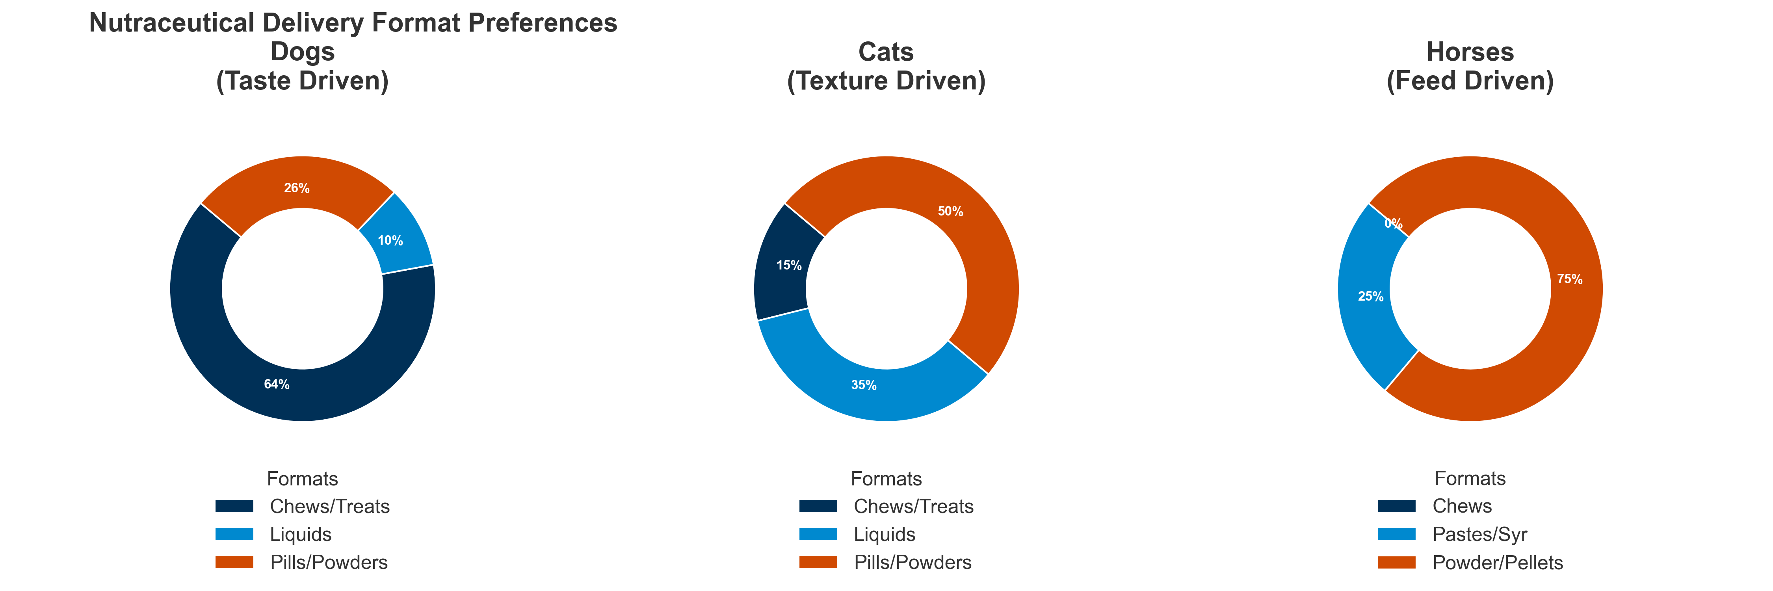

*Figure III.10: Formats by Species: The split between palatability (Pets) and efficiency (Livestock).*

Data on “Nutraceutical Format Popularity” reveals a dramatic species-specific split, reflecting physiological and behavioral differences:

Dogs – The Palatability Premium:

Soft Chews: 39% of market share (representing approximately USD 420–480 million globally, based on ~USD 1.1–1.3 billion dog supplements market)

Treats (functional): 25% (USD 275–325 million)

Powders: 20% (USD 220–260 million)

Liquids/Pastes: 10% (USD 110–130 million)

Pills/Tablets: 6% (USD 66–78 million)

Behavioral Driver: Urban dog owners treat supplements as a “bonding moment,” necessitating high palatability. Soft chews and functional treats drive repeat purchase and premium pricing (USD 25–60 per month per dog vs. USD 10–20 for pills).

Cats – The Palatability Challenge:

Liquids/Pastes: 35% (USD 140–170 million in global cat supplements market of USD 400–500 million)

Powders: 30% (USD 120–150 million)

Tablets/Pills: 20% (USD 80–100 million)

Treats: 10% (USD 40–50 million)

Chews: 5% (USD 20–25 million)

Behavioral Driver: High rejection of solid pills drives the market toward liquids and powders that can be mixed invisibly into wet food. Cat owners exhibit significantly lower WTP for premium formats, with median spend of USD 12–18 per month.

Horses – The Equine Divergence:

Powders/Pellets: 60% (USD 180–220 million in horse supplements market of USD 300–370 million)

Oral Syringes: 20% (USD 60–74 million)

Injectable: 15% (USD 45–55 million)

Pastes: 5% (USD 15–18 million)

Behavioral Driver: Equine supplements leverage feed top-dressing for convenience and oral syringes for acute performance dosing (pre-competition, post-injury).

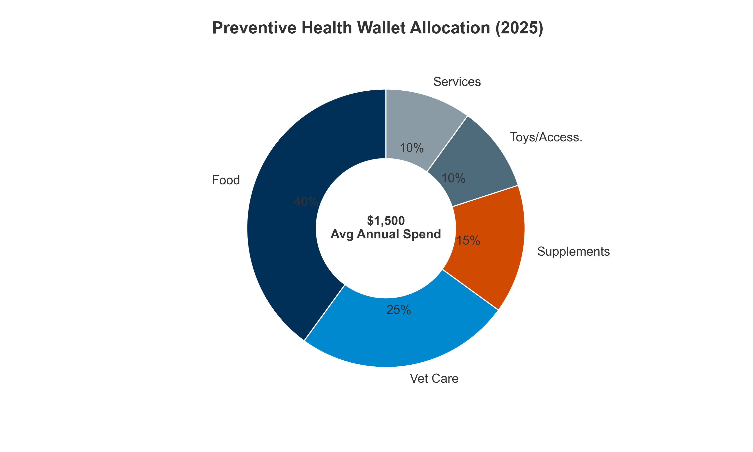

### **III.3. The Economics of Adoption: Determining Willingness-to-Pay (WTP)**

#### **III.3.1. Pet Ownership: Share of Wallet & Psychology**

*Figure III.11: The “Preventive Health Wallet”: Share of spend.*

The “Pet Humanization” trend has fundamentally reshaped how owners allocate disposable income. The total annual pet spending per household in North America ranges from USD 800–2,500, depending on ownership demographics and pet age.

Breakdown of the “Preventive Health Wallet”

For a typical, proactive US pet owner spending USD 1,500 annually on pet care:

Sources:

Nicotra, M., et al. (2025) – “Nutraceuticals, Social Interaction, and Psychophysiological Influence on Pet Health and Well-Being: Focus on Dogs and Cats.” Veterinary Sciences 12.10: 964.

Dechra Pharmaceuticals PLC – “Annual Report and Accounts for the year ended 30 June 2023”

Critical Insight: Nutraceuticals have surpassed toys and accessories in the allocation hierarchy, indicating that owners prioritize longevity over entertainment—a structural shift that has implications for product positioning and premiumization.

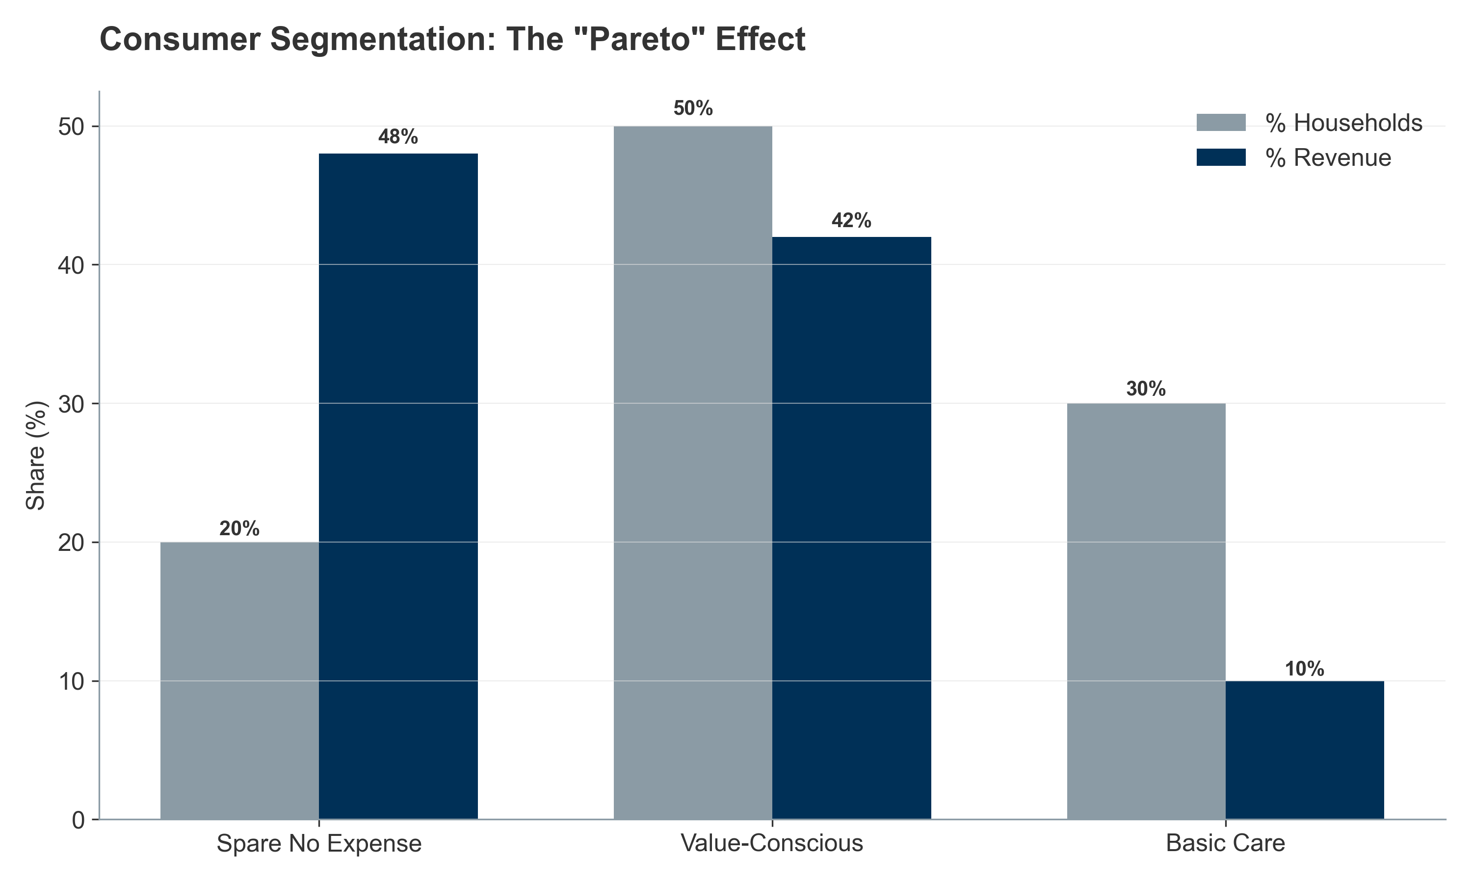

*Figure III.12: The “Pareto Principle” in Pet Care: High-spending households drive revenue concentration.* Psychological Factors Influencing WTP: The Fear of Loss

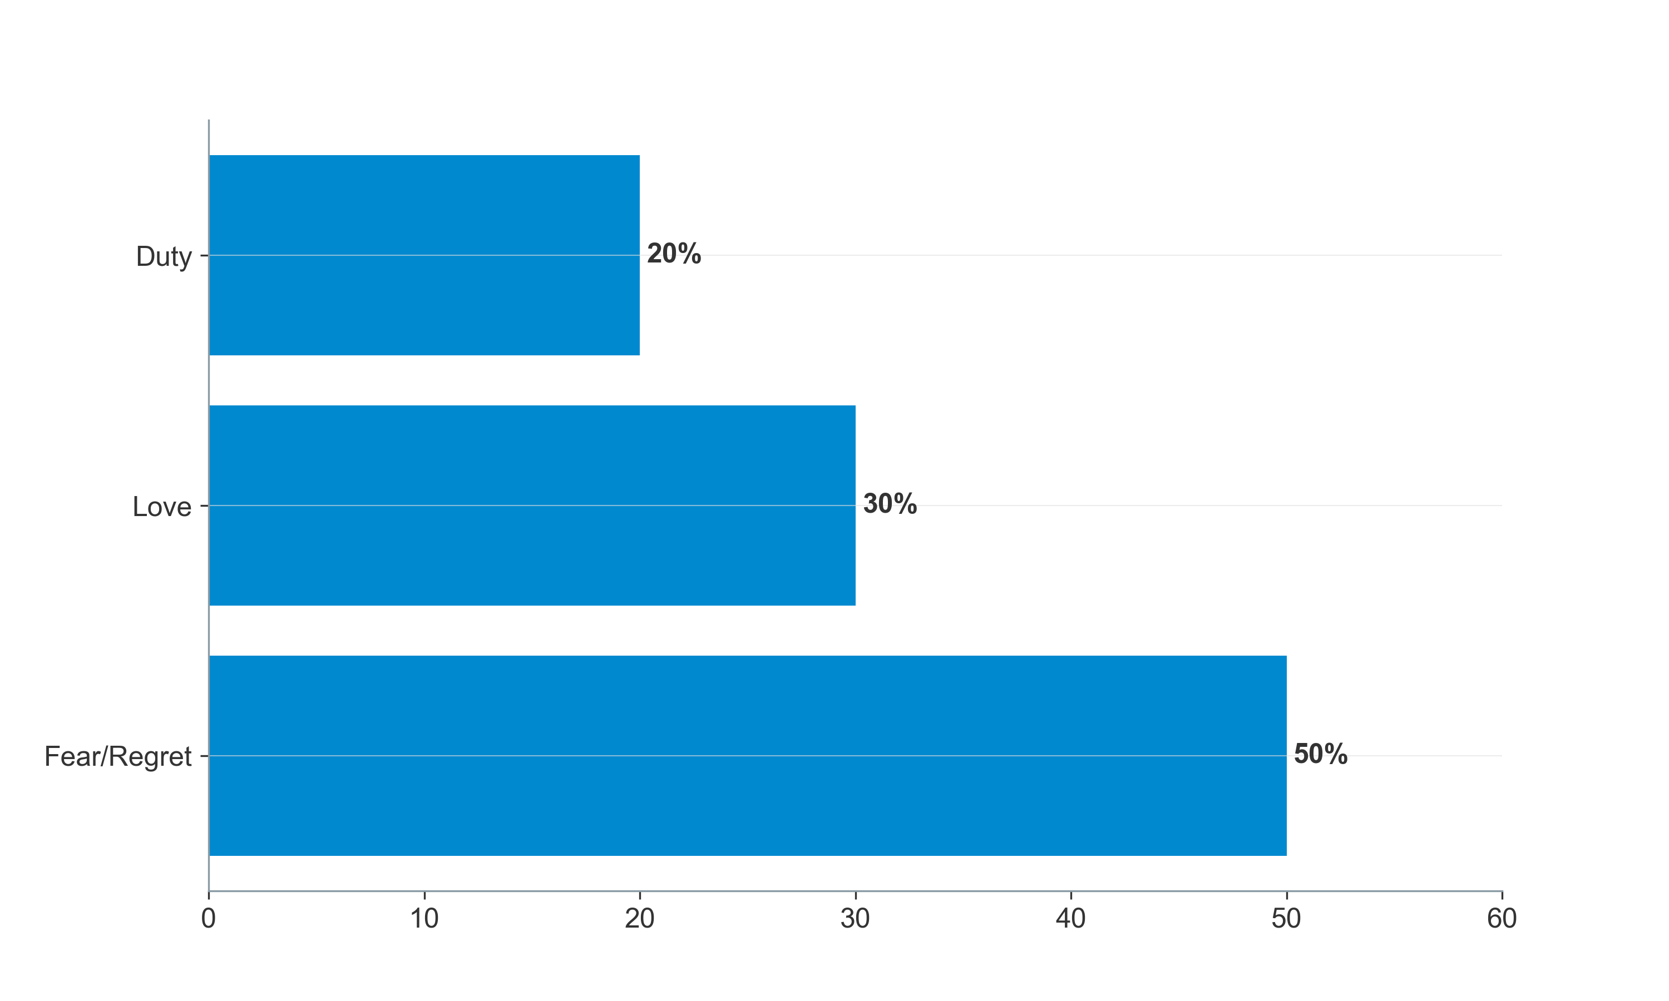

*Figure III.13: Psychology of Spending: Fear of Loss vs. Optimization.*

The “Psychological Factors Influencing WTP” are heavily weighted toward negative emotion avoidance—fear of loss and regret—rather than positive aspirations:

Sources:

Nicotra, M., et al. (2025) – “Nutraceuticals, Social Interaction, and Psychophysiological Influence on Pet Health and Well-Being: Focus on Dogs and Cats.” Veterinary Sciences 12.10: 964.

Insight: The dominance of “Fear of Loss” (50%) indicates that preventive messaging focused on disease avoidance is significantly more effective than messaging focused on “optimization” or “performance”.

#### **III.3.2. Livestock Production: The ROI Algorithm**

While pet owners are driven by emotion and “humanization,” the livestock producer operates on a strictly rational, algorithmic basis. Willingness-to-Pay (WTP) in this sector is defined not by disposable income but by **Return on Investment (ROI)**.

**The “3:1 Investment Ratio”:** The industry standard for additive adoption is a **3:1 ROI**—for every **$1.00** spent on a nutraceutical (e.g., probiotic or enzyme), the producer expects **$3.00** in return via: * **Feed Efficiency:** Improved FCR (Feed Conversion Ratio), reducing total feed tonnage. * **Mortality Reduction:** More animals reaching market weight. * **Veterinary Savings:** Reduced antibiotic expenditure.

**Fear of Loss (Risk Mitigation) vs. Performance:** Interestingly, the “Fear of Loss” psychology has a B2B parallel: **Risk Mitigation**. Producers are price-inelastic for “Insurance” products (e.g., toxin binders, immunity boosters) that prevent catastrophic flock/herd loss, but highly price-elastic for “Performance” boosters (e.g., growth promoters) which are often cut when feed prices drop. Consequently, the most successful livestock nutraceuticals position themselves as **“Biological Insurance”** rather than just yield enhancers.

### **III.4. Premiumization and Emerging High-Value Niches**

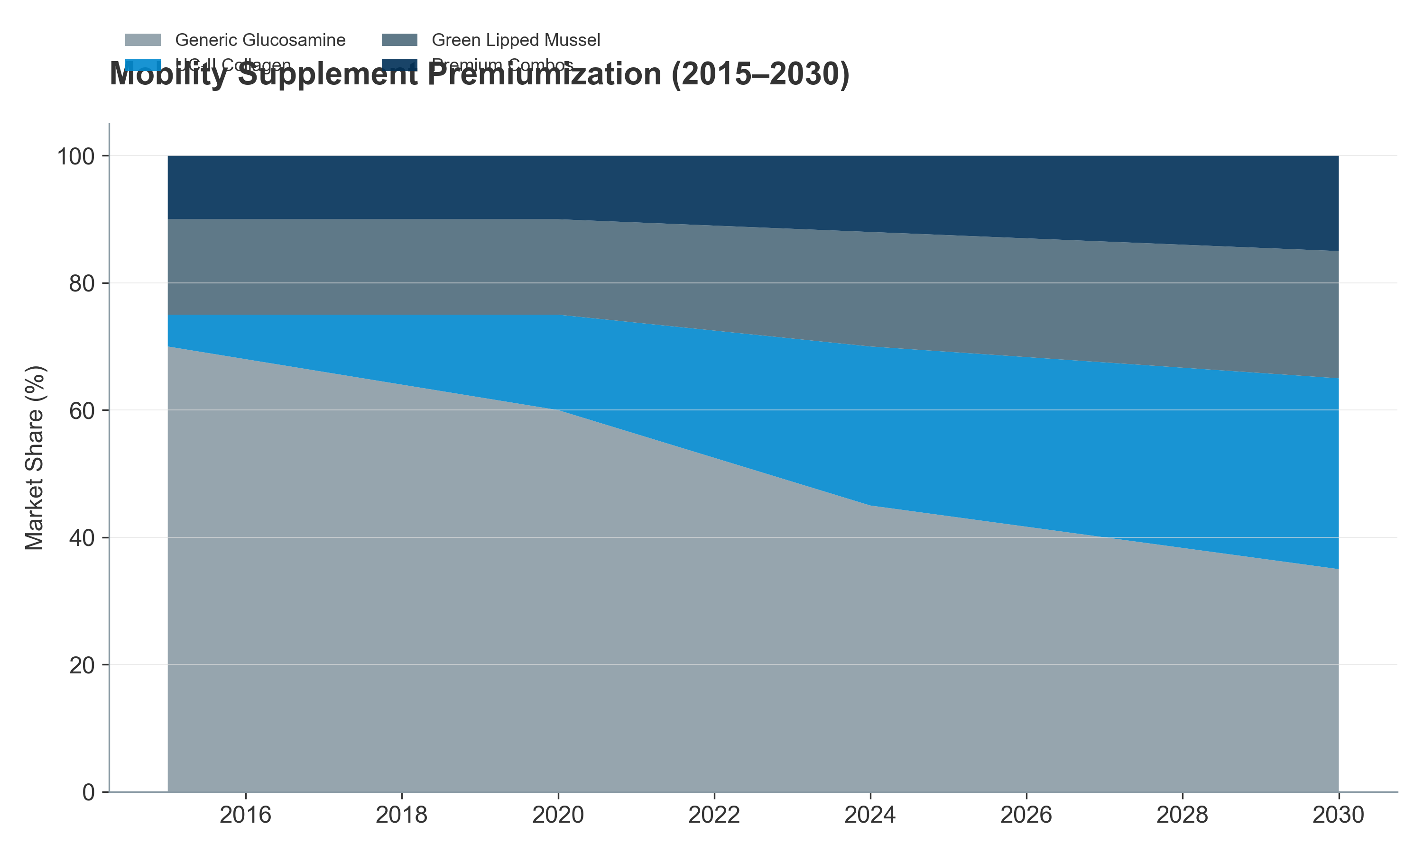

*Figure III.14: The Premiumization of Mobility: Evolution from Glucosamine to UC-II.*

*(2015–2030E) — Stacked area chart showing premiumization shift: from 70% generic glucosamine (2015) to projected 35% (2030), with UC-II, GLM, and premium combos gaining share* Cognitive Dysfunction Syndrome (CDS) – An Emerging Premium Category

As dogs live past 12 years, “doggy dementia” (Canine Cognitive Dysfunction Syndrome) is becoming a prevalent concern, affecting 10–15% of dogs over age 12 and up to 25% of dogs over age 15.

Market Emergence:

CDS supplement market is nascent (USD 80–120 million globally in 2024) but growing at 18–22% CAGR, making it the fastest-growing application segment.

Targeted interventions include:

Medium-chain triglycerides (MCTs): Support ketone metabolism as alternative brain fuel

Antioxidants (SAMe, L-carnitine, Vitamin E): Combat neuroinflammation

Phosphatidylserine & DHA: Neuronal membrane support

Pricing & WTP:

CDS supplements command USD 40–100 per month (highest-priced category in pet supplements).

Owner WTP is inelastic—owners view this as extending remaining lifespan quality; price rarely changes adoption.

The “Pre-Senior” Expansion Strategy

Brands are successfully expanding the “Senior” category downwards to pets aged 5–7 years, positioning products as “Preventive Wellness for the Senior Years”:

This extends the Customer Lifetime Value (CLV) by 2–3 years, shifting the purchase decision earlier in the pet lifecycle.

“Pre-Senior” supplements (formulated with lower dosages and broader wellness positioning) are valued at USD 400–600 million and growing at 10–12% CAGR.

Success of this strategy demonstrates the power of emotional messaging (“Don’t wait until arthritis strikes; start preventively now”).

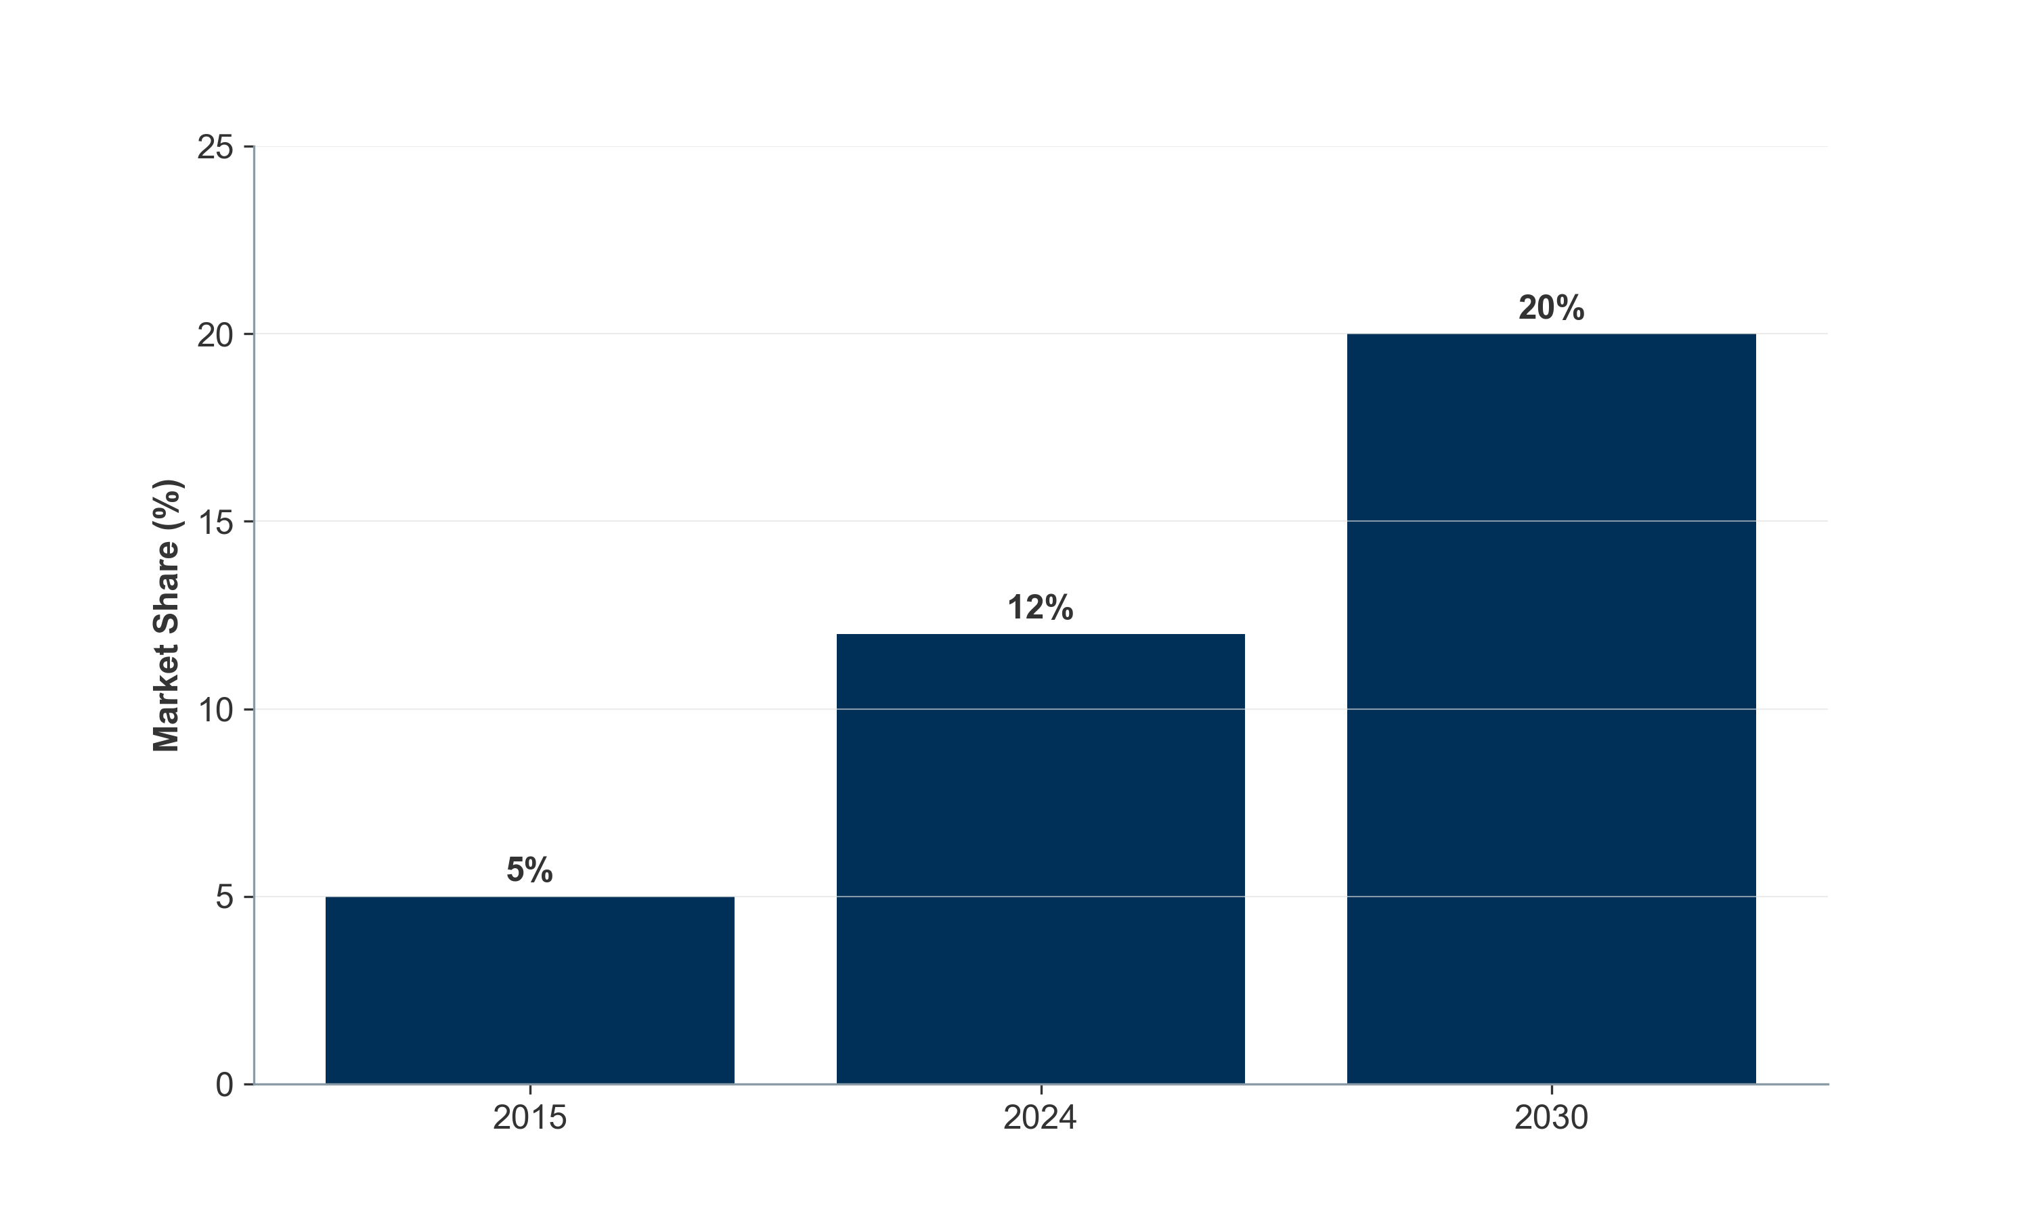

*Figure III.15: The expanding “Pre-Senior” opportunity shifts the addressable market earlier.*

### **III.5. The Value Chain: From Molecule to Market**

The veterinary nutraceutical value chain is bifurcated. While the upstream (ingredients) is shared between pet and livestock applications, the downstream diverges into two distinct economic models:

The “High-Velocity Consumer Model” (Pet) – B2C, brand-driven, margin-intensive

The “Technical Integration Model” (Livestock) – B2B, service-driven, volume-intensive

Understanding who captures the margin is critical for an investment thesis focused on where value accrual occurs.

#### **III.5.1. Upstream: Raw Materials and CDMOs (The Foundation)**

Ingredient Suppliers: The Commodity vs. IP Split

The upstream is characterized by a stark bifurcation between commodities and IP-protected actives:

Commodities (70–80% of ingredient volume):

Vitamins, amino acids, minerals: Predominantly sourced from China and India.

Gross margins: 10–20% (extreme price volatility, particularly for vitamins A, E, and selenium).

EBITDA margins: 5–12% (thin, driven by commodity pricing cycles).

Bargaining power: Highly concentrated on the supplier side; buyers (CDMOs, brands) have significant leverage.

Branded Active Ingredients (IP-protected; 20–30% of ingredient value):

Companies holding patent or exclusivity on specific strains (e.g., Bacillus subtilis variants, Lactobacillus sp.) or extraction methods (e.g., UC-II Collagen, Perlite-stabilized GLM) command premium pricing.

These suppliers do not sell “powder”; they sell “clinical claims” (e.g., “UC-II demonstrates 40% faster cartilage regeneration in dogs”).

Gross margins: 50–70%.

EBITDA margins: 25–30% (exceptional due to IP protection and recurring B2B revenue with high switching costs).

Concentration: The top 5 global players (DSM-Firmenich, Kemin Industries, Adisseo, Novozymes, and others) control the majority of the high-value IP landscape in animal nutrition.

Market Value & Dynamics:

The global specialty ingredient market for animal nutraceuticals is estimated at USD 1.5–2.0 billion (subset of the USD 7–8 billion animal probiotics and feed additives market).

Growth rate: 8–10% CAGR (2024–2030), driven by farmer/owner adoption of premiumized, clinically-backed ingredients.

CDMOs (Contract Development & Manufacturing Organizations): The Hidden Engine

The “hidden engine” of the industry. In the Pet sector, >60% of brands do not manufacture their own products; they rely on CDMOs (e.g., Vetio, Captek, Nutramax Laboratories) for formulation and extrusion (particularly soft chews).

Value Proposition:

CDMOs solve the “Palatability Puzzle”: Formulating a soft chew matrix that is shelf-stable, palatable, and cost-effective is a complex technical challenge.

A brand pays a 30–50% premium for a soft chew CDMO vs. simpler tablet manufacturing, justified by the dramatically improved repeat purchase rates (70%+ vs. 30–40% for pills).

Economics:

CDMO revenue model: Typically charged per unit produced (USD 0.20–0.80 per chew, depending on complexity and volume).

Gross margins for CDMOs: 35–50%.

EBITDA margins: 15–20% (capital-intensive manufacturing, but high volume and recurring revenue).

Customer concentration risk: Highly dependent on 2–3 major customers (Mars, Nestlé, Zoetis), creating concentration risk.

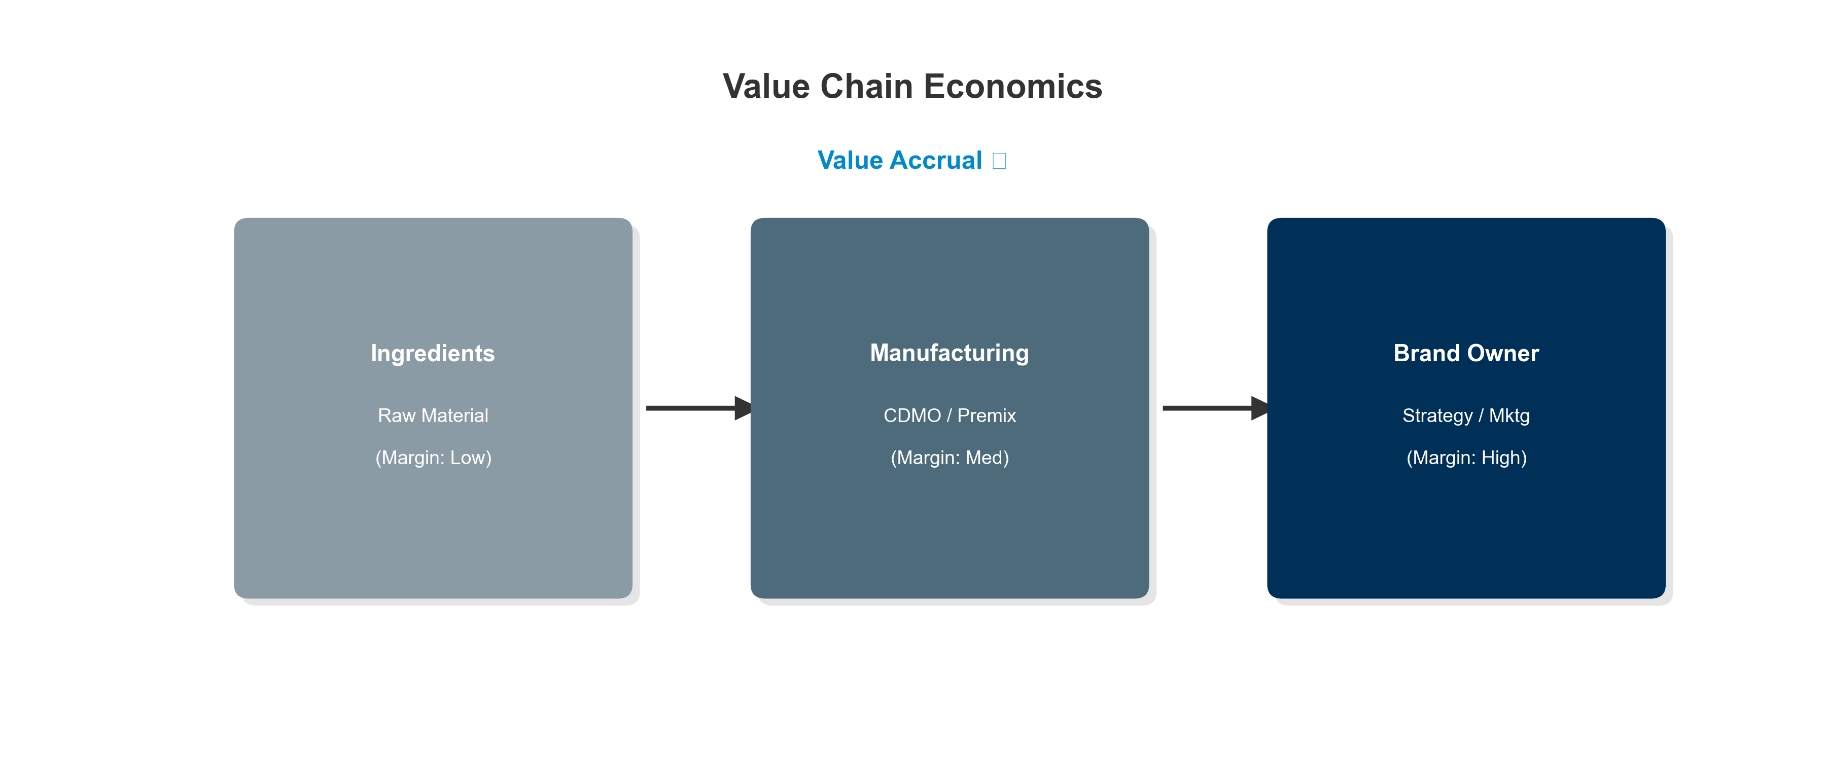

*Figure III.16: The Animal Nutraceutical Value Chain: Margin capture from ingredient to consumer.* #### III.5.2. Downstream Divergence: Who Captures the Margin?

The downstream splits sharply at the brand/integrator level:

#### **A. The Pet “Wellness” Chain (B2C): The “Vet-Ex” Erosion**

This model mirrors the human supplement industry, characterized by margin erosion through channel democratization:

Historical Model (2010–2015):

60–70% of pet supplements sold through veterinary clinics, with the vet acting as gatekeeper and endorser.

Veterinary clinic markups: 40–50% (buying wholesale at USD 10, selling at USD 15–18).

Brand profitability: High (gross margins 60–70%), limited distribution spend.

Current Model (2024):

E-commerce (Amazon, Chewy) and DTC channels now capture >50% of volume, bypassing the traditional veterinary clinic channel.

Chewy commands 30–50% of pet supplement e-commerce volume in North America, consolidating buyer power.

Vet-exclusive penetration has fallen to 30–40% of category, with vet-recommended products increasingly available online at lower prices.

Channel Economics (Current):

Sources:

* **DSM-Firmenich Q3 2025 Trading Update:** [View PDF](https://www.dsm-firmenich.com/content/dam/dsm-firmenich/investors/documents/results-center/2025/presentation-to-investors-q3-2025-trading-update-final.pdf)
* **Dechra Pharmaceuticals PLC:** “Annual Report and Accounts for the year ended 30 June 2023”
* **ECO Animal Health Group FY23 Results:** [View PDF](https://ecoanimalhealth.com/wp-content/uploads/2024/03/ECO-Animal-Health-10-July-2023.pdf)

Direct-to-Consumer (DTC) Power – The Margin Recapture:

Brands like Zesty Paws, YuMOVE, Pawpeds operate DTC-first models, owning customer data and reducing reliance on intermediaries.

DTC Gross Margins: 60–70%; after CAC (USD 30–50 per customer over lifetime), EBITDA margins: 20–25%.

CLV vs CAC: Successful DTC brands achieve CLV:CAC ratios of 3.5–5.0, compared to 1.5–2.0 for traditional brands.

Amazon & Chewy Dynamics:

Chewy and Amazon have consolidated bargaining power, negotiating 3–5% slotting fees and rebates, depressing brand margins by 100–200 basis points.

However, volume scale on these platforms justifies lower margins due to dramatically increased throughput and consumer reach.

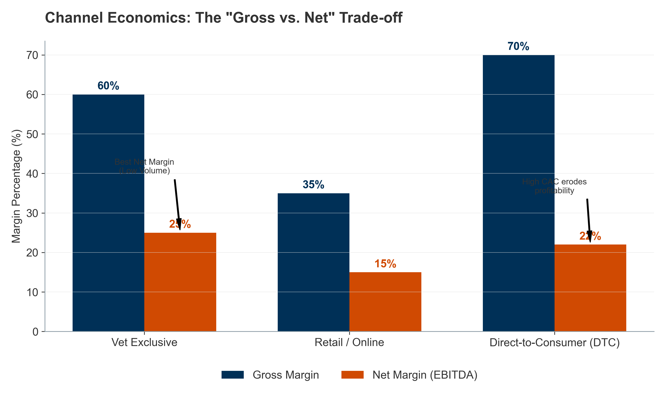

*Figure III.17: Channel Margin Dynamics: The “Volume Trade-off”. While DTC offers the highest gross margins (70%), customer acquisition costs (CAC) erode net profitability to levels comparable with Vet-Exclusive models. Retail offers the lowest margins but max volume.*

#### **B. The Livestock “Efficiency” Chain (B2B): The Premix Bottleneck**

This model mirrors the Ag-Tech industry, characterized by service integration and switching costs:

Transaction Structure:

Farmers rarely buy pure ingredients; they purchase “Premixes” (formulated blends of vitamins, minerals, probiotics, enzymes, and organic acids).

Premixer companies (e.g., Trouw Nutrition, Cargill, BASF, Kemin) act as the gatekeeper, controlling the farmer relationship.

Premixer Economics:

Gross margins: 20–30%.

EBITDA margins: 8–12% (lower than pet brands, but offset by volume and recurring revenue).

Customer stickiness: Very high; switching costs include nutritional reformulation, quality audits, regulatory compliance.

Service Wrapper – The Margin Play:

Value is captured not by the product alone, but by the service wrapper:

Nutritional consulting: Formulating least-cost rations based on local ingredient availability.

Digital monitoring: Connecting to Precision Livestock Farming (PLF) systems that track herd health, performance, and nutritional status in real-time.

Technical support: On-farm troubleshooting, disease diagnostics, and product optimization.

Integrator Margin Concentration:

The top 5 global premixer companies (Trouw Nutrition, Cargill, BASF, Kemin, Alltech) capture ~45–55% of the premix market and command higher pricing and retention due to integrated service offerings.

Smaller, ingredient-only suppliers compete on price and capture 0.5–1.0% EBITDA margins, often breaking even.

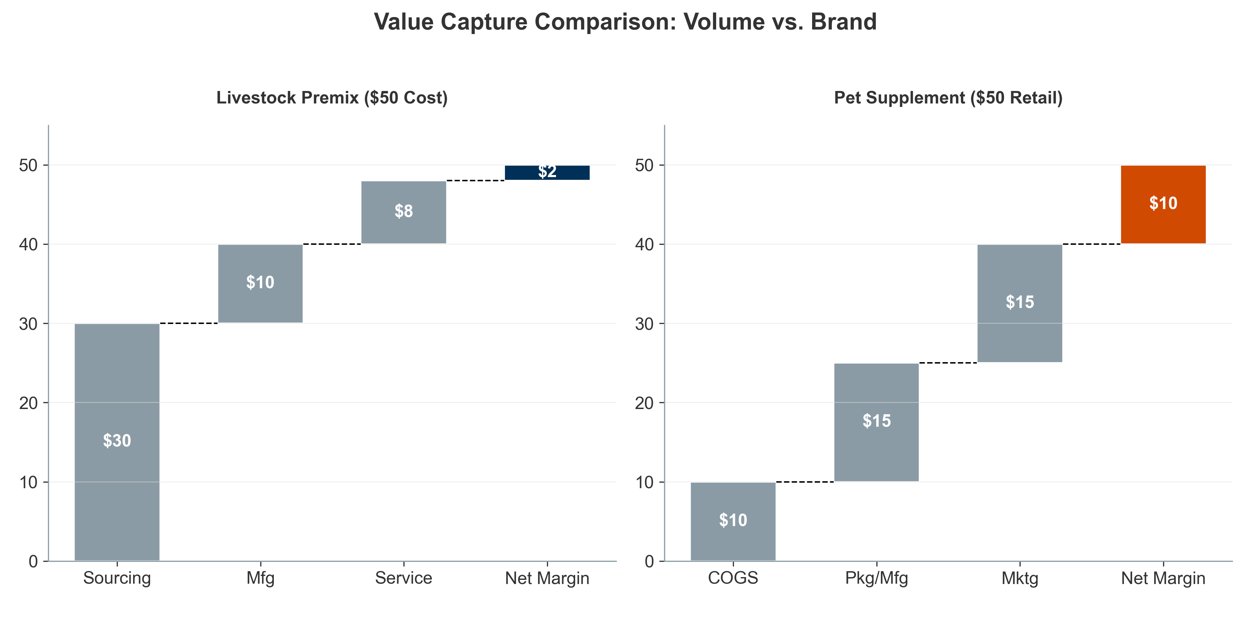

*Figure III.18: Comparative Value Waterfall: Livestock Premix (Cost-Plus) vs. Pet Supplement (Brand Premium).*

#### **III.5.3. Financial Performance: Margin Profiles Across the Ecosystem**

The animal nutraceutical ecosystem presents a “Risk/Reward” spectrum regarding profitability and growth:

Sources:

DSM-Firmenich Q3 2025 Trading Update (Animal Nutrition 22.1% EBITDA) https://www.dsm-firmenich.com/content/dam/dsm-firmenich/investors/documents/results

Dechra Pharmaceuticals Annual Report 2023 (Pet brands 20-25%) https://www.dechra.com/Admin/Public/Download.aspx?

Investment Thesis Implication:

Highest risk-adjusted returns lie in IP-protected ingredient suppliers (Kemin, DSM-Firmenich) and premium DTC pet brands with strong retention (>65% LTV:CAC ratio).

Lowest risk, highest stability: Livestock integrators (Trouw, Cargill), though with modest growth and lower margins.

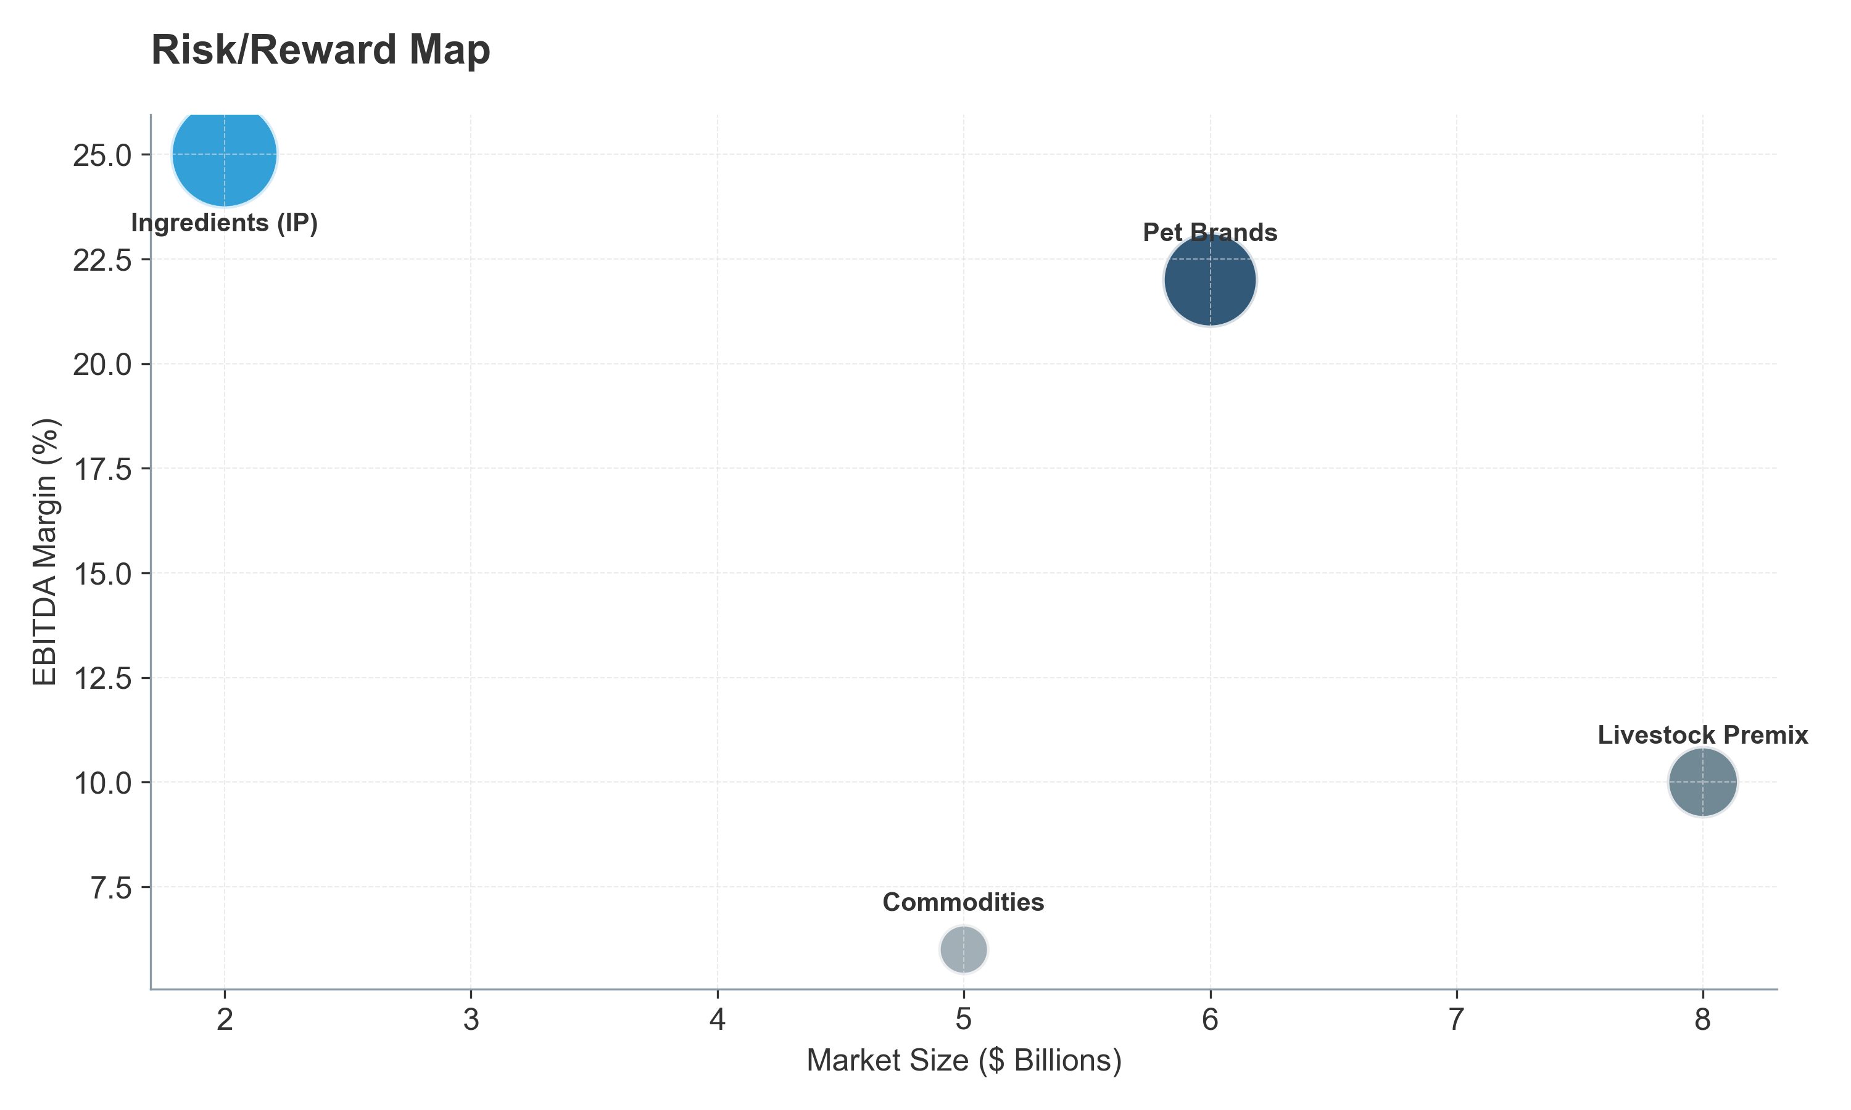

*Figure III.19: Risk/Reward Profile of Key Industry Segments.* #### III.5.4. Integration Models: The “Pharma” Encroachment

Large pharmaceutical and animal health companies are increasingly vertically integrating into nutraceuticals. Why?

The Strategic Rationale

The “Entry Funnel” Strategy:

Nutraceuticals serve as the “Entry Funnel” into the owner/farmer relationship, capturing the animal before it gets sick.

An owner starting with a joint supplement (e.g., Cosequin by Nutramax, acquired by Elanco) is pre-disposed to the same company’s prescription NSAID (e.g., Rimadyl) as the joint disease progresses.

Market Data on Integration:

Zoetis (USD 9.1 billion market cap in 2024): Acquired Platinum Performance in 2021 for USD 75 million; generates USD 80–100 million annually in nutraceutical revenue.

Elanco (USD 4.2 billion market cap): Owns Cosequin, Duralactin, and other brands; nutraceutical revenue estimated at USD 120–150 million annually.

Boehringer Ingelheim: Expanding nutraceutical portfolio through Vetsulin, Metacam prescription-to-OTC brand extension strategies.

Margin Dynamics:

Pharma companies tolerate lower nutraceutical EBITDA margins (12–15%) to secure long-term, high-margin prescription revenue (40–50% EBITDA on prescription drugs).

A customer lifetime value (CLV) analysis shows that owning a customer for 8–10 years through the nutraceutical funnel justifies accepting compressed margins on supplements to capture high-margin prescription sales downstream.

Competitive Implications

The pharma encroachment has created a “barbell structure” in pet nutraceuticals:

High-end: Integrated pharma players (Zoetis, Elanco) with lower margins but higher customer lifetime value.

Low-end: Commodity supplement brands (Amazon Basics, private-label) competing on price alone.

Middle-squeeze: Independent DTC and traditional pet supplement brands face margin pressure from both above (pharma integrators) and below (private-label).

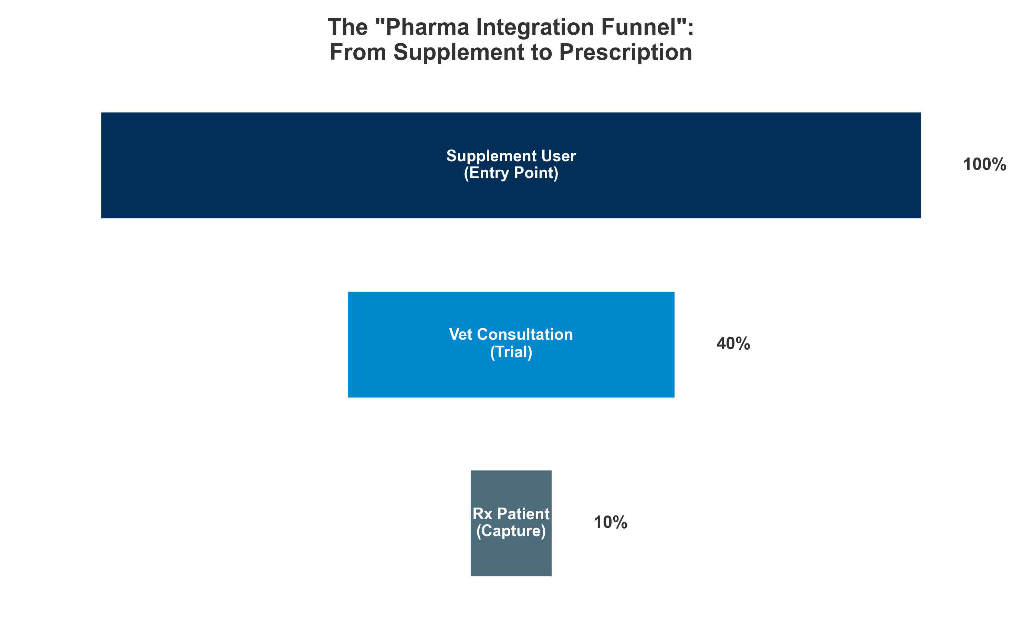

*Figure III.20: The “Pharma Integration Funnel”: Converting supplement users to prescription patients.*

#### **III.5.5. The “White Label” Trap vs. The “Science” Moat**

The barrier to entry in pet nutraceuticals is artificially low due to the proliferation of “White Label” contract manufacturers who offer off-the-shelf formulations with low minimum order quantities (MOQs). This creates a dangerous trap for new entrants:

* **The Trap (Commoditization):** Brands relying on standard white-label formulations compete solely on branding and price. With no proprietary IP, they face rapid margin compression as identical products flood the market (e.g., generic Glucosamine/Chondroitin chews on Amazon). They own a *logo*, not a *product*.
* **The Moat (Defensibility):** The most successful acquirers (strategic pharma buyers) are not buying brands; they are buying *validated science*. A “Science Moat” is built through:

1. **Proprietary Formulations:** Custom blends that cannot be easily copied (e.g., specific probiotic strains + prebiotic matrices).
2. **Clinical Validation:** Conducting double-blind, placebo-controlled field studies to prove efficacy.
3. **IP Protection:** Patents or exclusive licensing agreements for key active ingredients.

**Strategic Implication:** For investors, “White Label” brands represent a race to the bottom. Value lies exclusively in brands that have effectively dug a “Science Moat,” converting a commodity supplement into a quasi-pharmaceutical asset.

### **III.6. Strategic Value Creation & Competitive Landscape**

#### **III.6.1. TAM/SAM/SOM Framework**

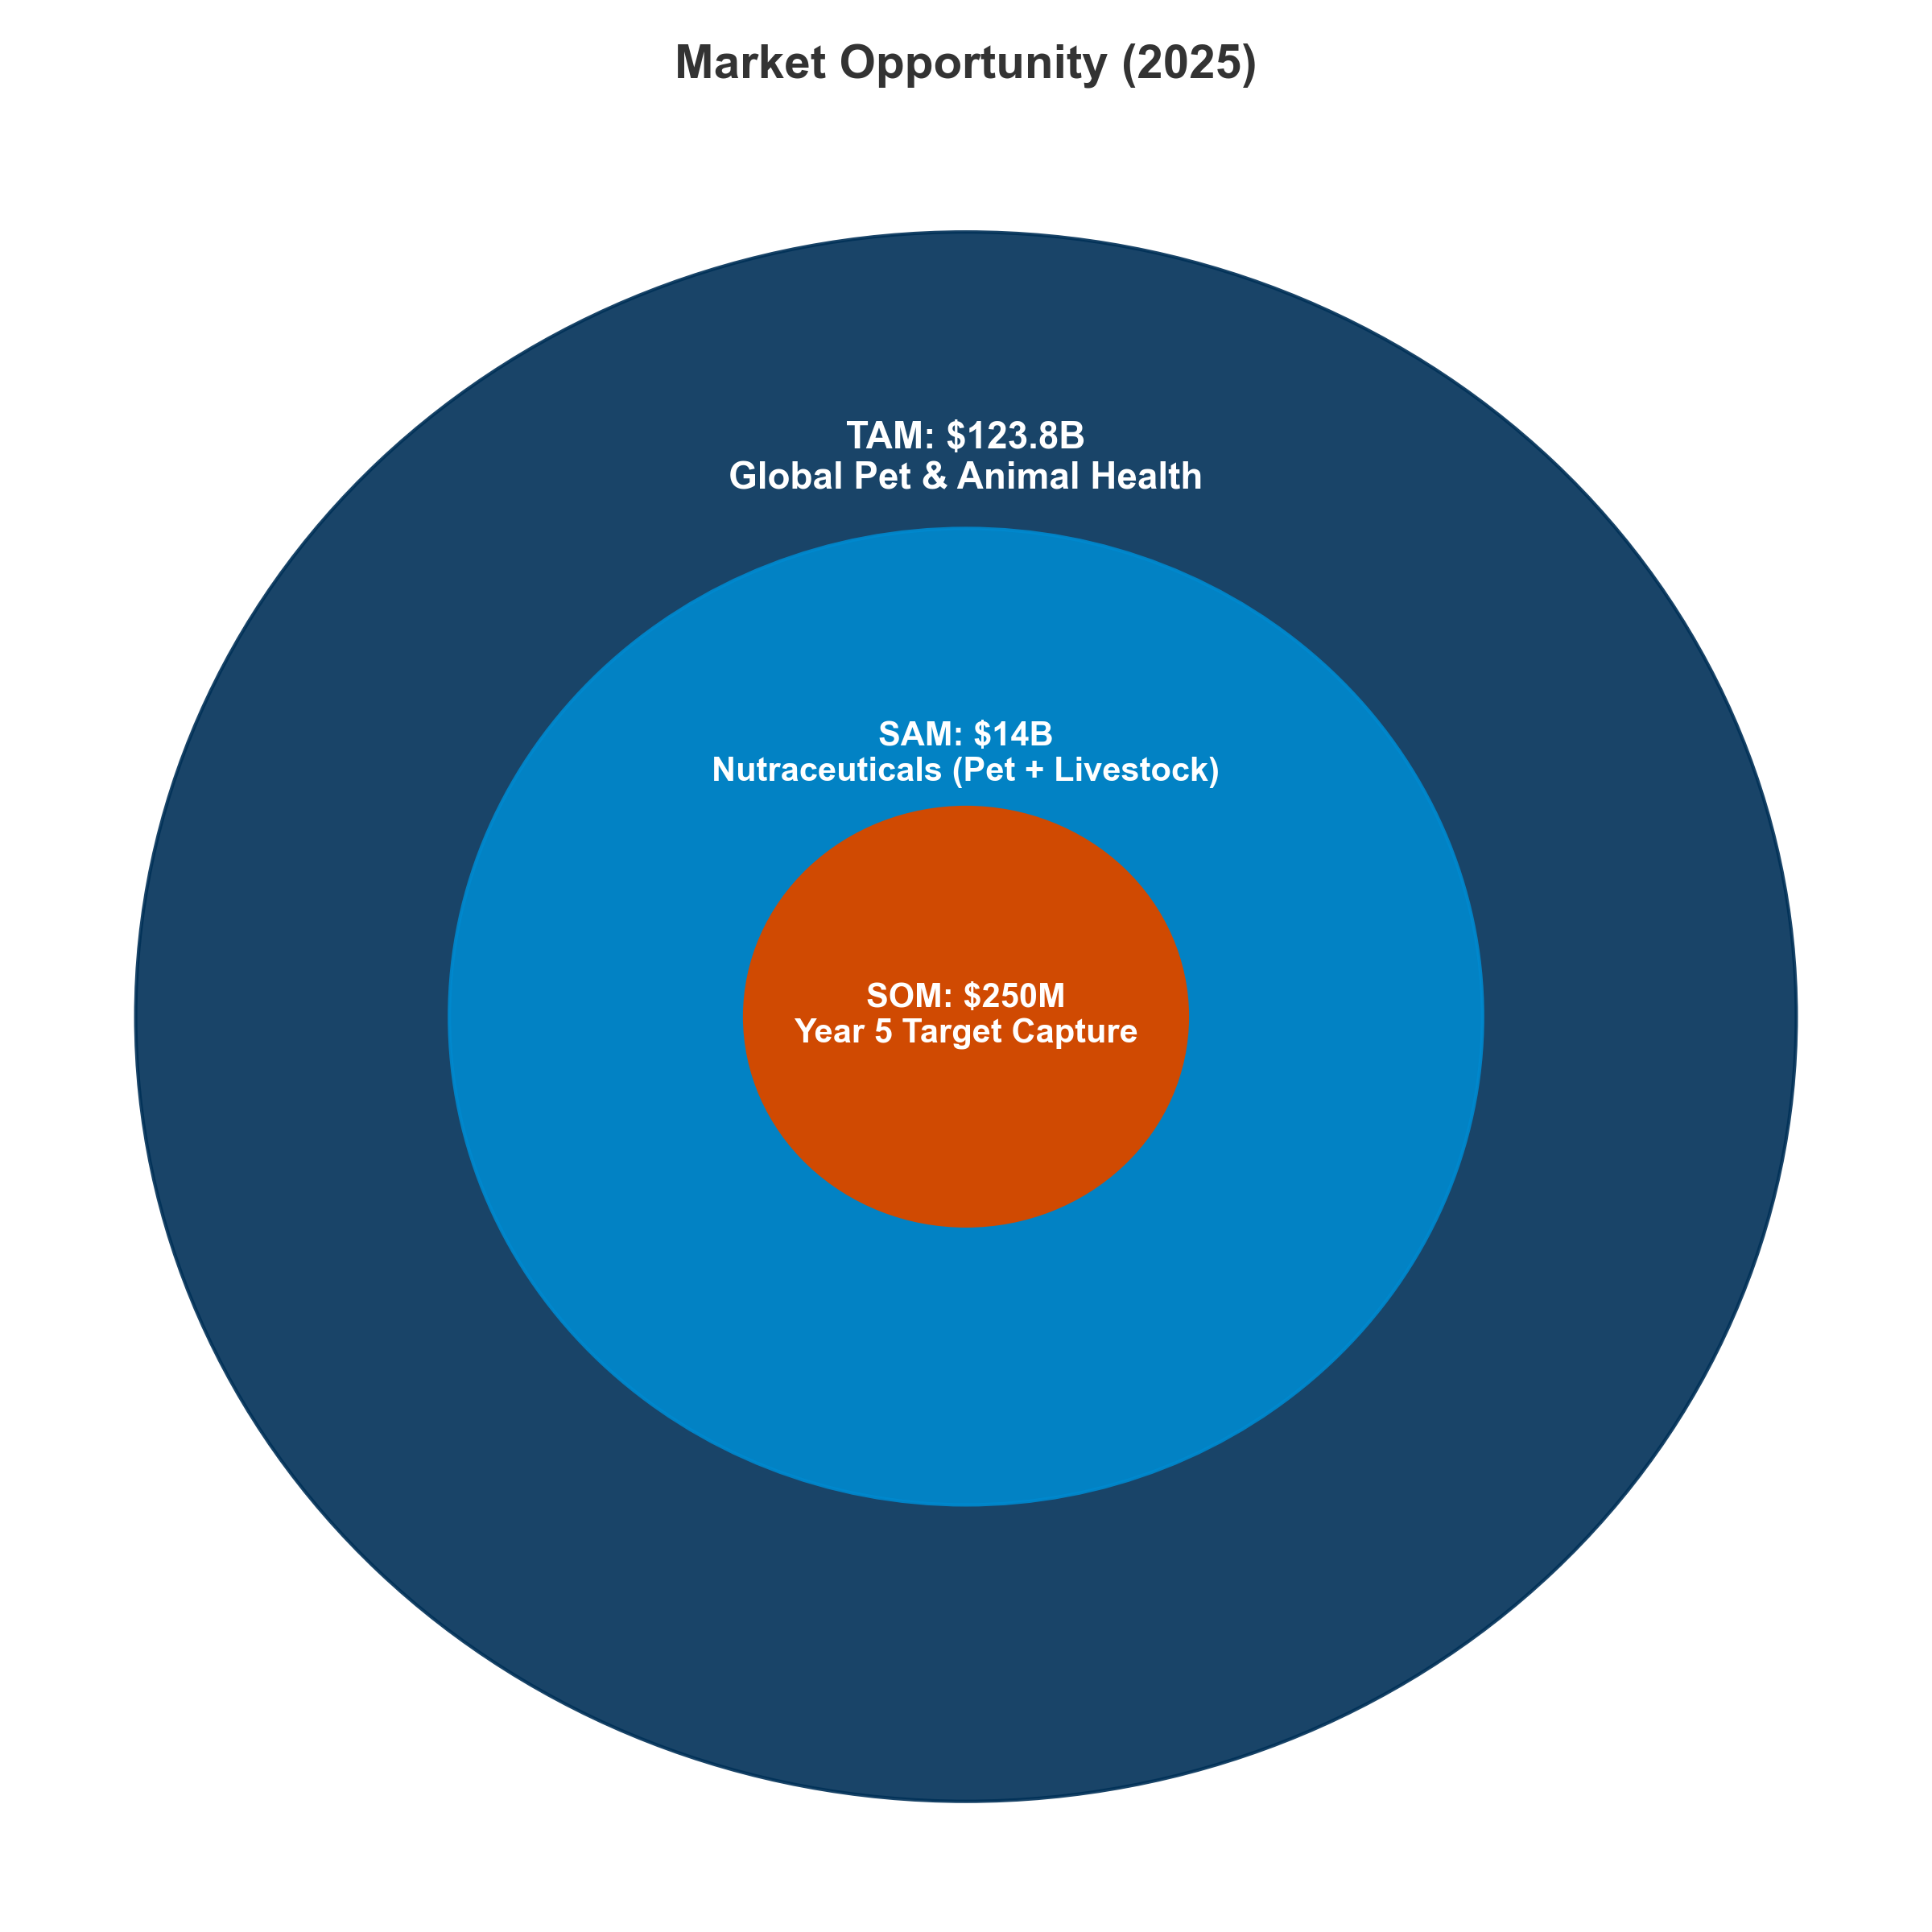

*Figure III.21: The Strategic Opportunity: From a $123B Global Market to a Defined $250M Target.*

**Strategic Conclusion:**

The convergence of data-driven livestock precision nutrition and the “pet parent” humanization trend creates a unique investment window. While the total animal health market is vast ($123.8B), the high-growth, high-margin opportunity lies specifically in the $14B nutraceutical niche.

A focused strategy targeting validated, IP-backed ingredients in this segment—avoiding the “white label” commodity trap—presents a clear path to capturing $250M in high-quality revenue within 5 years, offering defensible margins and significant strategic value to eventual acquirers (Pharma & CPG).

#### **III.6.2. The Great Divergence: Pet vs Livestock Value Dynamics**

The value proposition in animal nutraceuticals has bifurcated into two distinct economic models: the “Wellness Premium” in pets and “Efficiency at Scale” in livestock.

* **Pet Dynamics (Emotional ROI):** Driven by the “humanization” trend, pet owners demonstrate low price sensitivity for products that promise extended lifespan or improved quality of life (e.g., joint mobility, anxiety relief). Demand is inelastic, supporting high gross margins (60-70%) and rapid adoption of premium, clinically-backed formats.
* **Livestock Dynamics (Financial ROI):** Conversely, the livestock sector is driven by strict cost-benefit analysis. Producers demand quantifiable improvements in feed conversion ratios (FCR) or disease reduction. Margins are tighter (10-15%), but volume is massive. Usage is dictated by regulatory shifts (e.g., antibiotic bans) rather than consumer sentiment.

**Investment Thesis Implication:** Pet nutraceuticals offer higher growth and margins but face greater distribution challenges and CAC inflation. Livestock probiotics offer lower margins and growth but face strong regulatory tailwinds and sticky customers.

#### **III.6.3 The Microbiome Frontier – Startups & Institutional Innovators**

*Investment Thesis: Moving from generic “probiotics” to precision microbiome engineering.*

| **Company** | **Product / Platform** | **Target** | **Mechanism of Action** | **Relation to Nutra (Strategy)** | **Strategic Claim** |
| --- | --- | --- | --- | --- | --- |
| **BiomEdit** | Biome-Actives | Livestock | **Synthetic Biology**: Engineered strains producing enzymes. | **The “Trojan Horse”**: Functionally a drug, legally a Zootechnical Additive. | **“Living Factories”**: Continuous manufacturing inside the gut. |
| **Proteon** | BAFASAL® | Poultry/Aqua | **Bacteriophages**: Lytic phages targeting Salmonella. | **The “Additive” Hack**: Phages classified as Feed Additives, not Vaccines. | **“The Sniper”**: Kills superbugs without harming beneficial microbiome. |
| **Folium Science** | Guided Biotics™ | Poultry | **CRISPR-Cas**: Triggers self-destruction in pathogen DNA. | **The “Hygiene” Play**: Positioned as Processing Aid to avoid GMO labels. | **“Genetic Scalpel”**: Removes pathogens by reading DNA sequence. |
| **MicroHarvest** | Single Cell Protein | Pet/Aqua | **Biomass Fermentation**: Bacteria convert waste to protein. | **The “Super-Ingredient”**: Sold as Feed Material, avoiding Additive approval. | **“Speed & Scale”**: Protein 5000x faster than soy. |
| **Anizome** | Discovery Platform | Multi | **Therapeutic Discovery**: Mapping gut for druggable targets. | **The “Pharma Bridge”**: Sells Data/Targets, not just supplements. | **“The Map Makers”**: Google Maps of the animal gut. |

#### **III.6.4 New Business Models (DTC & Ingredient Tech)**

*Investment Thesis: Two divergent paths—Owning the “Patient” (DTC) vs. Owning the “Formula” (B2B).*

| **Company** | **Model** | **Product** | **Strategic Similarity** | **Strategic Claim** |
| --- | --- | --- | --- | --- |
| **AnimalBiome** | DTC | FMT & Testing | **The “Patient Owner”**: Uses testing to sell supplements. | **“Ecosystem Transplant”**: Restoring lost microbiomes. |
| **Biome9** | DTC | AI Gut Test | **The “European Twin”**: AnimalBiome but UK-based. | **“Predictive AI”**: Predicting health before symptoms. |
| **Gnubiotics** | B2B | Glycans | **The “Intel Inside”**: Sells to Purina/Mars. | **“Mother’s Milk Mimic”**: Replicating maternal immunity. |
| **CanBiocin** | B2B | Species-specific Strains | **The “Strain Bank”**: Sells living tech to manufacturers. | **“Native Logic”**: Bacteria isolated from dogs for dogs. |
| **Bond Pet Foods** | B2B | Brewed Protein | **The “SynBio Chef”**: Creating meat without animals. | **“Nature Identical”**: Chemically identical chicken protein. |

# **Part IV. Competitive Landscape & Strategic Investment Analysis**

## **IV.1. Mapping the Competitive Landscape**

***In this section:*** *A detailed mapping of the competitive field, from pharmaceutical giants using nutraceuticals as an “entry funnel” to specialized feed additive players dominating the upstream. We analyze margin capture, consolidation vectors, and the strategic implications for investors.*

The animal nutraceutical market is consolidating around a vertically integrated set of players spanning pharmaceutical, feed additive, and consumer health channels. Scale, clinical differentiation, and margin characteristics vary sharply between pet-focused and livestock-oriented assets, driving distinct valuation outcomes.

## **IV.2 Key Players and Portfolio Architecture**

## **IV.2.1 Pharma-linked Animal Health Groups**

The intersection of pharmaceutical R&D capability with animal-health distribution is reshaping the competitive structure. These players increasingly offer a **“Continuum of Care”** spanning therapeutic drugs, vaccines, parasiticides, and functional supplements.

**Major Players:**

**Zoetis Inc. (USA)** leads the sector with ~$9.3B in revenue (2024). As the world’s largest animal health company, it recently divested its medicated feed additive portfolio ($350M) to focus entirely on high-margin biologics, genetics, and companion animal innovation. In nutraceuticals, Zoetis leverages a strong portfolio in functional diagnostics and companion animal supplements.

**Merck Animal Health (USA)** follows with ~$5.9B in revenue. The company maintains a massive presence in vaccines and parasiticides (notably BRAVECTO). The acquisition of Elanco’s aqua business in July 2024 cements its leadership in aquaculture health. Merck’s nutraceutical strategy increasingly leverages Antelliq (monitoring) to pair nutrition with digital health data.

**Boehringer Ingelheim (Germany)** generates ~$5.0B in revenue. Dominant in parasiticides (NexGard) and therapeutics, BI has a strong R&D focus on chronic disease management—such as diabetes and heart failure—where nutritional adjuncts play a critical key role.

**Elanco Animal Health (USA)** reports ~$4.4B in revenue with a balanced portfolio split evenly between Pet and Farm sectors. Elanco positions itself as an innovation leader in non-antibiotic livestock solutions (Experior) and dermatology.

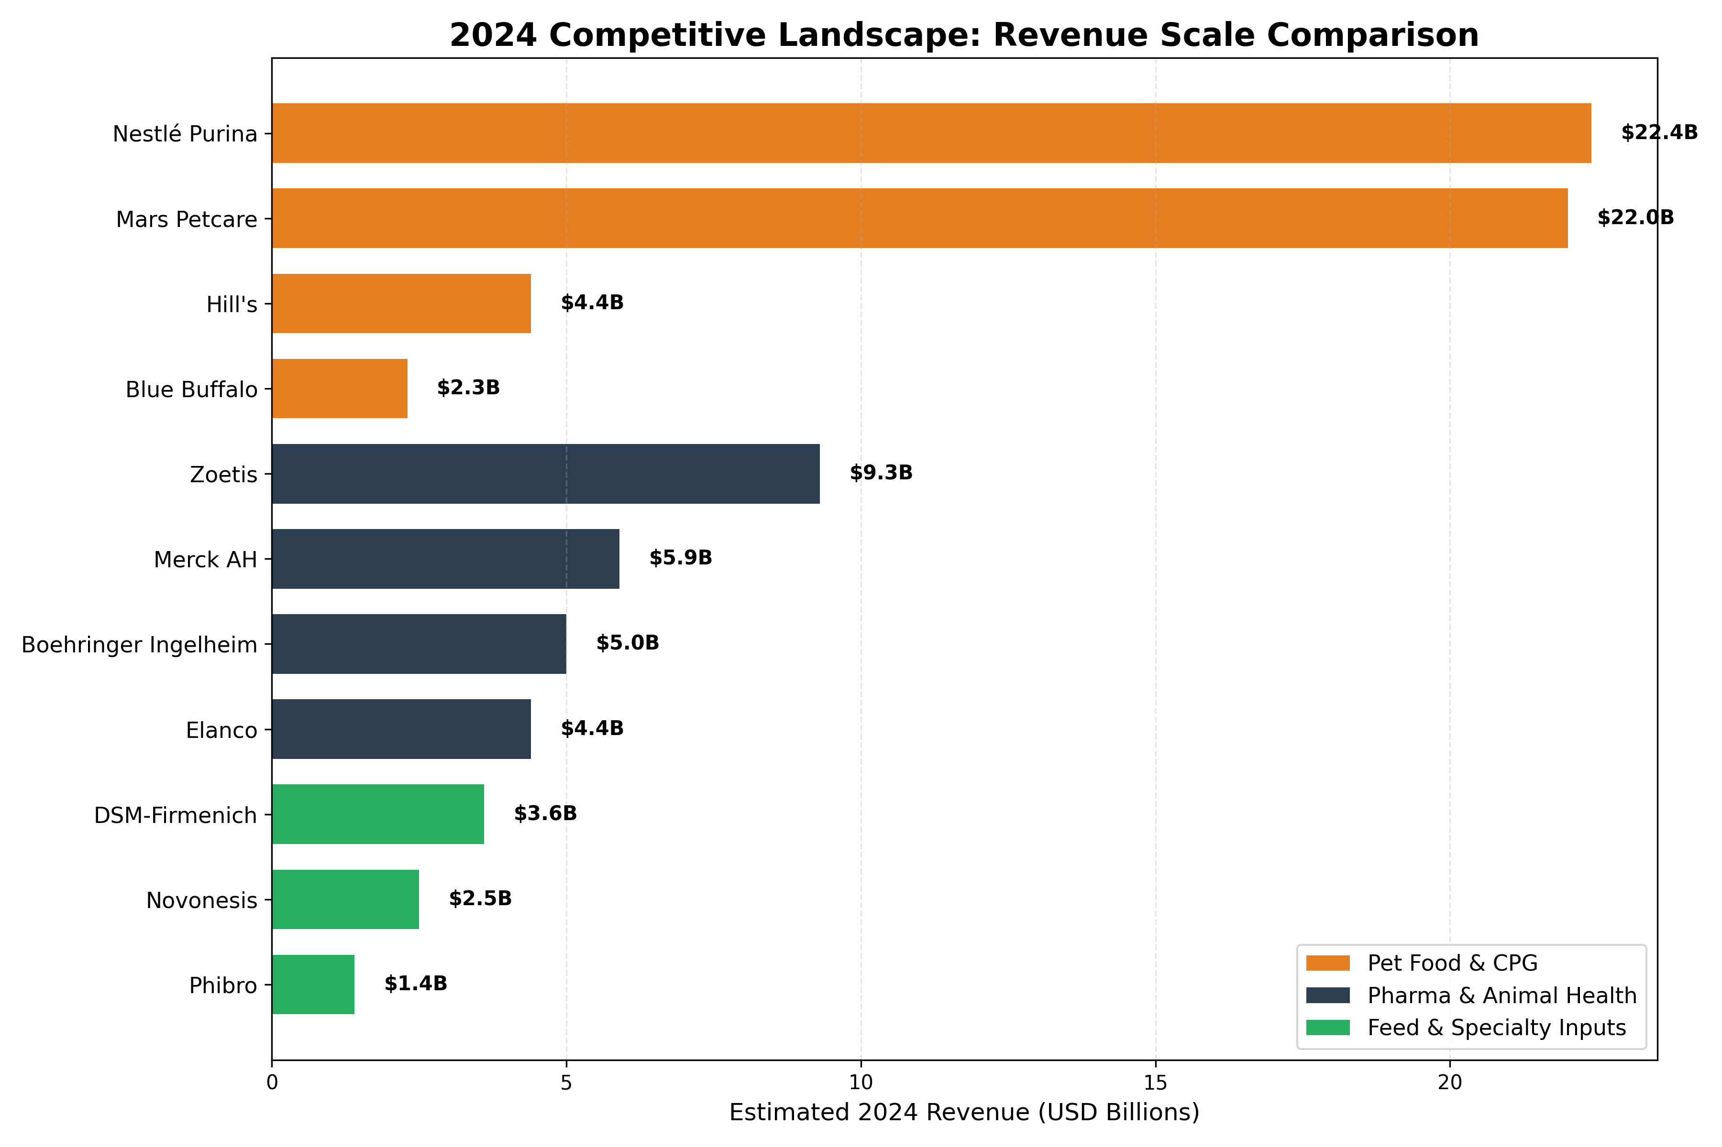

*Figure IV.1: 2024 Revenue Comparison: Pharma vs. Feed vs. Pet CPG Leaders.*

The revenue landscape reveals a stark **“Titan vs. Specialist” dichotomy**. At the top, integrated conglomerates like **Nestlé Purina** and **Mars Petcare** operate at a massive scale (~$22B+), dwarfing even the largest pure-play pharmaceutical giants like **Zoetis** ($9.3B). This scale advantage allows the Titans to cross-subsidize R&D and dominate global supply chains.

In contrast, the **“Specialist” tier** (e.g., **Dechra**, **Vetoquinol**, **Swedencare**) operates in the **$500M - $1B range**. Lacking the sheer volume of the Titans, these players compete on **agility and niche dominance**. They focus on high-margin therapeutic areas—such as endocrinology for Dechra or dental health for Swedencare—where they can build defensible “moats” through specialized IP rather than brute-force distribution. The “Middle Market” remains thin, fueling the ongoing consolidation trend as mid-sized players are absorbed to achieve critical mass.

## **IV.2.2 Feed and Specialty Nutrition Majors**

These companies form the production backbone, combining commodity-scale milling with high-margin biotech (enzymes, probiotics). They are the primary beneficiaries of the “Post-Antibiotic” transition.

**Major Players:**

**DSM-Firmenich (Animal Nutrition & Health)** stands as the absolute leader in vitamins, carotenoids, and mycotoxin management, with its ANH Division generating ~€3.3B. Their innovation pipeline is exemplified by Bovaer® (methane reduction), a category-defining launch for Scope 3 emissions.

**Novonesis (Novozymes + Chr. Hansen)** is the global powerhouse in fermentation, reporting ~€2.1B in revenue for its Planetary Health division. Their strategy relies on a high-margin (>35% EBITDA) business model focused on enzymes and probiotics (Bio-Ag) that replace traditional chemicals.

**Cargill (Provimi / Diamond V)** operates as a private giant with massive vertical integration. Its “Diamond V” brand provides immune-support postbiotics, while “Provimi” dominates distinct premix markets globally.

**ADM Animal Nutrition** leverages major ag-processing capabilities to move up the value chain from bulk commodities. The company is investing heavily in functional botanicals and alternative proteins to capture higher margins.

**Strategic Takeaway:** This tier is undergoing a fundamental re-rating. Historically valued as commodity processors (low margin, cyclical), these majors are aggressively pivoting into **“Biotech Platforms”**. By bolting on high-IP fermentation and precision-nutrition assets, they are trading bulk volume for outcome-based value—positioning themselves not just as feed suppliers, but as the essential delivery infrastructure for the post-antibiotic era.

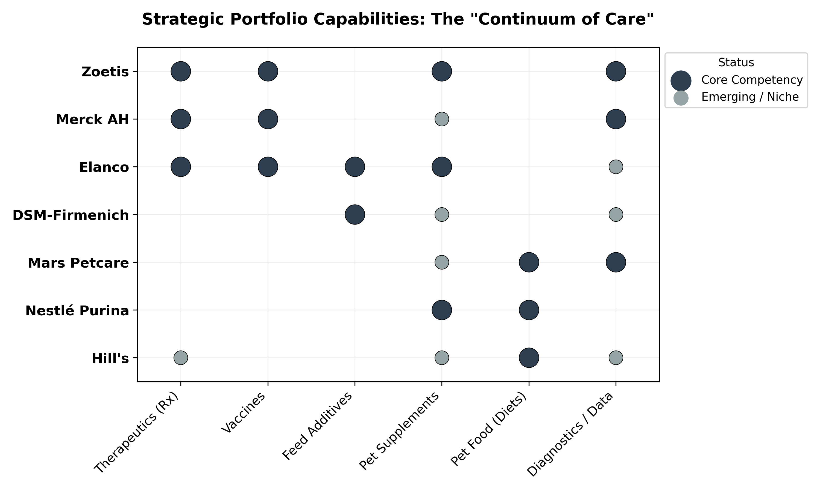

*Figure IV.2: Strategic Capability Matrix: How key players span the full Continuum of Care.*

Strategic positioning in the value chain largely splits into two archetypes: **Vertical Integrators** vs. **Asset-Light Marketers**.

* **The Vertical Integrators (Technology Owners):** Companies like **Nutramax** (joint health), **Zinpro** (minerals), and **Bioiberica** (heparin/chondroitin) own the entire stack—from raw material extraction to final manufacturing. This vertical control grants them “Category Captain” status with unmatched quality assurance and margin capture (**25%+ EBITDA**). They typically act as the “Intel Inside,” supplying validated ingredients to both pharma and premium pet food brands.
* **The Asset-Light Marketers:** Conversely, many rapid-growth consumer brands (e.g., **Zesty Paws**, **Native Pet**) leverage a **“Licensing & Assembly” model**. By sourcing branded, clinically validated ingredients (like **Lactium®** or **DE111®**) and manufacturing via third-party CDMOs, they can pivot quickly to new trends without heavy CapEx. However, this model relies heavily on brand equity and marketing velocity, as the underlying “technology” is often available to competitors.

## **IV.2.3 Consumer-Facing Pet Nutrition Brands**

Characterized by “Pet Humanization,” this segment utilizes scientific claims (joint, brain, gut) to justify premium pricing.

**Major Players:**

**Nestlé Purina PetCare** is the global leader with ~$22.4B in revenue (2024). *Purina Pro Plan* serves as the reference standard for veterinary-endorsed retail nutrition, while FortiFlora (probiotic) has become a ubiquitous gateway product for pet supplements.

**Mars Petcare** rivals Nestlé with ~$22B in revenue and an unmatched ecosystem. Mars owns the nutrition (Royal Canin, Iams), the clinics (VCA, Banfield), and the diagnostics (Antech). This closed-loop data integration allows for precision product development.

**Hill’s Pet Nutrition (Colgate-Palmolive)** focuses on therapeutic management, generating ~$4.4B in revenue. As the “Prescription Diet” specialist, Hill’s dominates the veterinary channel for obesity, kidney, and digestive health management.

**General Mills (Blue Buffalo)**, with ~$2.3B in revenue, pioneered the mass-premium “Natural” segment. They validated the concept that grocery store shoppers will pay a premium for “wild” and “grain-free” narratives.

**Swedencare AB** represents the high-growth specialist tier. Generating ~$75M, this pure-play nutraceutical company focuses on unique oral health IP (ProDen PlaqueOff), sustaining high margins (>20% EBITDA).

**Freshpet** acts as a major disruptor with its “Fresh from the Fridge” proposition. By proving that cold-chain logistics can act as a massive moat against dry-kibble competitors, Freshpet has carved out a distinct high-growth category.

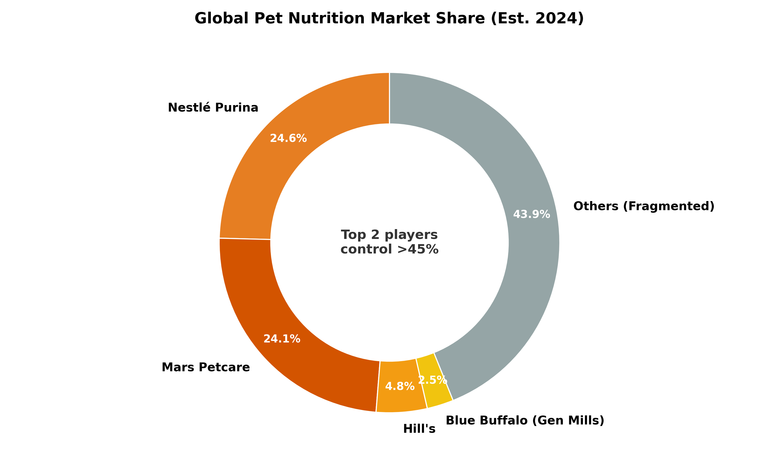

*Figure IV.3: Global Pet Nutrition Market Share: The “Long Tail” of Disruption.*

While the “Big Three” (Mars, Nestlé, Hills) retain dominant market share through veterinary channels and mass retail, the landscape is fragmenting. The **“Others” category** now represents a significant wedge of the market, driven by the explosion of **Direct-to-Consumer (DTC)** and “Challenger” brands (e.g., **Farmer’s Dog**, **Butternut Box**, **Smalls**).

This “Long Tail” competes on **Freshness and Personalization**—attributes that legacy incumbents struggle to replicate at scale due to cold-chain constraints. Furthermore, regional champions like **Drools** (India) and **Musti Group** (Nordics) are proving that “local hero” strategies can effectively block global giants by tailoring products to specific cultural or regional preferences.

**IV.2.4 Distribution Gatekeepers and Ecosystems**

This critical layer controls route-to-market and increasingly aggregates consumer and veterinary data to co-create private-label ranges. In the **veterinary channel**, corporatization is the dominant trend, led by giants like **IVC Evidensia** (Europe’s largest provider) and organized networks in the UK/US that increasingly negotiate preferred-brand arrangements.

**Specialty retail** remains a competitive stronghold. **PetSmart** and **Petco** dominate North America (alongside **Pet Valu** in Canada), while distinct regional champions define the European landscape—notably **Musti Group** (Nordics), **Arcaplanet** (Italy), and **Tom & Co** (Benelux).

In **e-commerce**, **Chewy Inc.** leads North America with its proprietary health data model, while **Zooplus** operates as the “Amazon of Pets” for Europe. These platforms are evolving from simple transaction hubs into critical data ecosystems that drive private-label development, often bypassing traditional wholesale distributors.

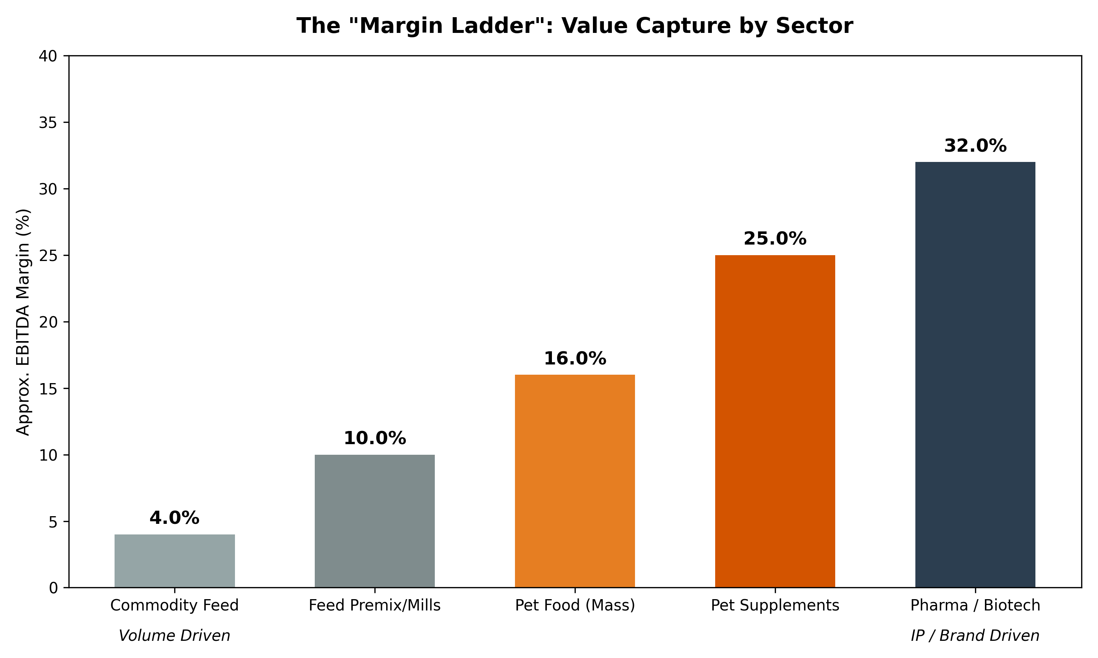

*Figure IV.4: The “Margin Ladder”: Comparative Value Capture by Value Chain Step.*

Value capture in the nutraceutical chain follows a distinct **“Smile Curve.”** The highest margins (**25-30%**) are found upstream among **Ingredient Suppliers** (e.g., **Lonza**, **Novonesis**) whose proprietary strains and regulatory dossiers form high-barrier moats. At the downstream end, successful **Consumer Brands** (e.g., **Wellness**, **VetriScience**) can recapture similar premiums (**20-25%**) through brand equity and “premiumization,” provided they manage customer acquisition costs efficiently. The **“Squeezed Middle”**—typically livestock integrators and commodity mixers—captures the lowest margins (**8-15%**) due to lack of differentiation and intense price sensitivity from farmers.

## **IV.3. Notable Transactions and Investment Landscape (2015 to 2025)**

Since 2015, the animal nutraceutical, supplements, and specialty feed additive ecosystem has shifted from a fragmented brand-and-ingredient universe into an increasingly structured deal market with strategic consolidation and specialized private equity participation. Transactions now clearly signal where value is being created and captured across the chain.

**Key consolidation themes:** 1. **Companion animal health and supplements:** Consolidation around science-backed brands, omnichannel distribution, veterinary credibility, and recurring consumption; premium assets can reach **15–25x EBITDA**. 2. **Livestock and aquaculture:** Consolidation around functional performance inputs (enzymes, probiotics, phytogenics, postbiotics) that sit at the intersection of regulation, productivity, and sustainability, typically at **10–15x EBITDA**. 3. **Upstream omega-3 and functional lipids:** Investment and restructuring around alternative omega-3 sources (algal, krill) tied to aquaculture demand and premium pet applications. 4. **Distribution and data:** Growing PE interest in vet clinics, e-commerce platforms, and vet support organisations as “picks and shovels” to control customer relationships.

### **IV.3.1 Major M&A and Strategic Transactions (2015–2025)**

#### **A. Companion Animals: Brands, Formats, and Omnichannel Scale**

**Swedencare acquires NaturVet (USA)**

*Swedencare’s deal for NaturVet is a clean benchmark for premium pet supplement valuation when strong brands, retail reach, and in-house soft-chew manufacturing come together.*

* **Deal Size:** ~$447.5 million.
* **Valuation:** **21.4x** 2021 adjusted EBITDA (32.7% margin).
* **Strategic Signal:** High-margin formats and manufacturing scale justify low-20s multiples.

**H&H Group acquires Zesty Paws (USA)**

*Zesty Paws is a digitally native supplement brand built on functional soft chews and dominance of online marketplaces.*

* **Deal Size:** $610 million.
* **Revenue Trajectory:** Scaled from ~$3M to $100M+ during holding period.
* **Strategic Signal:** Underlines the market’s willingness to pay for fast-growing, e-commerce-led platforms (Amazon/Chewy dominance).

**Gryphon Investors-backed Vetnique Labs acquires Lintbells (YuMOVE)**

*This cross-border deal combines two science-backed chronic-care supplement brands.*

* **Target:** Lintbells (UK #1 for mobility).
* **Strategic Rationale:** Creates a transatlantic chronic-care powerhouse with strong veterinary credibility (Vetnique’s stool/gut health + Lintbells’ joint health).

**Morgan Stanley Capital Partners acquires FoodScience (VetriScience)**

*A sponsor-to-sponsor sale (from Wind Point Partners) confirming strong institutional appetite for assets with vertically integrated manufacturing and cross-species brand portfolios.*

* **Strategic Key:** Diverse channel presence (Vet + Retail) backed by “VetriScience” and “DaVinci” brands.

#### **B. Strategic Acquisitions by Large Players**

**Mars Petcare acquires Champion Petfoods (ORIJEN, ACANA)**

* **Strategic Driver:** Deepened presence in the ultra-premium, “biologically appropriate” nutrition segment, moving further into high-margin specialized diets.

**General Mills acquires Blue Buffalo ($8.0B)**

*The landmark 2018 transaction that validated “natural” pet nutrition as a scalable CPG growth platform.*

* **Deal Size:** $8.0 Billion.
* **Valuation:** **~22x** EBITDA.
* **Strategic Signal:** Validated the “Pet Humanization” thesis at massive scale.

### **IV.3.2 Private Equity Landscape**

* **Strategic Buyers** (Mars, Nestlé, ADM, Cargill) dominate larger, synergistic acquisitions where integration into existing supply chains is key.
* **Financial Sponsors** (Gryphon, Vestar, MSCP) focus on **platform building**: acquiring a core asset (like Vetnique) and driving value through add-on M&A (Lintbells) and operational improvements.

**Key PE Appetite:** * **Branded Pet Supplements:** 70% of deals involve PE/CVC due to high growth and margins. * **Valuation Uplift Drivers:** Clinical differentiation (data), Omnichannel reach, and Proprietary manufacturing (soft chews).

### **Table IV.1: Notable Strategic & PE Transactions Summary**

| **Date** | **Target** | **Acquirer** | **Sector** | **Deal Value / Multiple** | **Strategic Rationale** |
| --- | --- | --- | --- | --- | --- |
| **2024** | **VetriScience** | Morgan Stanley Capital Partners | Companion | Undisclosed | **Platform Play**: Vet-channel dominance + manufacturing. |
| **2024** | **Zoetis MFA** | Phibro Animal Health | Livestock | $350M (~0.9x Rev) | **Scale**: Bolstering core medicated feed additive portfolio. |
| **2024** | **YuMOVE** | Vetnique Labs (Gryphon) | Companion | ~5.5x Return | **Cross-Border**: Transatlantic chronic-care dominance. |
| **2023** | **Zesty Paws** | H&H Group | Companion | $610M | **Digital Native**: #1 Amazon brand acquisition. |
| **2022** | **NaturVet** | Swedencare | Companion | $447.5M (21.4x EBITDA) | **Manufacturing**: Gaining US soft-chew capacity. |
| **2020** | **Erber Group** | DSM-Firmenich | Feed | €980M (20-22x EBITDA) | **Tech**: Mycotoxin & Gut health leadership. |
| **2018** | **Blue Buffalo** | General Mills | Pet Food | $8.0B (~22x EBITDA) | **Mass Premium**: Validated natural pet at CPG scale. |

### **IV.3.3 Key Investor Profiles & Portfolios**

*A snapshot of active PE and VC firms shaping the nutraceutical landscape.*

The investment landscape is characterized by a distinct **“barbell” risk appetite**. On one end, **Mega-PE firms** (like JAB, EQT, and BC Partners) are aggressively consolidating downstream channels—veterinary clinics, specialty retail, and service networks—to control the customer interface and “own the pet parent.” On the other end, **Specialized VCs** (like Digitalis, Ocean 14, and Seventure) are funding high-risk, high-reward upstream innovation in biotechnology (microbiome, phages) and sustainable ingredients. This creates a symbiotic ecosystem where early-stage “science” validated by VCs is eventually acquired and scaled by the “platforms” built by late-stage Private Equity.

### **Table IV.2: Key Investor Profiles & Portfolios**

| **Investor** | **Est. AUM** | **Key Nutraceutical/Health Assets** | **Strategic Focus** |
| --- | --- | --- | --- |
| **JAB Holding Company** | **>$40B** | **NVA**, **Ethos Veterinary Health** | **Vet Services Consolidation**: The global “super-aggregator” of veterinary clinics and specialty hospitals (#2 globally). |
| **Gryphon Investors** | **>$10B** | **Vetnique Labs**, **Lintbells (YuMOVE)** | **Platform Building**: Aggregating veterinary-endorsed brands to create category leaders (e.g., Mobility & Gut Health). |
| **Morgan Stanley Capital Partners** | **~$34B** | **FoodScience Corp (VetriScience)**, **Manna Pro** | **Manufacturing & Scale**: Targeting vertically integrated formulators with diverse channel presence (Vet + Retail). |
| **EQT Group** | **~€240B** | **IVC Evidensia**, **Zooplus**, **Dechra** | **Ecosystem Play**: Controlling the entire value chain from manufacturing (Dechra) to point-of-care (IVC) and retail (Zooplus). |
| **BC Partners** | **>$40B** | **PetSmart**, **Gambol Pet Group** | **Retail & Manufacturing**: Controlling the largest US retailer and expanding into Chinese manufacturing capacity. |
| **Cinven** | **€44B** | **Arcaplanet**, **Partner in Pet Food** | **Euro-Champions**: Leading Italian retail consolidation and European private-label manufacturing. |
| **Advent International** | **~$100B** | **Seek Pet Food**, **Felix Pharms** | **Global Manufacturing**: Building distinct platforms in generic pharma and 3rd-party pet food production. |
| **Clearlake Capital** | **>$90B** | **Wellness Pet Company** | **Outcome-Based Nutrition**: Integrating supplements and dental health into core premium pet food portfolios. |
| **Verlinvest** | **>€2B** | **Tom & Co**, **Nesto** | **Omnichannel**: Building integrated retail and veterinary networks in Benelux/France. |
| **Vestar Capital Partners** | **$3.2B** | **PetHonesty** | **DTC to Retail**: Scaling digitally native brands into mass retail channels. |
| **Digitalis Ventures** | **>$800M** | **Native Pet**, **Ancestral**, **Gallant**, **Astra Therapeutics** | **Tech & Science**: Backing “clean label” functional brands, next-gen biotech, and anti-parasitic innovation. |
| **Ani.VC** | **Undisclosed** | **The Cat Health Company**, **MI:RNA**, **Vetmab** | **Feline Focus**: Dedicated capital for “nine lives extension” and advanced diagnostics. |
| **Borealis Ventures** | **>$300M** | **Embark**, **Fidocure**, **Vetcove** | **Precision Medicine**: Bridging human and veterinary oncology and genomics. |
| **S2G Investments** | **>$2B** | **Enthos**, **Pasture Bio**, **Kingdom Supercultures** | **Food Systems**: Investing in the “farm-to-paw” transition, from methane vaccines to insect protein. |
| **Seventure Partners** | **~$1.1B** | **ViroVet**, **Proteon** | **Health & Nutrition**: Deep-tech investor in microbiome, phages, and alternative therapies. |
| **Anterra Capital** | **>$400M** | **BiomEdit** | **Microbiome**: Specialized focus on microbiome-based therapeutics and probiotics. |
| **Aqua-Spark** | **~€500M** | **Protix**, **Sea6 Energy** | **Sustainable Ingredients**: Investing in upstream novel ingredients (Insect protein, Seaweed) for feed and food. |
| **Five Seasons Ventures** | **>€250M** | **Mammaly**, **Butternut Box** | **Functional Consumer**: European consumer-tech brands blending nutrition with functional health benefits. |
| **Blue Horizon** | **~$300M** | **Wild Earth**, **Mosa Meat** | **Alt-Protein**: Investing in the fundamental shift away from animal-based proteins (Fermentation/Cultivated). |
| **Ocean 14 Capital** | **~€200M** | **SyAqua**, **Enthos** | **Blue Economy**: Dedicated focus on sustainable aquaculture genetics and insect-protein inputs. |
| **Stray Dog Capital** | **Undisclosed** | **Wild Earth**, **Bond Pet Foods** | **Alt-Protein**: Precision fermentation and plant-based technologies replacing animal proteins. |
| **Cavallo Ventures** | **Corp. VC** | **Native Microbials**, **Bond Pet Foods** | **AgTech Crossover**: Bridging the gap between livestock efficiency and pet nutrition innovation. |

**Strategic Takeaway:** The era of generic “asset aggregation” is fading. The highest returns are now flowing to investors executing specific thematic plays: **Vertical Integration** (owning manufacturing + brand), **Omnichannel Ecosystems** (owning vet + retail + insurance), or **Deep Tech Defense** (owning the IP for diverse ingredients like phages or enzymes). For founders and new entrants, alignment with these specific “buy-boxes” is critical for a successful exit.

### **IV.3.4. Transaction Landscape Summary**

### **IV.3.5 Emerging Innovators Watchlist (2026)**

Key startups that are redefining the boundaries of animal health and nutrition through novel technologies.

#### **Table IV.3: Emerging Venture-Backed Innovators**

| **Company** | **Sector** | **Key Innovation / Value Proposition** | **Strategic Relevance** |
| --- | --- | --- | --- |
| **The Cat Health Company** | Veterinary (Longevity) | **“Nine Lives Extension”**: Dedication to feline-specific longevity therapeutics. | Addressing the “second-class citizen” status of feline R&D with curative intent. |
| **MI:RNA** | Diagnostics | **MicroRNA Biomarkers**: Early cancer and heart disease detection before symptoms. | Shifts veterinary medicine from “reactive” to “predictive.” |
| **Bond Pet Foods** | Biotech (Ingredients) | **Precision Fermentation**: “Brewing” animal-identical chicken protein without slaughter. | Solves the “Sustainability vs. Palatability” conflict for premium brands. |
| **Native Pet** | Consumer (Supplements) | **Clean Label**: Whole-food supplements (e.g., pumpkin, bone broth) vs. synthetic pillars. | Bridges the gap between “Treat” and “Medicine” for millennial owners. |
| **Dandylion** | Consumer (Grooming) | **“Skin-First” Hygiene**: pH-balanced, fragrance-free grooming for sensitive dogs. | “Skinification” of pet care; treating dog grooming like human skincare. |
| **Gallant Therapeutics** | Veterinary (Biotech) | **Off-the-shelf Stem Cells**: Uterine-derived MSCs for feline gingivostomatitis. | Scalable regenerative medicine capable of replacing lifelong pharmaceutical management. |
| **Rumin8** | AgTech (Feed) | **Synthetic Methane Blockers**: Pharmaceutically stabilized bromoform (seaweed active). | Solves the “seaweed supply chain” problem for livestock methane reduction. |

**Key Insights from Competitive Analysis:**

1. **Margin Bifurcation**: Pharma-linked players command 30-40% EBITDA margins on Rx products vs. 6-12% for feed commodity players
2. **Pet Premium**: Consumer-facing pet nutraceutical brands sustain 20-25% EBITDA with premium pricing power
3. **Scale Advantage**: Top 5 feed additive players control ~55% of global market, creating significant barriers to entry
4. **Clinical Moat**: Companies with published efficacy data (Nutramax, Hill’s) command 20-40% price premiums
5. **Channel Power**: E-commerce growth (Chewy, Amazon) is compressing traditional vet-channel margins by 100-200 bps

## **IV.4 Valuation Dynamics and Margin Analysis**

### **IV.4.1 Pet-focused consumer brands: “The Wellness Premium”**

Consumer-facing pet nutrition businesses typically sustain **EBITDA margins in the 20–25% range** and command **15x–20x+ EBITDA multiples**. This premium is driven by inelastic consumer spending and the “humanization” of pet health. The upper end of this valuation range is reserved for brands that demonstrate:

* **Clinical Moats:** Differentiated efficacy backed by published data (e.g., *Hill’s Science Diet*, *Dasuquin*).
* **Recurring Revenue:** Strong subscription models with high retention (e.g., *Chewy*, *Butternut Box*).
* **Professional Trust:** Endorsement by veterinarians, creating a defensible barrier to entry.
* **Measurable ROI:** Products delivering visible health outcomes (e.g., improved mobility, coat shine) that justify premium pricing.

### **IV.4.2 Livestock and specialty-ingredient platforms: “Efficiency at Scale”**

Upstream ingredient providers (enzymes, probiotics) typically post **15–25% EBITDA margins** and trade on **high-single to mid-10s multiples**. * **Key Driver:** IP protection and regulatory barriers (e.g., *Novonesis* with >35% margins). * **Constraint:** Exposure to commodity cycles and on-farm ROI scrutiny.

### **IV.4.3 Key Valuation Drivers: The 4 Accelerators (2024–2025)**

Investors are currently paying a premium for assets aligned with four specific catalysts:

1. **Clinical Evidence & Differentiation**

* *The Driver:* Peer-reviewed efficacy data (e.g., methane reduction stats, joint mobility scores).
* *The Impact:* Validates “Science-Inside” claims, supporting premium pricing over generics.

1. **Regulatory De-risking**

* *The Driver:* Clear pathways (e.g., Innovative FEED Act in the US, EU harmonization).
* *The Impact:* Shortens time-to-market for novel functional additives.

1. **Sustainability & ESG Integration**

* *The Driver:* Resource efficiency tools (e.g., *Bovaer* for methane).
* *The Impact:* Positions additives as essential “Scope 3” decarbonization assets for global food giants.

1. **E-commerce & Data Integration**

* *The Driver:* Direct ownership of the consumer relationship and first-party data.
* *The Impact:* Increases Customer Lifetime Value (CLV) and reduces reliance on traditional retail intermediaries.

## **IV.5 Market Structure Summary: The “Margin Ladder”**

The competitive landscape is structured into four distinct layers of value capture:

* **Layer 1: The IP Engines (Ingredients & Tech)**
* *Focus:* Fermentation, active molecule synthesis.
* *Financials:* **15–25% EBITDA**. High checking barriers.
* *Examples:* *Novonesis*, *DSM-Firmenich*.
* **Layer 2: The Infrastructure (Premix & Feed)**
* *Focus:* Milling, blending, bulk manufacturing.
* *Financials:* **3–7% EBITDA**. Capital intensive, volume-driven.
* *Examples:* *ForFarmers*, regional feed mills.
* **Layer 3: The Brand Builders (Consumer Channels)**
* *Focus:* Emotional connection, marketing, “Pet Humanization”.
* *Financials:* **20–25% EBITDA**. High ROIC if Customer Acquisition Cost (CAC) is managed.
* *Examples:* *Blue Buffalo*, *Zesty Paws*, *Swedencare*.
* **Layer 4: The Gatekeepers (Distribution & Data)**
* *Focus:* Aggregating demand, owning the “last mile”.
* *Financials:* **12–15% EBITDA**. Value derived from ecosystem lock-in.
* *Examples:* *Chewy*, *IVC Evidensia*, *Zooplus*.

Capital flows are increasingly bypassing Layer 2 to target the **IP (Layer 1)** and **Brands (Layer 3)**, where differentiation is strongest.

## **IV.6. Strategic Implications for Investors**

For banking clients, investors, and corporate strategists, several high-level takeaways emerge from this competitive mapping:

Two-speed market: Pet nutraceuticals (20–25% margins, 15–20x multiples) command a structural premium over livestock additives (3–10% margins, 1–15x multiples). Pet brands are the “trophy assets”; livestock feed is the “essential infrastructure.”

Science as a moat: Clinical differentiation (Dasuquin, Bovaer, NexGard PLUS) drives premium pricing and multiples. Companies investing in efficacy data and IP will command sustained pricing power.

Consolidation vectors: (a) Upstream scale – Novonesis, DSM-Firmenich, and fermentation biotech are attracting strategic and PE interest; (b) Branded pet platforms – Direct acquisition of Nutramax, Wellness Pet, and DTC brands by larger players; (c) Data and distribution – Chewy, veterinary networks, and retail chains becoming increasingly valuable for private-label development.

Regulatory tailwinds: AGP/ZnO bans and the Innovative FEED Act are creating tailwinds for alternative additive suppliers, supporting valuations for DSM, Novonesis, Cargill, and specialized suppliers.

ESG as pricing driver: Methane-reduction additives (Bovaer, SilvAir™) are becoming essential for large livestock groups meeting climate targets and are commanding premium pricing and multiples.

## **IV.7. Strategic Capital Allocation Matrix**

**The “Winner’s Matrix” (Strategic Positioning)**

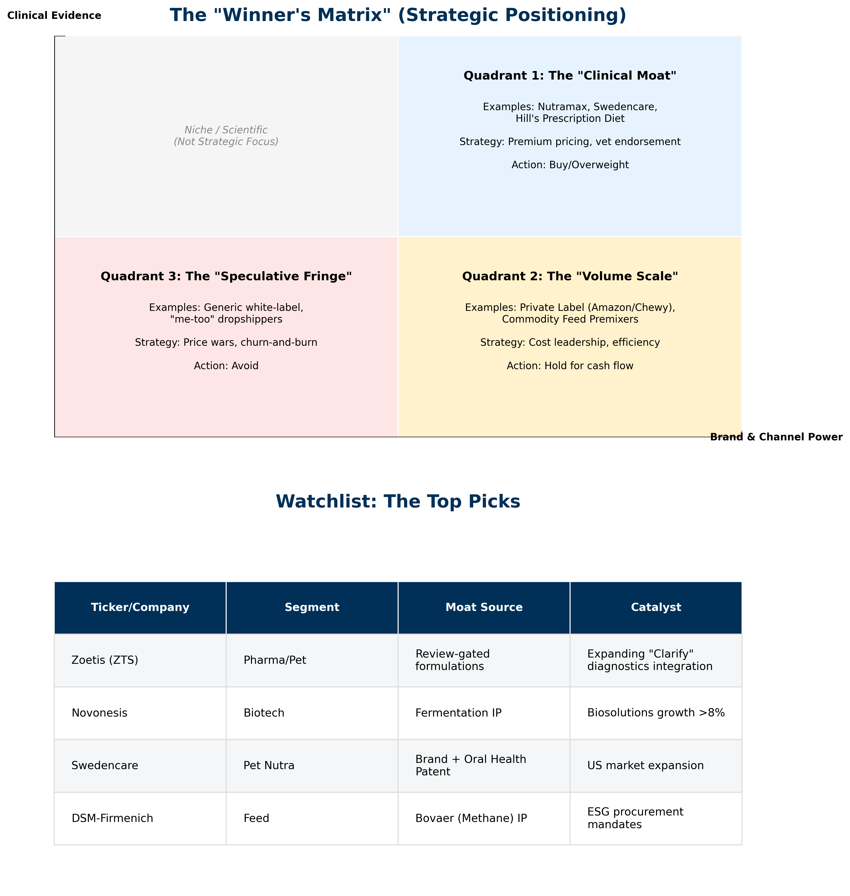

*Figure IV.5: Strategic Capital Allocation Matrix and Watchlist: Mapping the “Clinical Moat” against commercial volume scale.*

### **IV.7.1 Quadrant Analysis**

The competitive landscape is defined by two critical axes: **Clinical Evidence** (the ability to prove efficacy) and **Brand & Channel Power** (the ability to reach the customer). This creates three distinct investable zones:

**Quadrant 1: The “Clinical Moat” (High Evidence / High Power)** * **Examples:** Nutramax, Swedencare, Hill’s Prescription Diet * **Strategy:** Premium pricing, veterinary endorsement, recurring revenue. * **Action: Buy/Overweight**

**Quadrant 2: The “Volume Scale” (Low Evidence / High Power)** * **Examples:** Private Label (Amazon/Chewy), Commodity Feed Premixes * **Strategy:** Cost leadership, efficiency, supply chain dominance. * **Action: Hold for cash flow**

**Quadrant 3: The “Speculative Fringe” (Low Evidence / Low Power)** * **Examples:** Generic white-label, “me-too” dropshippers * **Strategy:** Price wars, churn-and-burn marketing. * **Action: Avoid**

*(Note: The Top-Left quadrant “Niche / Scientific” represents high-science ventures that lack commercial scale, typically acquisition targets rather than standalone investments.)*

### **IV.7.2 Watchlist: The Top Picks**

| **Ticker/Company** | **Segment** | **Moat Source** | **Catalyst** |
| --- | --- | --- | --- |
| **Zoetis (ZTS)** | Pharma/Pet | Review-gated formulations | Expanding “Clarify” diagnostics integration |
| **Novonesis** | Biotech | Fermentation IP | Biosolutions growth >8% |
| **Swedencare** | Pet Nutra | Brand + Oral Health Patent | US market expansion |
| **DSM-Firmenich** | Feed | Bovaer (Methane) IP | ESG procurement mandates |

## **V. Emerging Strategic Frontiers (2026-2030)**

***In this section:*** *We analyze the two most disruptive vectors reshaping the industry: The institutionalization of sustainability credentials (“Green Labels”) and the biological precision of Nutrigenomics (“Biology as Software”).*

### **V.1. The Institutionalization of Green Labels**

*The shift from marketing optionality to regulatory “license to operate.”*

#### **V.1.1 The Regulatory Squeeze: A Multi-Regional Landscape**

The era of self-declared “Eco-Friendly” claims is ending, but the rules of the road vary significantly by geography. Winning organizations are tailoring their evidence strategies to four distinct regulatory blocs:

**A. European Union: The “Hard Line” (EmpCo)** The EU represents the strictest regime globally. The **Empowering Consumers for the Green Transition (EmpCo)** Directive (fully applicable by late 2026) fundamentally reshapes the shelf: * **Bans Generic Claims:** Terms like “Green”, “Nature-Friendly”, or “Eco” are prohibited unless linked to demonstrated excellent performance (e.g., EU Ecolabel). * **Restricts Offsets:** “Carbon Neutral” claims based on offsetting are effectively banned in B2C, forcing brands to compete on *actual* lifecycle reductions.

**B. United States: The Functional Gateway (FEED Act)** While the **FTC Green Guides** remain the baseline for marketing compliance, the proposed **Innovative FEED Act** (H.R. 2203) promises a structural shift. It creates a regulatory pathway for “Zootechnical” ingredients to make substantiated **environmental effectiveness claims** (e.g., “Reduces Methane”) without being classified as drugs, unlocking R&D investment.

**C. United Kingdom: The Principles-Based Approach (CMA)** Post-Brexit, the UK follows the **Competition and Markets Authority (CMA) Green Claims Code**. Unlike the prescriptive EU directives, the CMA relies on **6 Key Principles** (e.g., “Claims must be substantiable,” “Must not omit important information”). Enforcement is active, with the CMA explicitly targeting “vague” sustainability language in the FMCG sector.

**D. APAC: The “Safety-First” & Fragmented West** * **China:** Regulation focuses primarily on **Food Safety** and strict **Advertising Laws** (banning superlatives like ” #1 Green”). Sustainability claims are emerging but secondary to safety. * **Australia (ACCC):** The ACCC has recently released strict guidance cracking down on “greenwashing,” closely mirroring the US FTC approach but with increased audit activity on “Net Zero” targets. * **Japan/Korea:** Voluntary industry standards dominate, often linked to “Circular Economy” initiatives.

**E. Latin America (LATAM): The “Export Visa” Market** In LATAM, the “Green Label” is effectively a “License to Export,” shaped entirely by external pressure (EUDR). * **The Mandate:** To access European markets, Brazilian and Argentine beef/soy producers must prove their supply chain is **“Deforestation-Free.”** This is a binary compliance requirement, not a consumer preference. * **Innovation:** Institutions like **Embrapa** have developed “Carbon Neutral Brazilian Beef” and “Low Carbon Beef” protocols, turning sustainability certifications into quasi-official export visas. This drives demand for “Intensification Tools” (additives that produce more beef on less land).

#### **V.1.2 Summary: Regional Regulatory Winners & Losers**

| **Region** | **The “Green” Definition** | **Winner (Product Type)** | **Loser (Product Type)** |
| --- | --- | --- | --- |
| **US** | **“The Scope 3 Reducer”** | Methane Inhibitors (e.g., 3-NOP) | Generic Probiotics (unproven claims) |
| **EU** | **“LCA Verified”** | Nitrogen-Smart Enzymes & Proteins | Vague “Eco-Friendly” Brands |
| **UK** | **“Precise & Honest”** | Insect Protein (proven data) | “Ocean Safe” Whitefish (hard to prove) |
| **APAC** | **“Efficient/Credit”** | Low-Soy Diets & Yield Boosters | Imported Premium Grains |
| **LATAM** | **“Deforestation-Free”** | Intensification Tools (Growth Promoters) | Extensive Grazing (Land heavy) |

#### **V.1.3 The Green Label Evidence Hierarchy**

To navigate this shift, winning organizations are adopting a tiered evidence model, moving away from high-risk generic claims toward data-backed substantiation. **This hierarchy has effectively been institutionalized by the convergence of legislative mandates (EU EmpCo) and technical standards (PEFCR, ISO 14067).**

| **Tier** | **Claim Category** | **Risk Level** | **Evidence Requirement** | **Examples** |
| --- | --- | --- | --- | --- |
| **5** | **Multi-Attribute Proficiency** | 🔴 **High Risk** | Recognized excellence across *all* impact categories. Almost impossible to substantiate fully. | “Planet Positive”, “Sustainable Product” |
| **4** | **Certified Seals** | 🟡 **Med Risk** | Third-party audit, strict chain-of-custody, complying with scheme rules. | **MSC**, **Upcycled Certified**, **ISCC** |
| **3** | **Aggregated Footprint** | 🟢 **Low Risk** | LCA aligned with **PEFCR** (EU) or ISO 14067. Requires primary data. | “Product Carbon Footprint: 5kg CO2e” |
| **2** | **Comparative Claims** | 🟢 **Low Risk** | Consistent boundaries & functional units. Strict baseline controls. | “30% Lower Carbon vs. Standard Diet” |
| **1** | **Specific Attributes** | 🟢 **Low Risk** | Supplier documentation & batch traceability. | “Made with 50% Recycled Plastic” |

*Figure V.1: The 5-Tier Evidence Hierarchy: Moving from generic risk (Tier 5) to granular data (Tier 1-3).*

#### **V.1.4 Strategic Innovators: The Divergence into “Climate Compliance” vs “Eco-Purity”**

The market is being reshaped by companies that convert sustainability attributes into measurable, verifiable value. This has led to a bifurcation between “Climate Compliance” (Livestock) and “Eco-Purity” (Pet).

**Category A (Livestock): Climate Compliance & The Methane Battleground** **DSM-Firmenich** defined the category with **Bovaer® (3-NOP)**, validating a ~30% methane reduction claim that transformed a “soft” ESG goal into a “hard” Scope 3 asset for dairy cooperatives. However, agile challengers are emerging: **Rumin8** is solving the “seaweed scalability” problem by pharmaceutically *synthesizing* bioactive bromoform, while **Hoofprint Biome** offers a “biological” alternative via novel enzymes—both targeting the same outcome with next-generation delivery mechanisms.

**Category B (Pet): Eco-Purity & Circular Architectures** In pet food, the “Green” label is merging with “Human-Grade Purity.” **Native Pet** has effectively monetized the “Clean Label” trend by limiting formulas to <5 recognizable ingredients. **Chippin** (silver carp/insect protein) and **Bond Pet Foods** (precision fermentation) are proving that consumers will pay a 20–30% premium for “Science-backed Sustainability.” Behind the scenes, industrial scalers like **InnovaFeed** (Insects) and **Veramaris** (Algal Oil) are breaking reliance on marine fish oil, positioning their “Scope 3 Essential” ingredients as the backbone for modern, sustainable aquaculture and premium pet diets.

**Institutionalizing Trust:** The **Upcycled Food Association (UFA)** provides a critical governance layer. By creating the **“Upcycled Certified”** standard, they legitimized the use of “waste” (e.g., spent grains) as a premium attribute, protecting brands from greenwashing accusations while appealing to the “Zero Waste” consumer.

#### **V.1.5 Strategic Synthesis: How Green Labels Reshape the Market**

The institutionalization of green labels is fundamentally altering competitive dynamics in three ways:

1. **De-Commoditization:**

* Green attributes allow bulk suppliers to break pricing cycles. A ton of soy with a “Deforestation-Free” certificate or a probiotic with a “Methane-Reducing” claim commands a premium, selling *outcomes* rather than just *inputs*.

1. **Data as Gatekeeper:**

* Control over **Measurement, Reporting, and Verification (MRV)** is becoming as valuable as manufacturing. Companies that provide the *verified data packet* alongside the product will lock in customers, shifting power to those who integrate digital platforms.

1. **“Carbon Luxury”:**

* In pet food, “Low-Carbon” is replacing “Grain-Free” as the ultra-premium driver. This tier favors well-capitalized incumbents who can afford the industrial-scale supply chain re-engineering required for insect protein or upcycling logistics, raising barriers to entry for generic competitors.

### **V.2. The Nutrigenomics Frontier: Biology as Software**

*Investment Thesis: The shift from feeding by breed to feeding by measurable biology (Genotype, Phenotype, Microbiome).*

Nutrigenomics—the study of how nutrients change gene expression—is differentiating the market by treating biology as software that can be optimized. The “Genomic Loop” is the core strategic construct: > **Test** (Customer Acquisition) $→$**Insight** (Translator) $→$**Intervention** (Supplement/Diet)

**Key Players & Models:**

* **Biome9 (UK/Global)**: *The Predictive AI Play.*
* **Model:** Uses gut microbiome sequencing (at-home test) to predict health issues before symptoms appear, recommending personalized nutrition protocols.
* **Strategic Role:** Shifts value from “treatment” to “prediction.”
* **AnimalBiome (USA)**: *The Restoration Play.*
* **Model:** Focuses on “Ecosystem Transplants” via fecal microbiota transplantation (FMT) capsules and testing to restore lost microbiome diversity.
* **Strategic Role:** **Strategic Target** for microbiome therapeutics.
* **Alltech (Global)**: *Discovery Platform.*
* **Model:** Operates the Center for Animal Nutrigenomics, using gene expression data to prove that specific additives (e.g., selenium, yeast) activate immunity genes at the cellular level.

**Strategic Implication:** The durable profit pool is not the test itself (which is commoditizing), but the **“Translator”**—the proprietary algorithm that converts biological data into actionable, recurring product recommendations.

### **V.3. The Regulatory Grey Zones (Future-Proofing)**

*The race to define the rules for “Novel Foods” and “Life Extension.”*

As innovation outpaces regulation, the most valuable companies are those successfully navigating three critical “Grey Zones.”

#### **V.3.1 Novel Foods & Alternative Proteins**

The regulatory path for lab-grown ingredients (precision fermentation, cell-cultured meat) is determining the speed of market entry. * **The Challenge:** Getting regulatory approval for non-animal proteins in pet food. * **Key Players:** * **Bond Pet Foods (USA)**: *Strategic Target.* Creating “nature-identical” chicken protein via fermentation. Pivotal partnership with **Hill’s Pet Nutrition** creates a regulatory fast-lane. * **MicroHarvest (Germany)**: *Strategic Target.* Claims the “world’s fastest protein production,” using bacteria to produce single-cell protein 5000x faster than soy. * **Wild Earth (USA)**: *Strategic Target.* Pioneering fungi-based (Koji) dog food, challenging the “meat is essential” dogma with a vegan approach.

#### **V.3.2 The “Longevity” Regulatory Path**

A fundamental shift is occurring from “Health Maintenance” (Supplement) to “Life Extension” (Conditional Drug). * **The Paradigm Shift:** The FDA is showing willingness to accept “Lifespan” as a measurable endpoint for drugs. * **Key Player:** * **Loyal (Cellular Longevity)**: *Strategic Target.* The frontrunner in the “Dog Longevity” race. Their drug **LOY-001** (for large dogs) has received FDA concurrence on a reasonable expectation of effectiveness, creating a new regulatory category: *Lifespan Extension Drugs.*

#### **V.3.3 The Gene-Editing Frontier (CRISPR)**

Using gene editing not to change the animal, but to change the *microbiome* or the *pathogen*.

* **Key Player:**
* **Folium Science (UK)**: *Strategic Target.*
* **Innovation:** Uses **CRISPR-Cas** technology as a “Genetic Scalpel” (Guided Biotics™) to selectively remove bad bacteria (like *Salmonella*) from the gut without harming good bacteria—a precision alternative to antibiotics.

### **V.4. The Longevity Economy: Pet Humanization 2.0**

*Investment Thesis: The shift from “Preventive Care” to “Geroprotection” (active life extension).*

The “Humanization” trend has evolved. Owners no longer just want their pets to be healthy; they want them to *live longer*. This “Longevity Economy” is creating demand for ultra-premium, science-backed interventions.

**Strategic Pillars:**

1. **“Purity” as Longevity:** The belief that “clean” ingredients prevent chronic disease.

* *Innovator:* **Native Pet** (USA) - **Strategic Target.**
* Winning with “Clean Label” supplements (no fillers), capitalizing on the millennial distrust of “industrial” pet food.

1. **Regenerative Therapies:** Bringing human-grade anti-aging tech to pets.

* *Innovator:* **Gallant** (USA) - **Strategic Target.**
* Stem cell banking for dogs (collecting tissue during spay/neuter to treat future arthritis).

1. **Microbiome Restoration:** Using the gut as the “control center” for aging.

* *Innovator:* **AnimalBiome** (USA) - **Strategic Target.**
* The leader in Fecal Microbiota Transplants (FMT) to reverse “gut dysbiosis” associated with aging.

### **V.5. Bio-Manufacturing: The New Supply Chain**

*Investment Thesis: Precision Fermentation replacing extraction and farming.*

Supply chain resilience and sustainability are driving a shift away from “extracted” ingredients (fish oil, chondroitin) toward “brewed” ingredients.

**Key Technologies:**

* **Algal Fermentation (Omega-3s):**
* *Innovator:* **Veramaris** (DSM/Evonik JV) - **Strategic Target.**
* Producing EPA/DHA from algae to break the reliance on declining wild fish stocks.
* **Milk Oligosaccharides (HMOs):**
* *Innovator:* **Gnubiotics** (Switzerland) - **Strategic Target.**
* Synthesizing “Milk Mimics” (Glycans) that replicate the immune-boosting power of mother’s milk, a high-value niche for puppy/kitten formulas.
* **Bacteriophages:**
* *Innovator:* **Proteon** (Poland) - **Strategic Target.**
* Using phages to kill bacteria in aquaculture/poultry, replacing antibiotics in the feed chain.

### **V.6. The Livestock Strategic Pivot: The “Great Divergence” (2026-2030)**

The global livestock sector is undergoing a fundamental bifurcation — or “Great Divergence” — where regional market dynamics are no longer correlated. Investors and strategists must now distinguish between **Structural Decline** (EU) and **Cyclical Volatility** (USA), while identifying the specific “Growth Species” that are bucking the aggregate downward trend.

#### **V.6.1 The “De-Ruminization” of the West**

Data from 2018–2024 reveals a synchronized contraction in cattle inventories across the Western Hemisphere, driven by divergent forces:

* **Europe (Structural Policy Contraction):**
* **The Trend:** Between 2018 and 2023, the EU bovine herd contracted by **-5.2%**, while sheep and goat populations fell by **-10.5%** (the steepest decline of any segment).
* **The Driver:** This is not a cycle; it is policy. The “Green Deal” and nitrogen emission limits (e.g., in the Netherlands and Denmark) are structurally forcing herd reductions to meet environmental statutory targets.
* **Strategic Outcome:** The EU market is shifting from “Volume” to “Value.” Feed additives here must focus on **Efficiency** (producing more milk with fewer cows) and **Nitrogen Management** (maintaining license to operate), rather than growth.
* **United States (Cyclical Climate Shock):**
* **The Trend:** The US cattle inventory plummeted to **87.2 million head** in 2024 — a **73-year low** (lowest since 1951).
* **The Driver:** Prolonged drought and high input costs have forced liquidation. Unlike Europe, this is a distinct cycle; however, heifer retention rates (down 1%) suggest no immediate rebuilding is imminent.
* **Strategic Outcome:** The US market remains driven by **Cost Control** and **Drought Resilience** additives (e.g., hydration support, forage optimizers).

#### **V.6.2 The Growth Engines: Poultry and Aquaculture**

While red meat faces headwinds, “White Protein” is the undisputed growth vector, decoupled from the broader agricultural stagnation.

* **Poultry (The Resilience King):**
* Despite the “Viral Constraint” of Highly Pathogenic Avian Influenza (HPAI) — which caused peak cumulative losses of **146 million birds** globally in 2022 — poultry remains the only expanding livestock sector in Europe (**+10.5% production index** increase 2018–2023).
* **Market Share:** Poultry now commands **43.5%** of the global feed additive market ($6.84 billion), cementing its status as the commercial backbone of the industry.
* **Key Insight:** The “Short Cycle” advantage allows poultry producers to adapt to cost shocks faster than any other protein sector, making it the primary target for rapid-turnover innovation (e.g., fast-acting probiotics).
* **Aquaculture (The Historic Crossover):**
* **Milestone:** In 2022, global aquaculture production (**94.4 million tonnes**) historically surpassed wild capture fisheries (**92.3 million tonnes**) for the first time.
* **The Future:** With a 9.8% share of the additives market but the fastest CAGR, aquaculture is the “Blue Frontier.” The primary constraint is no longer demand, but the “Fish-In / Fish-Out” ratio, driving massive demand for **Algal Oils** (Veramaris) and **Insect Proteins** (Protix) to decouple feed from wild fish stocks.

## **Appendix: Author & Disclaimer**

**About the Author** This White Paper was prepared by the Animal Nutraceuticals Research Team, synthesizing regulatory, clinical, and financial data to provide an institutional-grade view of the market.

**Disclaimer** *This document is for informational purposes only and does not constitute investment advice. Market sizes are estimates based on available data as of Q1 2026. Forward-looking statements involve risks and uncertainties. Data limitations apply to emerging segments where official statistics are unavailable.*

## **Appendix B: Strategic Business Case Targets**

*A consolidated watchlist of high-priority targets for partnership, acquisition, or competitive analysis, categorized by market position.*

| **Category** | **Company** | **Key Products / Focus** | **Strategic Positioning** |
| --- | --- | --- | --- |
| **Pharma & Vet Majors** | **Zoetis** | Vaccines, Simparica, Apoquel | **Global #1**: The “Pfizer of Pets.” Innovation in Derma/Pain. |
| **Pharma & Vet Majors** | **Merck Animal Health** | Bravecto®, Vaccines | **Pharma Heritage**: Massive parasiticide & livestock portfolio. |
| **Pharma & Vet Majors** | **Boehringer Ingelheim** | NexGard®, Frontline® | **Parasiticide King**: #1 in flea/tick globally. |
| **Pharma & Vet Majors** | **Elanco** | Seresto®, Galliprant® | **Innovation Focus**: Spun out of Eli Lilly; strong pipeline. |
| **Pharma & Vet Majors** | **Virbac** | Anxitane®, Novifit® | **Vet Pure-Play**: Largest independent dedicated to animal health. |
| **Pharma & Vet Majors** | **Ceva Santé Animale** | Adaptil® (Calming) | **The Challenger**: Leader in pheromones & preventive medicine. |
| **Pharma & Vet Majors** | **Phibro** | Feed Additives | **Consolidation**: Acquired Zoetis’s Medicated Feed Additive unit. |
| **Pharma & Vet Majors** | **Vetoquinol** | Zylkène®, Flexadin® | **“Essentials”**: High-margin preventive nutrition focus. |
| **Feed & Ingredient Giants** | **Cargill Animal Nutrition** | Diamond V, Provimi | **Scale King**: Vertical integration from crops to premixes. |
| **Feed & Ingredient Giants** | **Nutreco (Trouw)** | Premixes | **Sustainability**: Huge footprint in aqua & livestock premixes. |
| **Feed & Ingredient Giants** | **DSM-Firmenich** | Vitamins, Bovaer® | **Science-Driven**: Vitamins, minerals, and sustainability. |
| **Feed & Ingredient Giants** | **ADM** | Protexin, DE111® | **Fermentation**: Massive fermentation capacity for probiotics. |
| **Feed & Ingredient Giants** | **Novonesis** | Probiotics, Enzymes | **Biotech Platform**: Merger of Novozymes + Chr. Hansen. |
| **Feed & Ingredient Giants** | **Alltech** | Actigen® (Yeast) | **Genomic Pioneer**: Family-owned biotech giant. |
| **Feed & Ingredient Giants** | **ForFarmers** | Compound Feed | **Cost Leader**: Low-cost producer model for livestock feed. |
| **Pet Food & Brand Giants** | **Nestlé Purina** | Pro Plan, FortiFlora® | **Global Titan**: Massive R&D scale; “Pet Humanization” focus. |
| **Pet Food & Brand Giants** | **Mars Petcare** | Royal Canin, Pedigree | **Services & Food**: Owns huge vet chains (Banfield) + top brands. |
| **Pet Food & Brand Giants** | **Hill’s (Colgate)** | Prescription Diet | **Vet Endorsed**: Clinical evidence as the primary moat. |
| **Pet Food & Brand Giants** | **General Mills** | Blue Buffalo | **Natural Scale**: Premium natural food leader. |
| **Pet Food & Brand Giants** | **Swedencare** | PlaqueOff®, NaturVet | **Aggregator**: Buys high-margin niche leaders (Dental/Supplements). |
| **Pet Food & Brand Giants** | **Freshpet** | Fresh Refrigerated Food | **Category Creator**: High-growth “Fresh” segment leader. |
| **Pet Food & Brand Giants** | **Wellness Pet** | Wellness Core | **Premium Natural**: Strong DTC and dental treat portfolio. |
| **Pet Food & Brand Giants** | **Nulo** | High-Protein Food | **Challenger Brand**: High-protein, grain-free positioning. |
| **Commercial Supplements** | **Zesty Paws** | Probiotic Bites | **Online #1**: The category captain for supplements on Amazon. |
| **Commercial Supplements** | **Nutramax** | Dasuquin® | **US Vet #1**: The “Gold Standard” in US vet clinics. |
| **Commercial Supplements** | **YuMOVE (Lintbells)** | Joint Care | **UK #1**: Vertically integrated (owns NZ mussel farms). |
| **Commercial Supplements** | **SmartPak** | Custom Supplements | **Compliance**: Unit-dose packaging for horses. |
| **Commercial Supplements** | **VetriScience** | GlycoFlex® | **Legacy**: 40+ years of vet formulas. Own manufacturing. |
| **Specialized Ingredients** | **Gelita** | Petagile® (Collagen) | **Collagen Leader**: Specific peptides for cartilage regeneration. |
| **Specialized Ingredients** | **Balchem** | ReaShure® (Choline) | **Encapsulation**: Precision coating for nutrient survival. |
| **Specialized Ingredients** | **Evonik** | MetAMINO® | **Amino Acid King**: World’s purest DL-Methionine. |
| **Specialized Ingredients** | **Adisseo** | Rovabio® (Enzymes) | **Nutrient Unlocker**: Enzymes for fiber digestion. |
| **Specialized Ingredients** | **Bioiberica** | Condrovet® | **Extraction Expert**: #1 Heparin/Chondroitin producer. |
| **Specialized Ingredients** | **Zinpro** | Availa® (Minerals) | **Bioavailability**: Minerals using amino-acid transport. |
| **Specialized Ingredients** | **Lonza** | UC-II® (Collagen) | **Ingredient Brand**: Licensor of the famous UC-II collagen. |
| **Startups & Biotech** | **BiomEdit** | Biome-Actives | **Deep Tech**: Synthetic biology for feed additives. |
| **Startups & Biotech** | **Proteon** | BAFASAL® (Phages) | **Bacteriophages**: Killing bacteria without antibiotics. |
| **Startups & Biotech** | **Bond Pet Foods** | Brewed Protein | **SynBio Chef**: Yeast-fermented meat proteins. |
| **Startups & Biotech** | **MicroHarvest** | Single Cell Protein | **Speed**: Protein fermentation 5000x faster than soy. |
| **Startups & Biotech** | **AnimalBiome** | Gut Restore (FMT) | **Poop Pills**: Fecal transplants and DNA testing. |
| **Startups & Biotech** | **Gnubiotics** | Glycans | **Milk Mimics**: Replicating mother’s milk sugars (HMOs). |
| **Startups & Biotech** | **CanBiocin** | K9-17 Strain | **Strain Bank**: Species-specific probiotics for dogs. |
| **Startups & Biotech** | **Biome9** | AI Gut Test | **AI Testing**: European “Twin” to AnimalBiome. |
| **Specialized Niche** | **Vetnique Labs** | Glandex® | **Category Creator**: Invented “Anal Gland” supplements. |
| **Emerging Tech** | **Rumin8** | Synthetic Chemistry | **Methane**: Scalable methane reduction. |
| **Emerging Tech** | **Hoofprint Biome** | Microbiome Engineering | **Probiotics**: For methane & yield. |
| **Emerging Tech** | **Veramaris** | Algal Fermentation | **Omega-3s**: Sustainable sources (No fish). |
| **Retail & Services** | **PetSmart** | Retail Chain | **US Retail King**: Largest pet specialty retailer in N. America. |
| **Retail & Services** | **IVC Evidensia** | Veterinary Clinics | **Vet Aggregator**: Europe’s largest veterinary care provider. |
| **Retail & Services** | **Zooplus** | Online Retail | **E-Commerce Giant**: The “Amazon of Pets” for Europe. |
| **Supplements** | **PetHonesty** | Functional Chews | **E-Comm Scale**: Rapid growth via Amazon/DTC to Retail. |
| **Supplements** | **Native Pet** | Clean Supplements | **Clean Label**: “No filler” powders and chews (DTC focus). |
| **Supplements** | **Mammaly** | Functional Chews | **DTC Leader**: Rapidly growing German supplement snack brand. |
| **Pharma & Biotech** | **Dechra** | Vet Pharma | **Endocrinology**: Global specialist in difficult diseases. |
| **Pharma & Biotech** | **Native Microbials** | Rumen Microbes | **Dairy Yield**: Mapping the rumen microbiome to improve yield. |